**MINISTRY OF EDUCATION AND TRAINING**

**FPT UNIVERSITY**

Capstone Project Document

Football Pitches Booking

|  |  |
| --- | --- |
| **Group 10** | |
| **Group Members** | Nguyễn Duy Phương – SE60761 – [phuongndse60761@fpt.edu.vn](mailto:phuongndse60761@fpt.edu.vn)  Nguyễn Hữu Hoàng Giang – SE60606 – [giangnhhse60606@fpt.edu.vn](mailto:giangnhhse60606@fpt.edu.vn)  Nguyễn Đức Thịnh – 60398 – [thinhnd60398@fpt.edu.vn](mailto:thinhnd60398@fpt.edu.vn)  Nguyễn Quốc Khánh – 60556 – [khanhnq60556@fpt.edu.vn](mailto:khanhnq60556@fpt.edu.vn) |
| **Supervisor** | Lại Đức Hùng |
| **Ext Supervisor** |  |
| **Capstone Project code** | FPB |

- Ho Chi Minh, 01/2014 –

Table of Contents

Definitions, Acronyms, and Abbreviations 7

Report No.1: Introduction 8

1.1. Initial idea of group: 8

1.2. Overview of existing system: 8

1.3. Benefit of expected system: 8

Report No.2: Project Management Plan (PMP) 9

2.1. Problem Definition 9

2.1.1. Name of this CapStone Project. 9

2.1.2. Problem Abstract 9

2.1.3. Project Overview 9

2.2. Project organization 10

2.2.1. System Process Model 10

2.2.2. Roles and Responsibilities 11

2.2.3. Tools and Techniques 12

2.3. Project management plan 12

2.3.1. Tasks: 12

2.3.2. Task Sheet: Assignments and Timetable 14

2.4. Convention Rules 14

2.5. Other material 14

Report No.3: System Requirements Specifications (SRS) 15

3.1. User requirement specification 15

3.1.1. Guest: 15

3.1.2. Member: 15

3.1.3. Stadium Owner 15

3.1.4. Stadium Staff 15

3.1.5. Website Master 15

3.1.6. Website Staff 16

3.1.7. System 16

3.2. System requirement specification (Specific Requirements) 16

3.2.1. External Interface Requirements 16

3.2.2. Functional Requirements 17

3.2.3. Non-Functional Requirements 81

3.2.4. Entity Relationship Diagram 82

Report No.4: System Design Description (SDD) 83

4.1. Design Overview 83

4.2. System Architectural Design 84

4.2.1. Choice of System Architecture 84

4.2.2. Discussion of Alternative Designs 85

4.2.3. Description of System Interface 85

4.3. Component Diagram 86

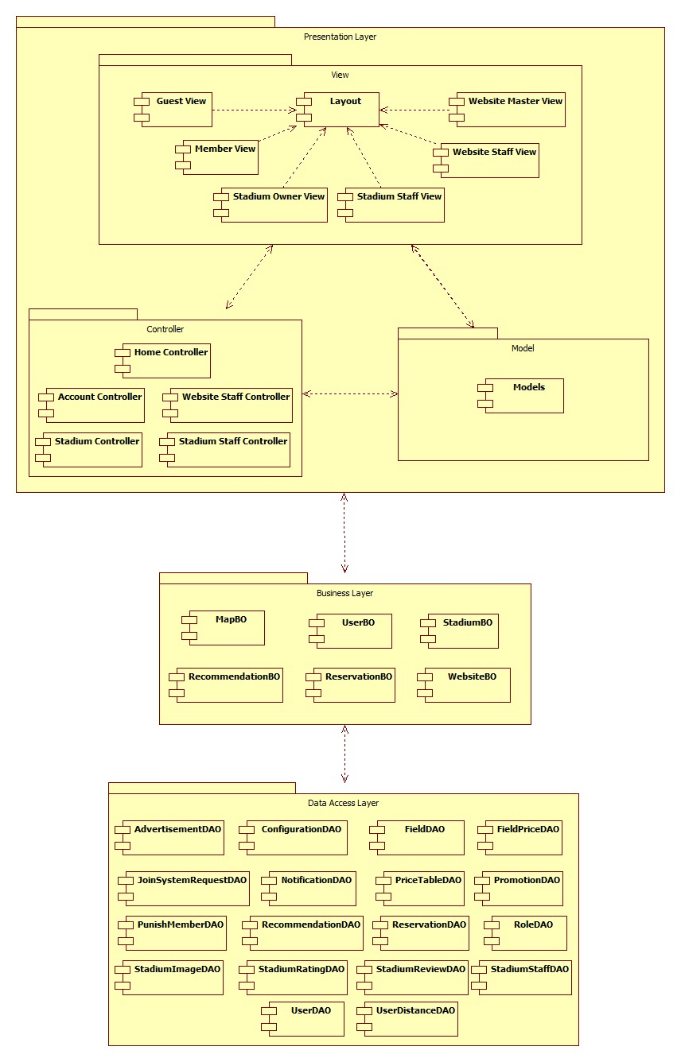 86

4.4. Detailed Description of Components 87

4.4.1. Class Diagram Explanation 87

4.5. Sequence Diagram 105

4.5.1. Create Stadium 105

4.5.2. Update Stadium 105

4.5.3. Update Configuration 105

4.5.4. Suggest Stadium 105

4.5.5. Suggest Rival 106

4.5.6. View Stadiums 106

4.5.7. Create Member Rank 106

4.5.8. Update Member Rank 106

4.5.9. Delete Member Rank 106

4.5.10. View Member Ranks 106

4.5.11. Create Advertising 106

4.5.12. Update Advertising 106

4.5.13. Delete Advertising 106

4.5.14. View Advertisings 106

4.5.15. Punish User 106

4.5.16. Update User 106

4.5.17. View Users 106

4.5.18. Update Stadium Profile 106

4.5.19. Add Field To Stadium 106

4.5.20. Update Field 106

4.5.21. View Fields 106

4.5.22. Create Reservation 107

4.5.23. Update Reservation 107

4.5.24. Approve Reservation 107

4.5.25. Decline Reservation 107

4.5.26. View Reservations 107

4.5.27. Create Promotion 107

4.5.28. Update Promotion 107

4.5.29. View Promotions 107

4.5.30. Find Stadium 107

4.5.31. Find Available Stadium 108

4.5.32. View Stadium Detail 108

4.5.33. Book Field 108

4.5.34. Cancel Reservation 108

4.5.35. Find Rival 108

4.5.36. Join Match 108

4.5.37. View Booking History 108

4.5.38. Rate Stadium 108

4.5.39. Review Stadium 108

4.5.40. Update Account Profile 108

4.5.41. Feedback Website 108

4.5.42. Request Join System 108

4.6. User Interface Design/ Hardware Interface Design (if any) 108

4.7. Database Design 109

4.7.1. Tables description 109

4.7.2. Advertisement 110

4.7.3. Field 110

4.7.4. FieldPrice 111

4.7.5. JoinSystemRequest 111

4.7.6. MemberRank 112

4.7.7. Promotion 112

4.7.8. Reservation 112

4.7.9. Role 113

4.7.10. Stadium 114

4.7.11. StadiumImage 114

4.7.12. StadiumRating 114

4.7.13. StadiumReview 115

4.7.14. StadiumStaff 115

4.7.15. User 115

4.8. Other material (if any) 116

Report No.5: System Implementation & Test (SIT) 117

5.1. Introduction 117

5.1.1. System Overview 117

5.1.2. Test Approach 117

5.2. Test Plan 117

5.2.1. Functions 117

5.2.2. Features not to be tested 117

5.3. Test Cases 118

5.3.1. Function 118

5.4. Checklist 162

5.4.1. Checklist validation 162

5.4.2. Submission Checklist 162

5.5. Other material (if any) 162

Report No.6: Report No.6 : System User’s Manual 163

6.1. Installation Guide 163

6.1.1. System requirements 163

6.1.2. Installation 163

6.1.3. Deploy Database 163

6.1.4. Deploy Application 163

6.2. 6.2 User’s Guide 168

6.2.1. Website Master 168

6.2.2. Website Staff 176

6.2.3. Stadium Staff 177

6.2.4. Stadium Owner 182

## Definitions, Acronyms, and Abbreviations

|  |  |  |
| --- | --- | --- |
| No. | Keyword | Definition |
| 1 | B2B2C | Stand for Business to business to customer.  In this system, first business is the organization that provides stadium owner to register their stadiums. The second business is stadium owner, who provides hire stadium service, and customer is the user, who want to hire field by this system. |
| 2 |  |  |
| 3 |  |  |
| 4 |  |  |
| 5 |  |  |

## Introduction

### Initial idea of group:

Football Pitches Booking is a B2B2C (Business to Business to Customer) website that allows customers to book field online. Beside that it helps the stadium owners with advertising football stadiums and managing reservation. In addition, the website enables its admin to manage customers and stadiums.

In this situation, the organization is the first business who provides market. And the stadium owners provide service.

### Overview of existing system:

For customers: existing systems just provide customers with address and contact information of stadium, then customers have to contact with the stadium owner to place a reservation. They have to call each stadium owner individually to check whether the field is available or not. Moreover, the current system does not have either functions to make statistics of customers' habits or some smart functions like offering options/suggestion to customers, which is time-consuming and inconvenient to customers.

For the stadium owners, sometimes they make mistakes in management such as duplicate reservation, which leads to bad result: they could lose their customers as well as profit. Beside the management is executed manually, if the player want to find a friendly match, the stadium owners must help them by calling other players to arrange a game.

For the website masters, the shortage of functions of the website is the obstacle to persuade stadium owners to pay for the services.

### Benefit of expected system:

Football Pitches Booking makes the reservation easier and save time for customers. Once they have booked, they don’t have to worry there will be a duplicate reservation caused by stadium owners' mistake. The website's smart functions help users to find the appropriate field by searching stadiums near their address, stadiums in habits booked, and the stadiums which are discounted. The benefits to customers are saving time, getting more information and enjoying discount of stadiums, beside that players find rival easily if they do not have enough player to create a game.

This system helps stadium owners to manage their field easily, reduce the implement process of business operations, save time and costs. The automatic system helps to prevent the risk of duplicate booking. Furthermore, stadium owners can use the website as a channel to advertise their services as well as communicate with their customers; hence, they can win more customers and gain more prestige through rating-feedback functions.

For the website master, with many smart and outstanding functions of the new system, they have more chances to increase the profit by attracting stadium owners to use this service.

## Project Management Plan (PMP)

### Problem Definition

#### Name of this CapStone Project.

This Capstone Project’s name is “Football Pitches Booking” or “FPB” in short.

#### Problem Abstract

Ho Chi Minh City (HCMC for short) has over seven million of population, is Vietnam’s centre of commerce and the country’s biggest city by far, though not its administrative capital. HCMC is a youthful city, almost residents are student and clerical worker. Even live in a busy environment, they still take their free time to play sport for their health and their relaxation. One of the most popular sport is football. Nowadays more and more spontaneous football games are opened, so the number of artificial grass field increases faster. Based on the latest count, there are more than one hundred stadiums in 2012, it include five, seven and eleven-man field. And the amount of stadium around HCMC increases constantly.

With the high demand of hiring field, almost stadium owners still manage their stadium manually. Player used to contact with stadium owner to book field by phone, and some problems were occurred. They have to call the stadium owner to ask for an available booking time, sometimes the manager’s mistake makes the duplicated reservation. This process is wasting time and making more inconvenience.   
There are some websites allow player to search stadium and book it, but it still has limitation. Player have to wait for confirmation of stadium owner after they check this booking time. Managers still arrange reservation manually and mistake still happens.

To meet that demand, we develop a website that allow user to book field online. They can find an appropriate field base on booking time, location or field type. Some automatic functions help them with saving time by customer habits statistics. Promotion function help stadium owners to attract their customer. Obviously player get more priority when they register this system.  
In summary, Football Pitches Booking is develop for attending to customer, stadium owner and so website administrator. It makes the reservation becomes easily, helps service provider manage precisely and encourages business efficiently.

#### Project Overview

##### The Current System

According to our research, there has never been a Football pitches booking online system like the one we are developing. There are some websites that provides stadium’s information. We divide it into two types: single stadium service (Website for one stadium owner) and multiple stadium service (Website for more than one stadium owner).

Single stadium service:

There are some services applied for one stadium. For example: <http://tuyensonsport.vn>; <http://sanbongdamini.seonhatnghe.com>

* User just books field belonging to this stadium. The way to book is call stadium owner.
* It is easy to makes mistake in management when executing manually such as duplicate reservation.

Multiple stadium service:

* Some websites collect stadium and provide information to user and they must contact stadium owner then. They have to call each stadium owner individually to check whether the field is available or not.
* Some websites have the booking online system, for example: http://datsan.com.vn  
  Datsan.com.vn is a website that allows users to pick a field and book it online. This website provides searching function to make it more convenient for users. Firstly, users have to choose field, then they fill in the booking form; one point of this form that must be noticed is the booking time. After that, they must wait for the confirmation of stadium owner.    
  Maybe the booking time that user booked is not available. So when the stadium owner calls back, user must change the booking time. It really wastes time and causes inconvenience to both customers and service providers.

##### The Proposed System

The system that needs to be established should have these abilities:

* The website must have more categories that are built on the basis of districts,  types of field etc. to make it more convenient for users.
* The website has "search stadium" function. Information can be searched based on location, booking time, type of field (5, 7 or 11 men field). In addition, it should have some auto functions such as suggesting appropriate stadium based on customer habits.
* Management function for stadium owners to manage their fields, arrange booking time manually if necessary.
* Promotion function to attract customers.
* The website enables players to create matches to challenge other players.

##### Boundaries of the System :

* Website focuses about booking field for player, managing stadium for stadium owner
* Website does not intervene about finance problem of stadium owner.

##### Development Environment:

**Hardware requirements:**

* + A computerwith hardware that capable of running Windows 7 operating system, 2GB of RAM for addition software

**Sotfware requirements:**

* + Operating System : Windows 7 Professional (32 or 64 bit).

### Project organization

#### System Process Model

The software will be developed by using waterfall model. The waterfall model developing process includes five main phases:



Figure 1: Waterfall model

* + - Requirement analysis and software definition: The first phase is also the most important phase of the process which may cause great effect to other phases. This phase includes gathering requirements from customer, or from other source like the Internet, and producing the most detail and accurate software definition.
    - System design: This phase is fundamental for implementation phase. Based on customer’s requirements to create logical modules, and definite their inter relations. Using algorithm and diagram to describe implementation of those modules.
    - System implementation and Unit testing: Developing software modules follow detail designs, and doing unit testing for each module.
    - Integration and System testing: Testing output, performance in modules integrating process, and retests all functions of whole system.
    - System deployment and maintenance: After testing completely, the software is handle over client, developing team will respond for maintenance of the system.

#### Roles and Responsibilities

|  |  |  |
| --- | --- | --- |
| Full Name | Role | Responsibilities |
| Lại Đức Hùng | Supervisor, Project Manager | * Tracking and managing process * Advising ideas and solutions * Specify requirement |
| Nguyễn Duy Phương | Team Leader, Business Analyst, Developer, Tester | * Tracking and managing process * Analyzing requirement * Writing documents and reports * Designing database * Creating and managing project’s structure * Creating and managing project configuration * Creating project’s plan * Designing GUI * Coding and testing |
| Nguyễn Hữu Hoàng Giang | Team Member, Business Analyst, Developer, Tester | * Analyzing requirement * Writing documents and reports * Designing database * Designing GUI * Coding and testing |
| Nguyễn Đức Thịnh | Team Member, Business Analyst, Developer, Tester | * Analyzing requirement * Writing documents and reports * Designing database * Designing GUI * Coding and testing |
| Nguyễn Quốc Khánh | Team Member, Business Analyst, Developer, Tester | * Analyzing requirement * Writing documents and reports * Designing database * Designing GUI * Coding and testing |

#### Tools and Techniques

##### Tools

* Visual Studio 2012
* Microsoft SQL Server 2008 R2
* Star UML 5.0
* Microsoft Office 2013
* Tortoise SVN
* Google Code

##### Techniques

* .NET Framework 4.0
* ASP.NET MVC 4
* UML Modeling 2.0
* HTML5, CSS3, jQuery
* LINQ

### Project management plan

#### Tasks:

##### Study requirement and review technology

|  |  |
| --- | --- |
| Description | Discussing with project manager to understand requirement, business process.  Self-review the technology will be used in project. |
| Deliverables | N/A |
| Resources Needed | 12 man-days |
| Dependencies and Constraints | N/A |
| Risks | Requirement too strange to develop.  The project is not feasible.  The chosen technology is not feasible. |

##### Project Introduction

|  |  |
| --- | --- |
| Description | From requirements and result of researching old system create project introduction document. |
| Deliverables | Project Introduction document. |
| Resources Needed | 4 man-days |
| Dependencies and Constraints | Depend on result of studying requirement. |
| Risks | Lack of experience in researching old system  Do not understand requirements clearly. |

##### Project Management Plan

|  |  |
| --- | --- |
| Description | Prepare project plan and task list. |
| Deliverables | Project Management Plan (PMP) document. |
| Resources Needed | 4 man-days |
| Dependencies and Constraints | Depend on result of studying requirement. |
| Risks | Lack of experience in scheduling may lead to fail in keeping deadline. |

##### System Requirement Specification

|  |  |
| --- | --- |
| Description | Specify system requirements |
| Deliverables | System Requirement Specification (SRS) document |
| Resources Needed | 28 man-days |
| Dependencies and Constraints | Depend on result of studying requirement.  Follow the SRS Template.  Keeping the deadline in plan. |
| Risks | Do not understand requirements clearly. |

##### System Design Description

|  |  |
| --- | --- |
| Description | Design system architecture, describe system component, user interface design, database in details level for developer. |
| Deliverables | System Design Description (SDD) document |
| Resources Needed | 38 man-days |
| Dependencies and Constraints | Clear requirements of system.  Follow design documents template. |
| Risks | Lack of experience in system designing.  Do not understand requirements clearly.  Requirement change quickly. |

##### System Implementation and Testing

|  |  |
| --- | --- |
| Description | Implement System follow System Design Description document.  Execute unit testing.  Integrate all parts into complete system.  Integration test and system test. |
| Deliverables | Source code.  Unit test document. |
| Resources Needed | 111 man-days |
| Dependencies and Constraints | Follow SDD.  Keeping schedule. |
| Risks | Developers may not misunderstand the design.  Testers are not experience in testing.  Lack of experience in integration.  Resources cannot keeping schedule. |

##### System User’s Manual

|  |  |
| --- | --- |
| Description | Prepare guide document for users. |
| Deliverables | System User’s Manual document. |
| Resources Needed | 6 man-days |
| Dependencies and Constraints | Depend on SDD document.  The guide must easy to understand. |
| Risks | User may not understand the guide |

#### Task Sheet: Assignments and Timetable

Reference to “Football Pitches Booking.mpp” in same folder.

### Convention Rules

Reference to Microsoft C# Programming Guide – C# Coding Conventions.

<http://msdn.microsoft.com/en-us/library/vstudio/ff926074.aspx>

### Other material

N/A.

## System Requirements Specifications (SRS)

### User requirement specification

Football Pitches Booking is a website that allows customers to book field online. Beside that it helps the stadium owners with advertising football stadiums and managing reservation. In addition, the website enables its admin to manage customers and stadiums. More detail, the system should have list of features below:

#### Guest

* Find and view the stadium’s detail
* Find available stadium at specific date, time and duration
* Find and view rival’s detail
* Register to become a member of website
* Login
* Recovery password

#### Member

* Update account profile
* Book a field
* Cancel reservation
* View booking history
* Rate stadium
* Review stadium
* Feedback website
* Join rival
* Request for stadium to join into system
* Report user

#### Stadium Owner

* Update stadium profiles
* Manage fields of stadium:
  + Add field to stadium
  + Update field’s information
  + View list field of stadiums
  + View list of price tables
  + Create price table
  + Update price table

#### Stadium Staff

* Manage reservation of stadium:
  + Create new reservation
  + Edit reservation
  + List reservations
  + Approve reservation
  + Decline reservation
* Manage promotion of stadium
  + List promotions
  + Create promotion
  + Edit promotion

#### Website Master

* Manage stadium:
  + List join system requests
  + Handle join system request
  + List stadiums
  + Edit stadium
  + Create stadium
* Manage rank
  + List ranks
  + Edit rank
  + Create rank
* Manage configuration
  + Update configuration value

#### Website Staff

* Manage advertising
  + List advertising
  + Create advertising
  + Edit advertising
  + Delete advertising
* Manage user
  + List users
  + Edit user
  + Punish user

#### System

* Suggest Stadium
* Suggest Rival

### System requirement specification (Specific Requirements)

#### External Interface Requirements

##### User Interfaces

* The interface of website is simple and friendly
* Main function with multistep should be careful note, easy to understand
  + - 1. Hardware Interfaces

N/A

##### System Interfaces

N/A

##### Communications Protocol

Website using HTTP protocol for communication with the web browser and the web server

#### Functional Requirements

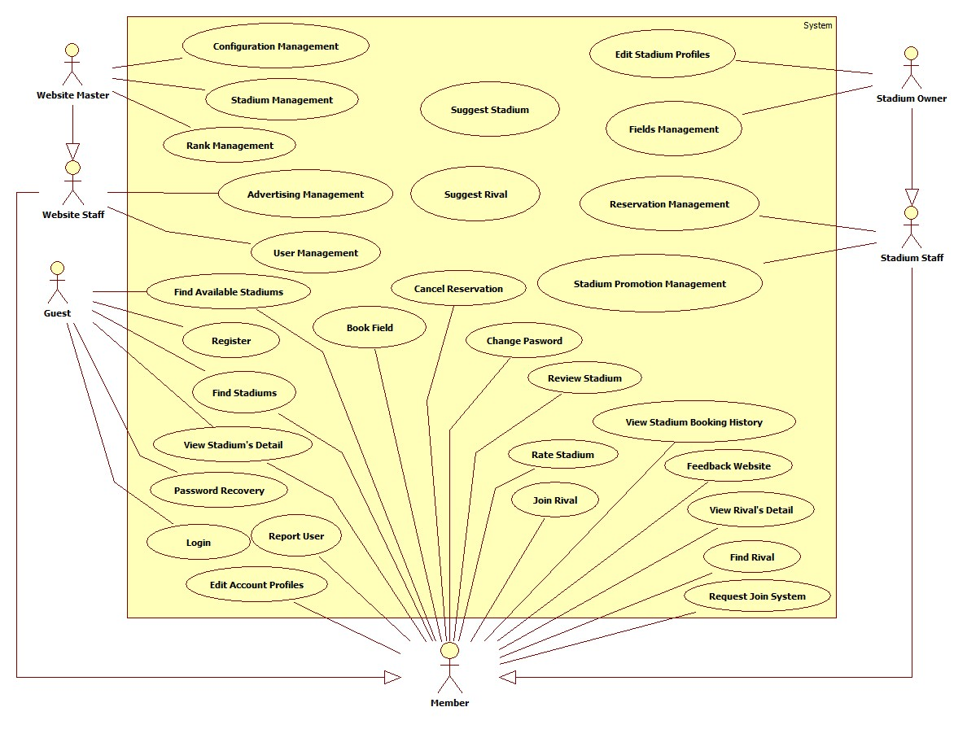

Figure 2: Use Case Summary

##### Stadium Management

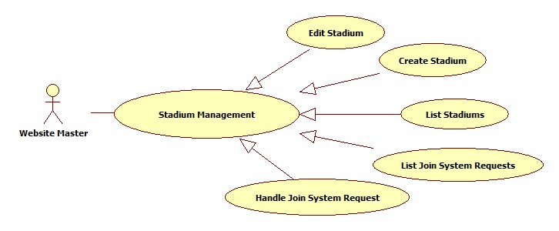

Figure 3: Stadium Management

###### List Stadiums

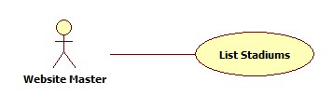

Figure 4: List Stadiums

|  |  |  |  |  |
| --- | --- | --- | --- | --- |
| **USE CASE-001 SPECIFICATION** | | | | |
| **Use-case No.** | UC_001 | **Use-case Version** | | 1.0 |
| **Use-case Name** | List Stadium | | | |
| **Author** | KhánhNQ | | | |
| **Date** | 12/02/2014 | **Priority** | High | |
| **Actor:**  Website Master  **Summary:**  This use case describes how to see list of stadiums  **Goal:**  List all stadiums in website  **Triggers:**  Actor goes to “Quản lý sân bóng” page  **Preconditions:**  Login as Website Master  **Post-conditions:**  N/A  **Main Success Scenario:**   |  |  |  | | --- | --- | --- | | Step | Actor Action | System Response | | 1 | Enter “Quản lý sân bóng” page | Display list of stadiums |   **Alternative Scenario:**  N/A  **Exceptions:**  N/A  **Relationships:**  N/A  **Business Rules:**  N/A | | | | |

###### Create Stadium

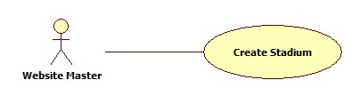

Figure 5: Create Stadium

|  |  |  |  |  |
| --- | --- | --- | --- | --- |
| **USE CASE-002 SPECIFICATION** | | | | |
| **Use-case No.** | UC_002 | **Use-case Version** | | 1.0 |
| **Use-case Name** | Create Stadium | | | |
| **Author** | KhánhNQ | | | |
| **Date** | 12/02/2014 | **Priority** | High | |
| **Actor:**  Website Master  **Summary:**  This use case describes how to create a stadium in website  **Goal:**  Create a stadium in website  **Triggers:**  Actor clicks on “Lưu” button after enter new stadium’s information  **Preconditions:**  Login as Website Master  **Post-conditions:**  N/A  **Main Success Scenario:**   |  |  |  | | --- | --- | --- | | Step | Actor Action | System Response | | 1 | Click “Thêm sân bóng” | The system will respond to “Thêm sân bóng” page | | 2 | Enter information of stadium. Click on “Lưu” button to finish | Display successful message |   **Alternative Scenario:**     |  |  | | --- | --- | | Actor Action | System Response | | Click on “Hủy bỏ” button to cancel | System will transfer to “Quản lý sân bóng” page |   **Exceptions:**  N/A  **Relationships:**  N/A  **Business Rules:**  N/A | | | | |

###### Edit Stadium

Reference:

###### List Join System Requests

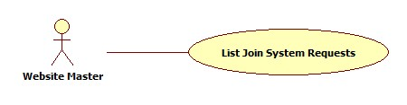

Figure 7: List Join System Requests

|  |  |  |  |  |
| --- | --- | --- | --- | --- |
| **USE CASE-004 SPECIFICATION** | | | | |
| **Use-case No.** | UC_004 | **Use-case Version** | | 1.0 |
| **Use-case Name** | List Join System Request | | | |
| **Author** | KhánhNQ | | | |
| **Date** | 12/02/2014 | **Priority** | High | |
| **Actor:**  Website Master  **Summary:**  This use case describes how to view the list of join system request.  **Goal:**  view the list of join system request  **Triggers:**  Actor enters “Yêu cầu tham gia” page  **Preconditions:**  Login as Website Master  **Post-conditions:**  N/A  **Main Success Scenario:**   |  |  |  | | --- | --- | --- | | Step | Actor Action | System Response | | 1 | Click on “Yêu cầu tham gia” to enter “Quản lý yêu cầu tham gia hệ thống” page | Display the list of join sysmte request |   **Alternative Scenario:**  N/A  **Exceptions:**  N/A  **Relationships:**  N/A  **Business Rules:**  N/A | | | | |

###### Handle Join System Request

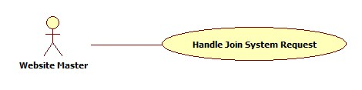

Figure 8: Handle Join System Request

|  |  |  |  |  |
| --- | --- | --- | --- | --- |
| **USE CASE-005 SPECIFICATION** | | | | |
| **Use-case No.** | UC_005 | **Use-case Version** | | 1.0 |
| **Use-case Name** | Handle Join System Request | | | |
| **Author** | KhánhNQ | | | |
| **Date** | 12/02/2014 | **Priority** | High | |
| **Actor:**  Website Master  **Summary:**  This use case describes how to handle join system request  **Goal:**  Handle request to join system  **Triggers:**  Actor clicks on “Cập nhật” button  **Preconditions:**  Login as Website Master  **Post-conditions:**  N/A  **Main Success Scenario:**   |  |  |  | | --- | --- | --- | | Step | Actor Action | System Response | | 1 | Click on “Chỉnh sửa” link of this request | View request’s detail | | 2 | Chose an option in “Trạng thái xử lý” combo box Click on “Cập nhật” button | Display successful message |   **Alternative Scenario:**   |  |  | | --- | --- | | Actor Action | System Response | | Click on “Hủy bỏ” button to cancel | Redirect to “Quản lý yêu cầu tham gia hệ thống” page |   **Exceptions:**  N/A  **Relationships:**  N/A  **Business Rules:**  N/A | | | | |

##### Configuration Management

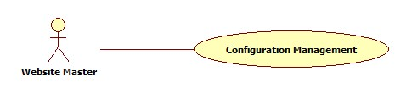

Figure 9: Configuration Management

|  |  |  |  |  |
| --- | --- | --- | --- | --- |
| **USE CASE-06 SPECIFICATION** | | | | |
| **Use-case No.** | UC_06 | **Use-case Version** | | 1.0 |
| **Use-case Name** | Configuration Management | | | |
| **Author** | KhanhNQ | | | |
| **Date** | 12/02/2014 | **Priority** | High | |
| **Actor:**  Website Master  **Summary:**  This use case describes how change the value of priorty norm for suggesting stadium or rival  **Goal:**  Edit value of configuration  **Triggers:**  Click “Lưu” button  **Preconditions:**  Login as Website Master  **Post-conditions:**    **Main Success Scenario:**   |  |  |  | | --- | --- | --- | | Step | Actor Action | System Response | | 1 | Enter quản “Quản lý gợi ý sân bóng” page | Display charts of priorty and value | | 2 | Drag the point to change value of priority Click on “Lưu” button | Display successful message |   **Alternative Scenario:**  N/A  **Exceptions:**  N/A  **Relationships:**  N/A  **Business Rules:**  N/A | | | | |

##### Advertising Management

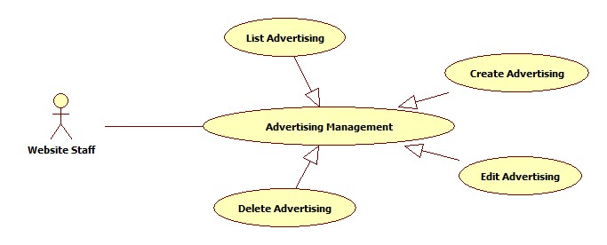

Figure 10: Advertising Management

###### List Advertisings

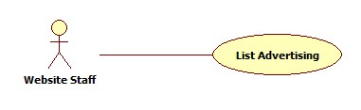

Figure 11: List Advertisings

|  |  |  |  |  |
| --- | --- | --- | --- | --- |
| **USE CASE-007 SPECIFICATION** | | | | |
| **Use-case No.** | UC_007 | **Use-case Version** | | 1.0 |
| **Use-case Name** | List Advertisings | | | |
| **Author** | KhanhNQ | | | |
| **Date** | 12/02/2014 | **Priority** | High | |
| **Actor:**  Website Master, Website Staff  **Summary:**  This use case describes how to see the list of advertisings in website  **Goal:**  See all advertisings  **Triggers:**  Actor goes to “Quảng cáo” page  **Preconditions:**  Login as Website Master or Website Staff  **Post-conditions:**    **Main Success Scenario:**   |  |  |  | | --- | --- | --- | | Step | Actor Action | System Response | | 1 |  | Display list of advertisings in system |   **Alternative Scenario:**  N/A  **Exceptions:**  N/A  **Relationships:**  N/A  **Business Rules:**  N/A | | | | |

###### Create Advertising

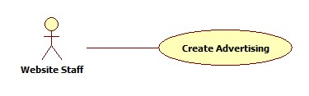

Figure 12: Create Advertising

|  |  |  |  |  |
| --- | --- | --- | --- | --- |
| **USE CASE-008 SPECIFICATION** | | | | |
| **Use-case No.** | UC_008 | **Use-case Version** | | 1.0 |
| **Use-case Name** | Create Advertising | | | |
| **Author** | KhanhNQ | | | |
| **Date** | 12/02/2014 | **Priority** | High | |
| **Actor:**  Website Staff, Website Master  **Summary:**  This use case describes how to create a new advertising in website  **Goal:**  Create advertising in Website  **Triggers:**  Actor clicks on “Thêm quảng cáo” button to create new advertising in website  **Preconditions:**  Login as Website Master or Website Staff  **Post-conditions:**    **Main Success Scenario:**   |  |  |  | | --- | --- | --- | | Step | Actor Action | System Response | | 1 | Click on “Thêm quảng cáo” | The system will respond to “Thêm quảng cáo” page | | 2 | Enter information of this advertising  Click “Lưu” button | Display successful message |   **Alternative Scenario:**   |  |  | | --- | --- | | Actor Action | System Response | | Click on “Hủy” button to cancel | System will transfer to “Quản lý quảng cáo” page |   **Exceptions:**  N/A  **Relationships:**  N/A  **Business Rules:**  N/A | | | | |

###### Edit Advertising

Reference:

##### User Management

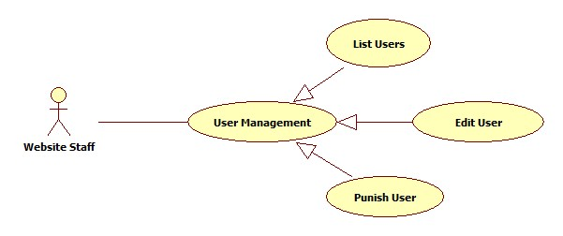

Figure 14: User Management

###### List Users

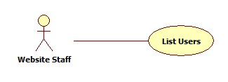

Figure 15: List Users

|  |  |  |  |  |
| --- | --- | --- | --- | --- |
| **USE CASE-010 SPECIFICATION** | | | | |
| **Use-case No.** | UC_010 | **Use-case Version** | | 1.0 |
| **Use-case Name** | List Users | | | |
| **Author** | KhanhNQ | | | |
| **Date** | 12/02/2014 | **Priority** | High | |
| **Actor:**  Website Staff, Website Master  **Summary:**  This use case describes how to see all users in website  **Goal:**  See all Users in website  **Triggers:**  Actor go to User Management page  **Preconditions:**  Login as Website Master or Website Staff  **Post-conditions:**  N/A  **Main Success Scenario:**   |  |  |  | | --- | --- | --- | | Step | Actor Action | System Response | | 1 |  | Display all users in system |   **Alternative Scenario:**  N/A  **Exceptions:**  N/A  **Relationships:**  N/A  **Business Rules:**  N/A | | | | |

###### Edit User

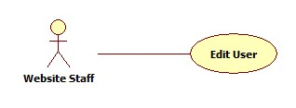

Figure 16: Edit User

|  |  |  |  |  |
| --- | --- | --- | --- | --- |
| **USE CASE-011 SPECIFICATION** | | | | |
| **Use-case No.** | UC_011 | **Use-case Version** | | 1.0 |
| **Use-case Name** | Edit User | | | |
| **Author** | KhanhNQ | | | |
| **Date** | 12/02/2014 | **Priority** | High | |
| **Actor:**  Website Staff, Website Master  **Summary:**  This use case describes how to edit user’s information  **Goal:**  View and change user’s information  **Triggers:**  Actor clicks on “Chỉnh sửa” link of the user which will be edited  **Preconditions:**  N/A  **Post-conditions:**  N/A  **Main Success Scenario:**   |  |  |  | | --- | --- | --- | | Step | Actor Action | System Response | | 1 | clicks on “Chỉnh sửa” link of the user which will be edited | The system will show the User’s Information Page | | 2 | Update information  Click on “Lưu” button to save information | Display successful message |   **Alternative Scenario:**   |  |  | | --- | --- | | Actor Action | System Response | | Click on “Hủy bỏ” button | System will transfer to “Thành viên” page |   **Exceptions:**  User login as Website Staff cannot edit information of other website staff or website master.  **Relationships:**  N/A  **Business Rules:**  N/A | | | | |

###### Punish User

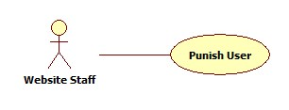

Figure 17: Punish User

|  |  |  |  |  |
| --- | --- | --- | --- | --- |
| **USE CASE-012 SPECIFICATION** | | | | |
| **Use-case No.** | UC_012 | **Use-case Version** | | 1.0 |
| **Use-case Name** | Punish User | | | |
| **Author** | KhanhNQ | | | |
| **Date** | 12/02/2014 | **Priority** | High | |
| **Actor:**  Website Staff, Website Master  **Summary:**  This use case describes how to punish an user  **Goal:**  Punish an user  **Triggers:**  Actor clicks “Cập nhật” button after choosing “Cấm hoạt động” option of the “Trạng thái hoạt động” drop down list.  **Preconditions:**  Login as Website Master or Website Staff  **Post-conditions:**  N/A  **Main Success Scenario:**   |  |  |  | | --- | --- | --- | | Step | Actor Action | System Response | | 1 | Chooses “Cấm hoạt động” option in the “Trạng thái hoạt động” drop down list |  | | 2 | Click “Lưu” button | Show successful message |   **Alternative Scenario:**     |  |  | | --- | --- | | Actor Action | System Response | | Click on “Hủy bỏ” button to cancel | Redirect to “Thành viên” page |   **Exceptions:**  User login as Website Staff cannot deactivate the other website staff or website master.  **Relationships:**  N/A  **Business Rules:**  N/A | | | | |

##### Rank Management

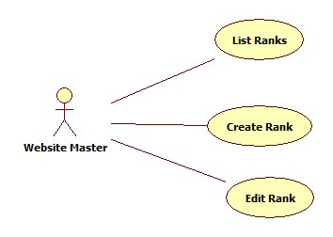

Figure 18: Rank Management

###### List Ranks

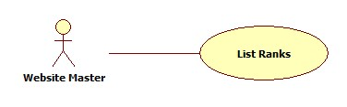

Figure 19: List Ranks

|  |  |  |  |  |
| --- | --- | --- | --- | --- |
| **USE CASE-013 SPECIFICATION** | | | | |
| **Use-case No.** | UC_013 | **Use-case Version** | | 1.0 |
| **Use-case Name** | List Ranks | | | |
| **Author** | ThinhND | | | |
| **Date** | 12/02/2014 | **Priority** | High | |
| **Actor:**  Website Master  **Summary:**  This use case describes how to view list of ranks  **Goal:**  List all ranks  **Triggers:**  Actor enter “Quản lý cấp độ thành viên” page  **Preconditions:**  Login as Website Master  **Post-conditions:**  N/A  **Main Success Scenario:**   |  |  |  | | --- | --- | --- | | Step | Actor Action | System Response | | 1 | Enter “Quản lý cấp độ thành viên” page | Display list of all ranks |   **Alternative Scenario:**  N/A  **Exceptions:**  N/A  **Relationships:**  N/A  **Business Rules:**  N/A | | | | |
|  | | | | |

###### Create Rank



Figure 20: Create Rank

|  |  |  |  |  |
| --- | --- | --- | --- | --- |
| **USE CASE-014 SPECIFICATION** | | | | |
| **Use-case No.** | UC_014 | **Use-case Version** | | 1.0 |
| **Use-case Name** | Create Rank | | | |
| **Author** | ThinhND | | | |
| **Date** | 12/02/2014 | **Priority** | High | |
| **Actor:**  Website Master  **Summary:**  This use case describes how to edit stadium’s profiles  **Goal:**  Create new rank  **Triggers:**  Actor clicks on “Lưu” button  **Preconditions:**  Login as Website Master  **Post-conditions:**  N/A  **Main Success Scenario:**   |  |  |  | | --- | --- | --- | | Step | Actor Action | System Response | | 1 | Click on “Tạo cấp độ mới” link in “Quản lý cấp độ thành viên” | Display create rank form | | 2 | Enter new rank’s information  Click “Cập nhật” button | Display successful message |   **Alternative Scenario:**   |  |  | | --- | --- | | Actor Action | System Response | | Click on “Hủy bỏ” button | Discard all recent action and redirect to “Quản lý cấp độ thành viên” page |   **Exceptions:**  N/A  **Relationships:**  N/A  **Business Rules:**  N/A | | | | |

###### Edit Rank

Reference:

##### Edit Stadium’s Profile

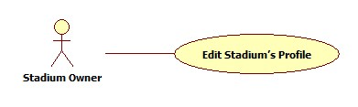

Figure 22: Edit Stadium's Profile

|  |  |  |  |  |
| --- | --- | --- | --- | --- |
| **USE CASE-016 SPECIFICATION** | | | | |
| **Use-case No.** | UC_016 | **Use-case Version** | | 1.0 |
| **Use-case Name** | Edit Stadium’s Profile | | | |
| **Author** | ThinhND | | | |
| **Date** | 12/02/2014 | **Priority** | High | |
| **Actor:**  Stadium Owner  **Summary:**  This use case describes how to edit stadium’s profiles  **Goal:**  Edit information of stadium  **Triggers:**  Actor clicks on “Cập nhật” button  **Preconditions:**  Login as Stadium Owner  **Post-conditions:**  N/A  **Main Success Scenario:**   |  |  |  | | --- | --- | --- | | Step | Actor Action | System Response | | 1 | Click on “Chỉnh sửa” link of the stadium which will be edited | Display Edit form with filled information | | 2 | Enter new information of stadium  Click “Cập nhật” button | Update new profiles for this stadium |   **Alternative Scenario:**   |  |  | | --- | --- | | Actor Action | System Response | | Click on “Hủy bỏ” button | Discard all recent action and redirect to “Quẩn lý sân bóng” page |   **Exceptions:**  N/A  **Relationships:**  N/A  **Business Rules:**  N/A | | | | |

##### Field Management

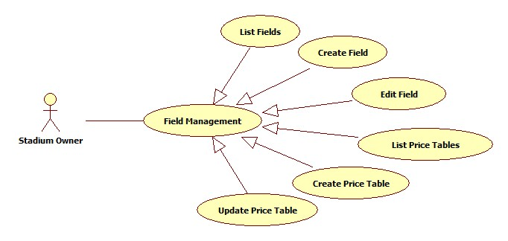

Figure 23: Field Management

###### List Fields

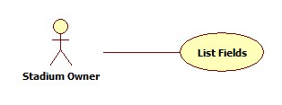

Figure 24: List Fields

|  |  |  |  |  |
| --- | --- | --- | --- | --- |
| **USE CASE-017 SPECIFICATION** | | | | |
| **Use-case No.** | UC_017 | **Use-case Version** | | 1.0 |
| **Use-case Name** | List Fields | | | |
| **Author** | ThinhND | | | |
| **Date** | 12/02/2014 | **Priority** | High | |
| **Actor:**  Stadium Owner  **Summary:**  This use case describes how to list all fields of a stadium.  **Goal:**  List all fields of stadium.  **Triggers:**  Actor clicks on “Sân con” link of the stadium  **Preconditions:**  Login as Stadium Owner  **Post-conditions:**  N/A  **Main Success Scenario:**   |  |  |  | | --- | --- | --- | | Step | Actor Action | System Response | | 1 | Actor clicks on “Sân con” link of the stadium | Show the field list of this stadium |   **Alternative Scenario:**  N/A  **Exceptions:**  Field has not been created by stadium owner.  **Relationships:**  N/A  **Business Rules:**  N/A | | | | |

###### Create Field

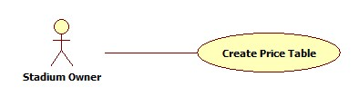

Figure 25: Create Field

|  |  |  |  |  |
| --- | --- | --- | --- | --- |
| **USE CASE-018 SPECIFICATION** | | | | |
| **Use-case No.** | UC_018 | **Use-case Version** | | 1.0 |
| **Use-case Name** | Create Field | | | |
| **Author** | ThinhND | | | |
| **Date** | 12/02/2014 | **Priority** | High | |
| **Actor:**  Stadium Owner  **Summary:**  This use case describes how to create a field of stadium.  **Goal:**  Create a field  **Triggers:**  Actor clicks on “Lưu” button  **Preconditions:**  Login as Stadium Owner role  **Post-conditions:**  N/A  **Main Success Scenario:**   |  |  |  | | --- | --- | --- | | Step | Actor Action | System Response | | 1 | Click on “Thêm sân con” button in the “Quản lý sân con” page | Display Create field form | | 2 | Enter information of this field  Click on “Lưu” button | Display successful message |   **Alternative Scenario:**   |  |  | | --- | --- | | Actor Action | System Response | | Click on “Hủy bỏ” button | Discard all recent activity and redirect to “Quản lý sân con” page |   **Exceptions:**  The List price has not been created.  **Relationships:**  N/A  **Business Rules:**  N/A | | | | |

###### Edit Field

Reference:

###### List Price Tables

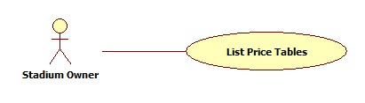

Figure 27: List Price Tables

|  |  |  |  |  |
| --- | --- | --- | --- | --- |
| **USE CASE-020 SPECIFICATION** | | | | |
| **Use-case No.** | UC_020 | **Use-case Version** | | 1.0 |
| **Use-case Name** | List Price Tables | | | |
| **Author** | ThinhND | | | |
| **Date** | 12/02/2014 | **Priority** | High | |
| **Actor:**  Stadium Owner  **Summary:**  This use case describes how view all price tables  **Goal:**  View list price tables  **Triggers:**  Actor clicks on “Bảng giá” button of the stadium  **Preconditions:**  Login as Stadium Owner role  **Post-conditions:**  N/A  **Main Success Scenario:**   |  |  |  | | --- | --- | --- | | Step | Actor Action | System Response | | 1 | Click on “Bảng giá” link in of the stadium which will be showed | Display price table list |   **Alternative Scenario:**  N/A  **Exceptions:**  N/A  **Relationships:**  N/A  **Business Rules:**  N/A | | | | |

###### Create Price Table

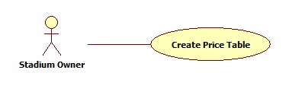

Figure 28: Create Price Table

|  |  |  |  |  |
| --- | --- | --- | --- | --- |
| **USE CASE-021 SPECIFICATION** | | | | |
| **Use-case No.** | UC_021 | **Use-case Version** | | 1.0 |
| **Use-case Name** | Create Field Price | | | |
| **Author** | ThinhND | | | |
| **Date** | 12/02/2014 | **Priority** | High | |
| **Actor:**  Stadium Owner  **Summary:**  This use case describes how to create price table  **Goal:**  Create a price table  **Triggers:**  Actor clicks on “Lưu” button  **Preconditions:**  Login as Stadium Owner role  **Post-conditions:**  N/A  **Main Success Scenario:**   |  |  |  | | --- | --- | --- | | Step | Actor Action | System Response | | 1 | Click on “Lưu” button in the “Quản lý bảng giá” page | Display create price table form | | 2 | Enter information of this price table  Click on “Thêm bảng giá” button | Display successful message |   **Alternative Scenario:**   |  |  | | --- | --- | | Actor Action | System Response | | Click on “Hủy bỏ” button | Discard all recent activity and redirect to “Quản lý bảng giá” page |   **Exceptions:**  N/A  **Relationships:**  N/A  **Business Rules:**  N/A | | | | |

###### Update Price Table

Reference:

##### Reservations Management

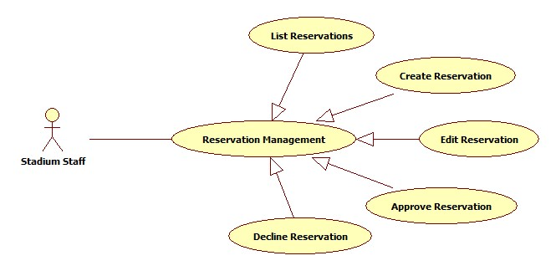

Figure 30: Reservation Management

###### List Reservations

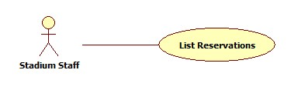

Figure 31: List Reservations

|  |  |  |  |  |
| --- | --- | --- | --- | --- |
| **USE CASE-023 SPECIFICATION** | | | | |
| **Use-case No.** | UC_023 | **Use-case Version** | | 1.0 |
| **Use-case Name** | List Reservations | | | |
| **Author** | ThinhND | | | |
| **Date** | 12/02/2014 | **Priority** | High | |
| **Actor:**  Stadium Staff, Stadium Owner  **Summary:**  This use case describes how to listt all reservations.  **Goal:**  List all reservations.  **Triggers:**  Actor goes to “Quản lý đặt sân” page  **Preconditions:**  Login as Stadium Staff or Stadium Owner role  **Post-conditions:**  N/A  **Main Success Scenario:**   |  |  |  | | --- | --- | --- | | Step | Actor Action | System Response | | 1 | Click on stadium link in “Quản lý đặt sân” page | The system shows the list of reservations of this stadium |   **Alternative Scenario:**  N/A  **Exceptions:**  N/A  **Relationships:**  N/A  **Business Rules:**  N/A | | | | |

###### Create Reservation

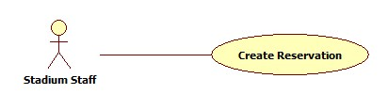

Figure 32: Create Reservation

|  |  |  |  |  |
| --- | --- | --- | --- | --- |
| **USE CASE-024 SPECIFICATION** | | | | |
| **Use-case No.** | UC_024 | **Use-case Version** | | 1.0 |
| **Use-case Name** | Create Reservation | | | |
| **Author** | ThinhND | | | |
| **Date** | 12/02/2014 | **Priority** | High | |
| **Actor:**  Stadium Staff, Stadium Owner  **Summary:**  This use case describes how to create a reservation  **Goal:**  Create a reservation.  **Triggers:**  Click on “Lưu” button in “Thêm đơn đặt sân” page  **Preconditions:**  Login as Stadium Staff or Stadium Owner role  **Post-conditions:**  N/A  **Main Success Scenario:**   |  |  |  | | --- | --- | --- | | Step | Actor Action | System Response | | 1 | Click on “Thêm đơn đặt sân” button | Display Book form | | 2 | Enter information of reservation  Click on “Lưu” button | Display successful message |   **Alternative Scenario:**   |  |  | | --- | --- | | Actor Action | System Response | | Click on “Hủy bỏ” button | Discard all recent action and redirect to “Quản lý đặt sân” page |   **Exceptions:**  This field is not available such as existing reservation, duplicate booking time, etc.  **Relationships:**  N/A  **Business Rules:**  N/A | | | | |

###### Edit Reservation

Reference:

###### Approve Reservation

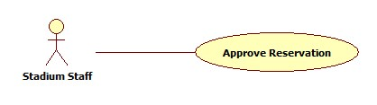

Figure 34: Approve Reservation

|  |  |  |  |  |
| --- | --- | --- | --- | --- |
| **USE CASE-026 SPECIFICATION** | | | | |
| **Use-case No.** | UC_026 | **Use-case Version** | | 1.0 |
| **Use-case Name** | Approve Reservation | | | |
| **Author** | ThinhND | | | |
| **Date** | 12/02/2014 | **Priority** | High | |
| **Actor:**  Stadium Staff, Stadium Owner  **Summary:**  This use case describes how to approve a reservation  **Goal:**  Approve a reservation  **Triggers:**  Click on “Lưu” button  **Preconditions:**  Login as Stadium Staff or Stadium Owner role  **Post-conditions:**  N/A  **Main Success Scenario:**   |  |  |  | | --- | --- | --- | | Step | Actor Action | System Response | | 1 | Click on “Chỉnh sửa” link of this reservation | Display this Reservation’s detail | | 2 | Click on “Lưu” button | Display successful message |   **Alternative Scenario:**   |  |  | | --- | --- | | Actor Action | System Response | | Click on “Quay lại” button | Discard all recent action and redirect to “Quản lý đặt sân” page |   **Exceptions:**  N/A  **Relationships:**  N/A  **Business Rules:**  N/A | | | | |

###### Decline Reservation

Reference:

##### Stadium Promotion Management

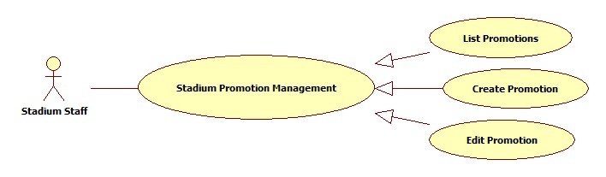

Figure 36: Stadium Promotion Management

###### List Promotions

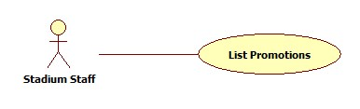

Figure 37: List Promotions

|  |  |  |  |  |
| --- | --- | --- | --- | --- |
| **USE CASE-028 SPECIFICATION** | | | | |
| **Use-case No.** | UC_028 | **Use-case Version** | | 1.0 |
| **Use-case Name** | List Promotions | | | |
| **Author** | ThinhND | | | |
| **Date** | 12/02/2014 | **Priority** | High | |
| **Actor:**  Stadium Staff, Stadium Owner  **Summary:**  This use case describe how to list all the promotion of stadium  **Goal:**  List all promotions of a stadium  **Triggers:**  Actor clicks on stadium of “Quản lý khuyến mãi” page  **Preconditions:**  Login as Stadium Staff or Stadium Owner role  **Post-conditions:**  N/A  **Main Success Scenario:**   |  |  |  | | --- | --- | --- | | Step | Actor Action | System Response | | 1 | Actor clicks on stadium of “Quản lý khuyến mãi” page | The system shows list of promotion. |   **Alternative Scenario:**  N/A  **Exceptions:**  N/A  **Relationships:**  N/A  **Business Rules:**  N/A | | | | |

###### Create Promotion

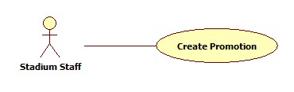

Figure 38: Create Promotion

|  |  |  |  |  |
| --- | --- | --- | --- | --- |
| **USE CASE-029 SPECIFICATION** | | | | |
| **Use-case No.** | UC_029 | **Use-case Version** | | 1.0 |
| **Use-case Name** | Create Promotion | | | |
| **Author** | ThinhND | | | |
| **Date** | 12/02/2014 | **Priority** | High | |
| **Actor:**  Stadium Staff, Stadium Owner  **Summary:**  This use case describes creating new promotion.  **Goal:**  Create a promotion for stadium.  **Triggers:**  Click on “Lưu” button  **Preconditions:**  Login as Stadium Staff or Stadium Owner role  **Post-conditions:**  N/A  **Main Success Scenario:**   |  |  |  | | --- | --- | --- | | Step | Actor Action | System Response | | 1 | Click on “Thêm khuyến mãi” of this stadium | Display create promotion form | | 2 | Enter information of this promotion Click “Lưu” button | Show successful message |   **Alternative Scenario:**   |  |  | | --- | --- | | Actor Action | System Response | | Click on “Hủy bỏ” button | Discard all recent action and redirect to “Quản lý khuyến mãi” page |   **Exceptions:**  N/A  **Relationships:**  N/A  **Business Rules:**  N/A | | | | |

###### Edit Promotion

Reference:

##### Register

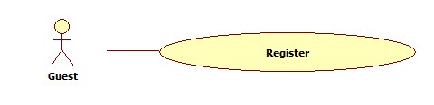

Figure 40: Register

|  |  |  |  |  |
| --- | --- | --- | --- | --- |
| **USE CASE-031 SPECIFICATION** | | | | |
| **Use-case No.** | UC_031 | **Use-case Version** | | 1.0 |
| **Use-case Name** | Register | | | |
| **Author** | KhánhNQ | | | |
| **Date** | 12/02/2014 | **Priority** | High | |
| **Actor:**  Guest  **Summary:**  This use case describes how to register a new account  **Goal:**  Register new account  **Triggers:**  Click on “Đăng ký” button  **Preconditions:**  N/A  **Post-conditions:**  N/A  **Main Success Scenario:**   |  |  |  | | --- | --- | --- | | Step | Actor Action | System Response | | 1 | Click on “Đăng Ký’ link | System will response Register page | | 2 | Enter account’s information  Click “Đăng ký” button | Display successful message |   **Alternative Scenario:**     |  |  | | --- | --- | | Actor Action | System Response | | Click on “Hủy” button to cancel | Redirect to Home page |   **Exceptions:**     |  |  |  | | --- | --- | --- | |  | Actor Action | System Response | | 1. | Account has existed in database. | Display error message: “Tên tài khoản đã được sử dụng. Xin vui lòng chọn tên khác” | | 2. | Email has existed in database. | Display error message: “Email đã được sử dụng. Xin vui lòng chọn email khác” | | 3. | Input not a valid information in Email’s textbox. | Display error message: “Email không đúng”. | | 4. | Password’s length is not in range: [6,20]. | Display error message: “Yêu cầu tài khoản từ 6 đến 32 kí tự”. | | 5. | Input confirm password information different with password. | Display error message: “Sai mật khẩu xác nhận”. |   **Relationships:**  N/A  **Business Rules:**  N/A | | | | |

##### Password Recovery

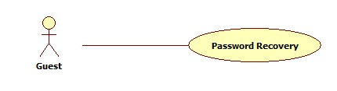

Figure 41: Password Recovery

|  |  |  |  |  |
| --- | --- | --- | --- | --- |
| **USE CASE-032 SPECIFICATION** | | | | |
| **Use-case No.** | UC_032 | **Use-case Version** | | 1.0 |
| **Use-case Name** | Password Recovery | | | |
| **Author** | KhánhNQ | | | |
| **Date** | 12/02/2014 | **Priority** | High | |
| **Actor:**  Guest  **Summary:**  This use case describes how to recovery member’s password  **Goal:**  Recovery password  **Triggers:**  Actor clicks on “Lấy lại mật khẩu” button  **Preconditions:**  Guest already has account  **Post-conditions:**  N/A  **Main Success Scenario:**   |  |  |  | | --- | --- | --- | | Step | Actor Action | System Response | | 1 | Click on “Quên mật khẩu” link | System will response Recovery Password page | | 2 | Enter required information  Click on “Lấy lại mật khẩu” button | Display sent email message |   **Alternative Scenario:**   |  |  | | --- | --- | | Actor Action | System Response | | Click on “Hủy” button to cancel | Redirect to Home page |   **Exceptions:**  Email that user provide does not exist in system  **Relationships:**  N/A  **Business Rules:**  N/A | | | | |

##### Login

Reference:

##### View Stadium’s Detail:

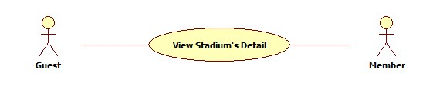

Figure 43: View Stadium's Detail

|  |  |  |  |  |
| --- | --- | --- | --- | --- |
| **USE CASE-034 SPECIFICATION** | | | | |
| **Use-case No.** | UC_034 | **Use-case Version** | | 1.0 |
| **Use-case Name** | View Stadium’s Detail | | | |
| **Author** | KhánhNQ | | | |
| **Date** | 12/02/2014 | **Priority** | High | |
| **Actor:**  Guest, Member, Stadium Staff, Stadium Owner, Website Staff, Website Master  **Summary:**  This use case describe how to view detail of a stadium  **Goal:**  View detail of stadium  **Triggers:**  Actor clicks on any stadium  **Preconditions:**  N/A  **Post-conditions:**  Display detail of stadium  **Main Success Scenario:**   |  |  |  | | --- | --- | --- | | Step | Actor Action | System Response | | 1 | Click on any stadium | Display detail of stadium |   **Alternative Scenario:**  N/A  **Exceptions:**  N/A  **Relationships:**  N/A  **Business Rules:**  N/A | | | | |

##### Find Available Stadiums

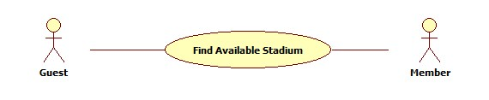

Figure 44: Find Available Stadium

|  |  |  |  |  |
| --- | --- | --- | --- | --- |
| **USE CASE-035 SPECIFICATION** | | | | |
| **Use-case No.** | UC_035 | **Use-case Version** | | 1.0 |
| **Use-case Name** | Find Available Stadiums | | | |
| **Author** | ThinhND | | | |
| **Date** | 12/02/2014 | **Priority** | High | |
| **Actor:**  Guest, Member, Stadium Staff, Stadium Owner, Website Staff, Website Master  **Summary:**  This use case describes how to find an available stadium with some conditions  **Goal:**  Find available stadium  **Triggers:**  Actor clicks on “Tìm kiếm” button  **Preconditions:**  N/A  **Post-conditions:**    **Main Success Scenario:**   |  |  |  | | --- | --- | --- | | Step | Actor Action | System Response | | 1 | Choose condition information  Click on “Tìm kiếm” button | Show list of stadiums |   **Alternative Scenario:**  N/A  **Exceptions:**  There is no available stadium for those condition  **Relationships:**  N/A  **Business Rules:**  N/A | | | | |

##### Find Stadiums

Reference:

##### Book Field

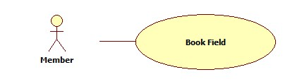

Figure 46: Book Field

|  |  |  |  |  |
| --- | --- | --- | --- | --- |
| **USE CASE-037 SPECIFICATION** | | | | |
| **Use-case No.** | UC_037 | **Use-case Version** | | 1.0 |
| **Use-case Name** | Book Field | | | |
| **Author** | ThinhND | | | |
| **Date** | 12/02/2014 | **Priority** | High | |
| **Actor:**  Member, Stadium Staff, Stadium Owner, Website Staff, Website Master  **Summary:**  This use case describes how to book a field  **Goal:**  Book a field of stadium  **Triggers:**  Actor clicks “Lưu” button  **Preconditions:**  Login as Member, Stadium Staff, Stadium Owner, Website Staff or Website Master  **Post-conditions:**  N/A  **Main Success Scenario:**   |  |  |  | | --- | --- | --- | | Step | Actor Action | System Response | | 1 | Click on “Đặt sân” button of stadium detail page or “Đặt” button after find stadium | Display reservation form | | 2 | Enter information of reservation  Click “Lưu” button | Display successful message |   **Alternative Scenario:**   |  |  | | --- | --- | | Actor Action | System Response | | There’s is no available field | Display message | | Click on “Hủy bỏ” button | Discard all recent action and redirect to Home page |   **Exceptions:**  This field is not available such as existing reservation, duplicate booking time, etc.  **Relationships:**  N/A  **Business Rules:**  N/A | | | | |

##### Rate Stadium

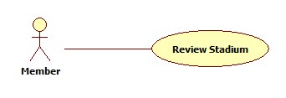

Figure 47: Review Stadium

|  |  |  |  |  |
| --- | --- | --- | --- | --- |
| **USE CASE-038 SPECIFICATION** | | | | |
| **Use-case No.** | UC_038 | **Use-case Version** | | 1.0 |
| **Use-case Name** | Rate Stadium | | | |
| **Author** | ThinhND | | | |
| **Date** | 12/02/2014 | **Priority** | High | |
| **Actor:**  Member, Stadium Staff, Stadium Owner, Website Staff, Website Master  **Summary:**  This use case describes how to rate a stadium  **Goal:**  Rate a stadium  **Triggers:**  Actor click on Rate stars of stadium  **Preconditions:**  Login as user  **Post-conditions:**  N/A  **Main Success Scenario:**   |  |  |  | | --- | --- | --- | | Step | Actor Action | System Response | | 1 | Click on Rate stars | Show result immediately |   **Alternative Scenario:**  N/A  **Exceptions:**  N/A  **Relationships:**  N/A  **Business Rules:**  N/A | | | | |

##### Rivew Stadium

Reference:

##### Feedback Website

Reference:

##### Cancel Reservation

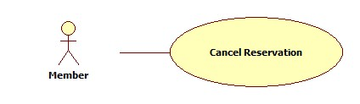

Figure 50: Cancel Reservation

|  |  |  |  |  |
| --- | --- | --- | --- | --- |
| **USE CASE-41 SPECIFICATION** | | | | |
| **Use-case No.** | UC_41 | **Use-case Version** | | 1.0 |
| **Use-case Name** | Cancel Reservation | | | |
| **Author** | ThinhND | | | |
| **Date** | 12/02/2014 | **Priority** | High | |
| **Actor:**  Member, Stadium Staff, Stadium Owner, Website Staff, Website Master  **Summary:**  This use case describes how to cancel reservation  **Goal:**  Cancel a reservation  **Triggers:**  Actor clicks “Hủy đặt sân” button  **Preconditions:**  Login as user. Reservation is not expired.  **Post-conditions:**  N/A  **Main Success Scenario:**   |  |  |  | | --- | --- | --- | | Step | Actor Action | System Response | | 1 | Click on “Lịch sử đặt sân” below the account | Show list of reservation | | 2 | Click on “Chỉnh sửa” link of the reservation which will be canceled | Show reservation detail | | 3 | Click on “Hủy đặt sân” button | Display Successful message |   **Alternative Scenario:**   |  |  | | --- | --- | | Actor Action | System Response | | Click on “Quay lại” button | Redirect to “Lịch sử đặt sân” page |   **Exceptions:**  Reservation is unable to cancel.  **Relationships:**  N/A  **Business Rules:**  N/A | | | | |
|  | | | | |

##### Edit Account Profile

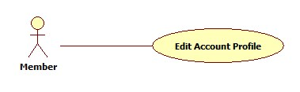

Figure 51: Edit Account Profile

|  |  |  |  |  |
| --- | --- | --- | --- | --- |
| **USE CASE-042 SPECIFICATION** | | | | |
| **Use-case No.** | UC_042 | **Use-case Version** | | 1.0 |
| **Use-case Name** | Edit Account Profiles | | | |
| **Author** | ThinhND | | | |
| **Date** | 12/02/2014 | **Priority** | High | |
| **Actor:**  Member, Stadium Staff, Stadium Owner, Website Staff, Website Master  **Summary:**  This use case describes how to edit user’s account profiles  **Goal:**  Update user’s account profiles  **Triggers:**  Actor clicks on“Lưu” button  **Preconditions:**  Login as user  **Post-conditions:**  N/A  **Main Success Scenario:**   |  |  |  | | --- | --- | --- | | Step | Actor Action | System Response | | 1 | Click on “Quảnh lý tài khoản” link below the account | Display account’s information | | 2 | Click on “Chỉnh sửa” button | Display “Cập nhật thông tin cá nhân” page | | 3 | Enter new information Click on “Lưu” button | Display successful message |   **Alternative Scenario:**   |  |  | | --- | --- | | Actor Action | System Response | | Click on “Quay lại” button | Redirect to “Chi tiết thông tin thành viên” page |   **Exceptions:**  N/A  **Relationships:**  N/A  **Business Rules:**  N/A | | | | |

##### Change Password

Reference:

##### Find Rival

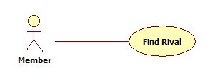

Figure 53: Find Rival

|  |  |  |  |  |
| --- | --- | --- | --- | --- |
| **USE CASE-044 SPECIFICATION** | | | | |
| **Use-case No.** | UC_044 | **Use-case Version** | | 1.0 |
| **Use-case Name** | Find Rival | | | |
| **Author** | ThinhND | | | |
| **Date** | 12/02/2014 | **Priority** | High | |
| **Actor:**  Guest, Member, Stadium Staff, Stadium Owner, Website Staff, Website Master  **Summary:**  This use case describes how to find a rival  **Goal:**  Find rival  **Triggers:**  Actor clicks on “Tìm kiếm” button  **Preconditions:**  N/A  **Post-conditions:**  N/A  **Main Success Scenario:**   |  |  |  | | --- | --- | --- | | Step | Actor Action | System Response | | 1 | Go to “Tìm kèo” page | Show list of all rivals | | 2 | Enter searching information Click on “Tìm kiếm” button | Show result |   **Alternative Scenario:**  N/A  **Exceptions:**  N/A  **Relationships:**  N/A  **Business Rules:**  N/A | | | | |

##### View Rival’s Detail

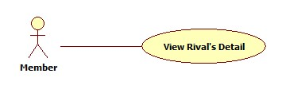

Figure 54: View Rival's Detail

|  |  |  |  |  |
| --- | --- | --- | --- | --- |
| **USE CASE-045 SPECIFICATION** | | | | |
| **Use-case No.** | UC_045 | **Use-case Version** | | 1.0 |
| **Use-case Name** | List Rivals | | | |
| **Author** | ThinhND | | | |
| **Date** | 12/02/2014 | **Priority** | High | |
| **Actor:**  Member, Stadium Staff, Stadium Owner, Website Staff, Website Master  **Summary:**  This use case describes how to view list of rivals  **Goal:**  View list of rivals  **Triggers:**  Actor enters “Tìm kèo” page  **Preconditions:**  Login as user  **Post-conditions:**  N/A  **Main Success Scenario:**   |  |  |  | | --- | --- | --- | | Step | Actor Action | System Response | | 1 | Enter “Tìm kèo” page | Display rival list |   **Alternative Scenario:**  N/A  **Exceptions:**  N/A  **Relationships:**  N/A  **Business Rules:**  N/A | | | | |

##### Join Rival

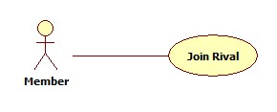

Figure 55: Join Rival

|  |  |  |  |  |
| --- | --- | --- | --- | --- |
| **USE CASE-046 SPECIFICATION** | | | | |
| **Use-case No.** | UC_046 | **Use-case Version** | | 1.0 |
| **Use-case Name** | Join Rival | | | |
| **Author** | ThinhND | | | |
| **Date** | 12/02/2014 | **Priority** | High | |
| **Actor:**  Member, Stadium Staff, Stadium Owner, Website Staff, Website Master  **Summary:**  This use case describes how to join a rival  **Goal:**  Join a rival  **Triggers:**  Actor clicks on “Cáp kèo” button  **Preconditions:**  Login as user  **Post-conditions:**  N/A  **Main Success Scenario:**   |  |  |  | | --- | --- | --- | | Step | Actor Action | System Response | | 1 | Click on “Chi tiết” link of this rival | Display rival’s detail | | 2 | Choose “Có” in “Bạn muốn cáp kèo này” combo box Enter additional information  Click “Cáp kèo” button | Display successful message |   **Alternative Scenario:**   |  |  | | --- | --- | | Actor Action | System Response | | Click on “Quay lại” button | Redirect to Home page |   **Exceptions:**  N/A  **Relationships:**  N/A  **Business Rules:**  N/A | | | | |

##### View Stadium Booking History

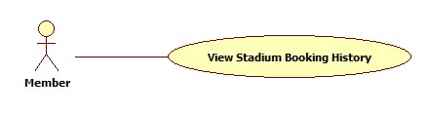

Figure 56: View Stadium Booking History

|  |  |  |  |  |
| --- | --- | --- | --- | --- |
| **USE CASE-047 SPECIFICATION** | | | | |
| **Use-case No.** | UC_047 | **Use-case Version** | | 1.0 |
| **Use-case Name** | View Stadium Booking History | | | |
| **Author** | ThinhND | | | |
| **Date** | 12/02/2014 | **Priority** | High | |
| **Actor:**  Member, Stadium Staff, Stadium Owner, Website Staff, Website Master  **Summary:**  This use case describes how to view reservation history  **Goal:**  View reservation history  **Triggers:**  Click on “Chi tiết” link of the reservation  **Preconditions:**  Login as user  **Post-conditions:**  N/A  **Main Success Scenario:**   |  |  |  | | --- | --- | --- | | Step | Actor Action | System Response | | 1 | Click on “Lịch sử đặt sân” link below the account | Show list of reservation | | 2 | Click on “Chi tiết” link of the reservation which will be viewed | Show reservation’s detail |   **Alternative Scenario:**  N/A  **Exceptions:**  N/A  **Relationships:**  N/A  **Business Rules:**  N/A | | | | |

##### Request Join System

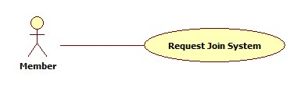

Figure 57: Request Join System

|  |  |  |  |  |
| --- | --- | --- | --- | --- |
| **USE CASE-048 SPECIFICATION** | | | | |
| **Use-case No.** | UC_048 | **Use-case Version** | | 1.0 |
| **Use-case Name** | Request Join System | | | |
| **Author** | ThinhND | | | |
| **Date** | 12/02/2014 | **Priority** | High | |
| **Actor:**  Member  **Summary:**  This use case describes how to request to join system  **Goal:**  Request join system  **Triggers:**  Actor clicks on “Gửi yêu cầu” button  **Preconditions:**  Login as user  **Post-conditions:**  N/A  **Main Success Scenario:**   |  |  |  | | --- | --- | --- | | Step | Actor Action | System Response | | 1 | Click on “Gia nhập chúng tôi” to enter “Đăng ký sân bóng của bạn” page | Display register new stadium form | | 2 | Enter information of stadium  Click on “Gửi yêu cầu” button | Display successful message |   **Alternative Scenario:**   |  |  | | --- | --- | | Actor Action | System Response | | Click on “Hủy” button | Dicard all recent action and redirect to Home page |   **Exceptions:**  N/A  **Relationships:**  N/A  **Business Rules:**  N/A | | | | |

##### Reference Use Cases:

…

#### Non-Functional Requirements

##### Reliability

* Mean Time Between Failures (MTBF): The acceptable failure is once a year
* Mean Time To Repair (MTTR): The acceptable mean time for a particular failure must be least than 12 hours
* Maximum Bugs or Defect Rate: 05 bugs / KLOC

##### Availability

* The system always responds to every user who got permission. The server shall be working 24/7.

##### Security

* Customer information must be secured
* The system always check authenticate and permission for every function

##### Maintainability

N/A

##### Portability

N/A

##### Performance

N/A

#### Entity Relationship Diagram

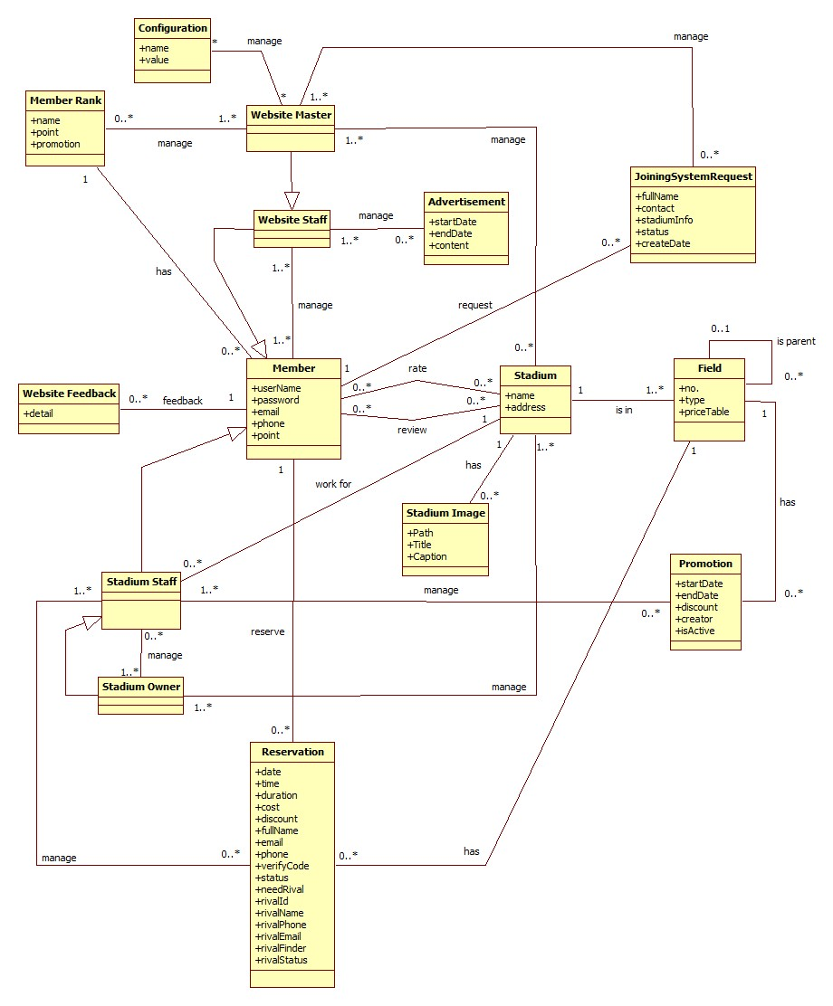

Figure 58: Entity Relationship Diagram

## System Design Description (SDD)

### Design Overview

* This document describes the technical and UI design of the FPB system. It includes the architectural design and the detailed design of common functions and business functions. It also includes the design of database model.
* The architectural design describes the overall architecture of the system, and the architecture of each main component and subsystem. It will describe the patterns being used, the role of each component and the role of the system in the working environment.
* The detailed design describes static and dynamic structure for each component and function. It includes class diagrams, class explanations, and sequence diagrams of the main use cases. The detailed design uses notations of .NET framework 4.0 and C#, as they are the framework and language for developing this system.
* The database design describes the relationship between entities, and details of each entity. It uses notations of SQL Server 2008 R2 as it is the database server for developing the system.
* The user interface design describes the layout of the system, and some design for the screens

### System Architectural Design

#### Choice of System Architecture

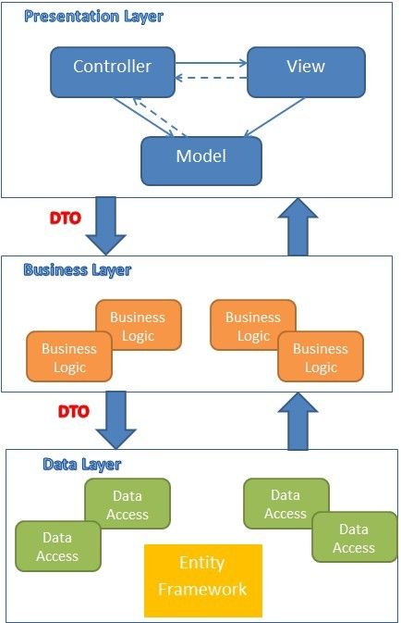

Figure 59: MVC implemented in a three-layer architecture

The above diagram is explained as the following:

**Model**: Used to prepare data for view

**View**: The view displays the data and also takes input form user. It renders the model data into a form, such as graphics, buttons, and tables, and so on to display to the user.

**Controller:** The controller handles all requests coming from the view or user interface. The data flows to whole application are controlled by controller.

**Business Logic:** This layer coordinates the application, processes commands, makes logical decisions and evaluations, and performs calculations. It also moves and processes data between the two surrounding layers.

**Data Access:** Here information is stored and retrieved from a database or file system. The information is then passed back to the logic tier for processing, and then eventually back to the user.

#### Discussion of Alternative Designs

N/A

#### Description of System Interface

N/A

### Component Diagram

### D:\Capstone Project\Diagram\Component Diagram.jpg

Figure 60: Component Diagram

### Detailed Description of Components

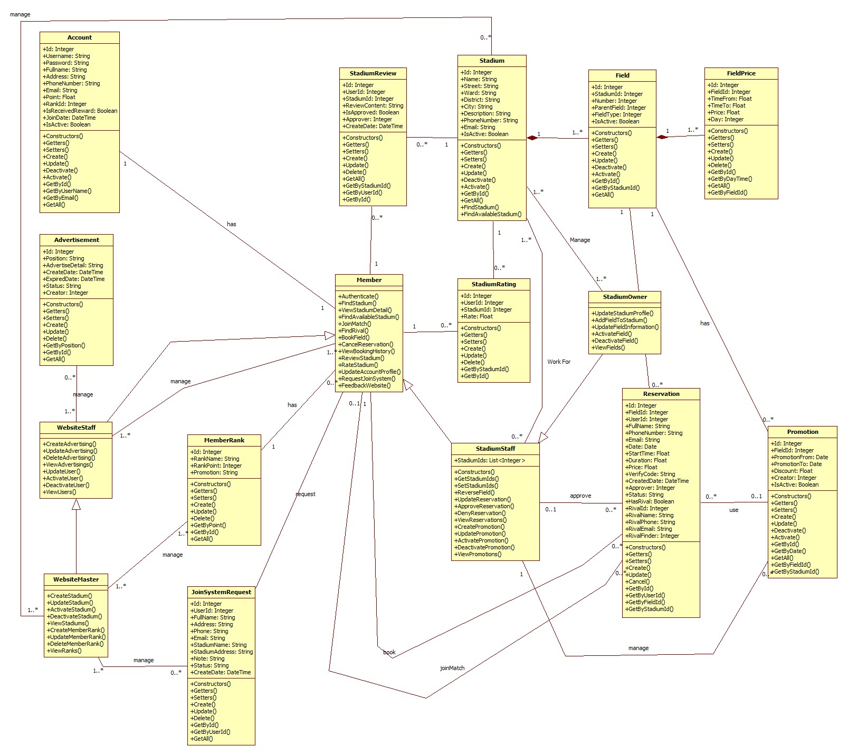

Figure 61: General Class Diagram

#### Class Diagram Explanation

##### Role

* **Attributes**

|  |  |  |
| --- | --- | --- |
| **Name** | **Type** | **Description** |
| Id | Integer | Id of Role |
| Role | String | Role |

* **Methods**

|  |  |  |  |
| --- | --- | --- | --- |
| **Name** | **Parameter** | **Return Type** | **Description** |
| Constructors | Optional | Account | Initialize a role with value (optional) |
| Getters | N/A | Type of attribute | Get value of an attribute corresponding with getter of attribute |
| Setters | Value of attribute | Void | Set value for an attribute corresponding with setter of attribute |
| Create | All of attribute of class Role | Integer | Create a role and save it to database |
| Update | * Role | Integer | Update information of an existing role in database |

##### Account

* **Attributes**

|  |  |  |
| --- | --- | --- |
| **Name** | **Type** | **Description** |
| Id | Integer | Id of an user in system |
| Username | String | Name of account, it is unique in system |
| Password | String | Password of account |
| FullName | String | Full name of user |
| Address | String | Address of user |
| PhoneNumber | String | Phone number of user |
| Email | String | Email of user |
| Point | Float | Point of user, it is used to calculate rank of account |
| RankId | Integer | Rank of account |
| IsReceivedReward | Boolean | Every time the rank grow up, account may receive a reward, this field is used to tracking whether account received reward or not |
| JoinDate | Date | The date when user join this system |
| IsActive | Boolean | Is this account active |
| Role | Integer | Id of role |

* **Methods**

|  |  |  |  |
| --- | --- | --- | --- |
| **Name** | **Parameter** | **Return Type** | **Description** |
| Constructors | Optional | Account | Initialize an account with value (optional) |
| Getters | N/A | Type of attribute | Get value of an attribute corresponding with getter of attribute |
| Setters | Value of attribute | Void | Set value for an attribute corresponding with setter of attribute |
| Create | All of attribute of class Account | Integer | Create an account and save it to database |
| Update | * Password * FullName * Address * PhoneNumber * Email * Point * RankId * IsReceivedReward * Role | Integer | Update information of an existing account in database |
| Deactivate | N/A | Integer | De-active an account |
| Activate | N/A | Integer | Activate an account |
| GetById | * Id | Account | Get an account instance by Id of account from database |
| GetByUserName | * UserName | Account | Get an account instance by UserName of account from database |
| GetByEmail | * Email | Account | Get an account instance by Email of account from database |
| GetAll | N/A | List<Account> | Get all account from database |

##### Stadium

* **Attributes**

|  |  |  |
| --- | --- | --- |
| **Name** | **Type** | **Description** |
| Id | Integer | Id of stadium |
| Name | String | Name of stadium |
| Street | String | Name of street that stadium located |
| Ward | String | Name of ward that stadium located |
| District | String | Name of district that stadium located |
| City | String | Name of city or province that stadium located |
| Description | String | Description of stadium |
| PhoneNumber | String | Phone number of stadium |
| Email | String | Email of stadium |
| IsActive | Boolean | Is the stadium active |

* **Methods**

|  |  |  |  |
| --- | --- | --- | --- |
| **Name** | **Parameter** | **Return Type** | **Description** |
| Constructors | Optional | Stadium | Initialize an Stadium with value (optional) |
| Getters | N/A | Type of attribute | Get value of an attribute corresponding with getter of attribute |
| Setters | Value of attribute | Void | Set value for an attribute corresponding with setter of attribute |
| Create | All of attribute of class Stadium | Integer | Create a stadium and save it to database |
| Update | * Name * Street * Ward * District * City * Description * PhoneNumber * Email | Integer | Update information of an existing stadium in database |
| Deactivate | N/A | Integer | De-active a stadium |
| Activate | N/A | Integer | Activate a stadium |
| GetById | * Id | Stadium | Get an stadium instance by Id of stadium from database |
| GetAll | N/A | List<Stadium> | Get all account from database |
| FindStadium | * Name * Address * FieldType | List<Stadium> | Get all stadiums correspond with filter |
| FindAvailableStadium | * Address * FieldType * Date * StartTime * Duration | List<Stadium> | Get all stadiums those are available with request date, time, location |

##### Field

* **Attributes**

|  |  |  |
| --- | --- | --- |
| **Name** | **Type** | **Description** |
| Id | Integer | Id of field |
| StadiumId | Integer | Id of stadium that contain this field |
| Number | Integer | Number of field in stadium |
| ParentField | Integer | Id of another field that contain this field |
| FieldType | Integer | Type of field |
| IsActive | Boolean | Is this field active |

* **Methods**

|  |  |  |  |
| --- | --- | --- | --- |
| **Name** | **Parameter** | **Return Type** | **Description** |
| Constructors | Optional | Field | Initialize an Field with value (optional) |
| Getters | N/A | Type of attribute | Get value of an attribute corresponding with getter of attribute |
| Setters | Value of attribute | Void | Set value for an attribute corresponding with setter of attribute |
| Create | All of attribute of class Field | Integer | Create a field and save it to database |
| Update | * Name * Street * Ward * District * City * Description * PhoneNumber * Email | Integer | Update information of an existing field in database |
| Deactivate | N/A | Integer | De-active a field |
| Activate | N/A | Integer | Activate a field |
| GetById | * Id | Field | Get a field instance by Id of field from database |
| GetByStadiumId | * StadiumId | List<Field> | Get all field of the stadium that has corresponding id |
| GetAll | N/A | List<Field> | Get all field from database |

##### FieldPrice

* **Attributes**

|  |  |  |
| --- | --- | --- |
| **Name** | **Type** | **Description** |
| Id | Integer | Id of field price |
| FieldId | Integer | Id of field that has this price |
| TimeFrom | Float | Start time in day that use this price |
| TimeTo | Float | End time in day that use this price |
| Price | Float | Price |
| Day | Integer | Day in week that use this price  Start with Sunday is 0, Monday is 1, … |

* **Methods**

|  |  |  |  |
| --- | --- | --- | --- |
| **Name** | **Parameter** | **Return Type** | **Description** |
| Constructors | Optional | FieldPrice | Initialize an FieldPrice with value (optional) |
| Getters | N/A | Type of attribute | Get value of an attribute corresponding with getter of attribute |
| Setters | Value of attribute | Void | Set value for an attribute corresponding with setter of attribute |
| Create | All of attribute of class FieldPrice | Integer | Create a price of field and save it to database |
| Update | * FieldId * TimeFrom * TimeTo * Price * Day | Integer | Update information of an existing field price in database |
| Delete | * Id | Integer | Delete a field price |
| GetById | * Id | FieldPrice | Get a field price instance by Id of field pricefrom database |
| GetByDayTime | * Day * StartTime | FieldPrice | Get Field Price for Day, StartTime |
| GetAll | N/A | List<FieldPrice> | Get all field price from database |
| GetByFieldId | * FieldId | List<FieldPrice> | Get All FieldPrice of a field |

##### Promotion

* **Attributes**

|  |  |  |
| --- | --- | --- |
| **Name** | **Type** | **Description** |
| Id | Integer | Id of promotion |
| FieldId | Integer | Id of field that use this promotion |
| PromotionFrom | Date | Start date that use this promotion |
| PromotionTo | Date | Expired date of this promotion |
| Discount | Float | Discount amount of this promotion |
| Creator | Integer | Id of staff that create this promotion |
| IsActive | Boolean | Is this promotion active |

* **Methods**

|  |  |  |  |
| --- | --- | --- | --- |
| **Name** | **Parameter** | **Return Type** | **Description** |
| Constructors | Optional | Promotion | Initialize an Promotion with value (optional) |
| Getters | N/A | Type of attribute | Get value of an attribute corresponding with getter of attribute |
| Setters | Value of attribute | Void | Set value for an attribute corresponding with setter of attribute |
| Create | All of attribute of class Promotion | Integer | Create a promotion and save it to database |
| Update | * FieldId * PromotionFrom * PromotionTo * Discount * Creator | Integer | Update information of an existing promotion in database |
| Delete | * Id | Integer | Delete a field price |
| GetById | * Id | Promotion | Get a Promotion instance by Id from database |
| GetByDate | * Date | List< Promotion > | Get all Promotion for date |
| GetAll | N/A | List< Promotion > | Get all Promotion from database |
| GetByFieldId | * FieldId | List< Promotion > | Get all Promotion of a field |
| GetByStadiumId | * StadiumId | List<Promotion> | Get all Promotion of a stadium |

##### StadiumReview

* **Attributes**

|  |  |  |
| --- | --- | --- |
| **Name** | **Type** | **Description** |
| Id | Integer | Id of review |
| UserId | Integer | Id of user create this review |
| StadiumId | Integer | Id of stadium being reviewed |
| ReviewContent | Float | Content of this review |
| IsApproved | Float | Is this review approved |
| Approver | Integer | Id of stadium staff approve this review |
| CreateDate | DateTime | The date that this review is created |

* **Methods**

|  |  |  |  |
| --- | --- | --- | --- |
| **Name** | **Parameter** | **Return Type** | **Description** |
| Constructors | Optional | StadiumReview | Initialize an StadiumReview with value (optional) |
| Getters | N/A | Type of attribute | Get value of an attribute corresponding with getter of attribute |
| Setters | Value of attribute | Void | Set value for an attribute corresponding with setter of attribute |
| Create | All of attribute of class StadiumReview | Integer | Create a review of stadium and save it to database |
| Update | * ReviewContent * IsApproved * TimeTo | Integer | Update information of an existing review in database |
| Delete | * Id | Integer | Delete a Review |
| GetById | * Id | StadiumReview | Get a review by Id of StadiumReview from database |
| GetByUserId | * UserId | List<StadiumReview> | Get all review of an user |
| GetAll | N/A | List<StadiumReview> | Get all review from database |
| GetByStadiumId | * StadiumId | List<StadiumReview> | Get all review of a stadium |

##### StadiumRating

* **Attributes**

|  |  |  |
| --- | --- | --- |
| **Name** | **Type** | **Description** |
| Id | Integer | Id of review |
| UserId | Integer | Id of user create this rate |
| StadiumId | Integer | Id of stadium being rated |
| Rate | Float | Rate |

* **Methods**

|  |  |  |  |
| --- | --- | --- | --- |
| **Name** | **Parameter** | **Return Type** | **Description** |
| Constructors | Optional | StadiumRating | Initialize an StadiumRating with value (optional) |
| Getters | N/A | Type of attribute | Get value of an attribute corresponding with getter of attribute |
| Setters | Value of attribute | Void | Set value for an attribute corresponding with setter of attribute |
| Create | All of attribute of class StadiumRating | Integer | Create a rate of stadium and save it to database |
| Update | * Rate | Integer | Update rate of an existing rate in database |
| Delete | * Id | Integer | Delete a Rate |
| GetById | * Id | StadiumRating | Get a review by Id of StadiumRating from database |
| GetByStadiumId | * StadiumId | List<StadiumRating> | Get all rate of a stadium |

##### Reservation

* **Attributes**

|  |  |  |
| --- | --- | --- |
| **Name** | **Type** | **Description** |
| Id | Integer | Id of Reservation |
| FieldId | Integer | Id of field that user book |
| UserId | Integer | Id of user create reservation |
| FullName | String | Name of person who book the field (booker) |
| PhoneNumber | String | Phone number of booker |
| Email | String | Email of booker |
| Date | Date | Date which booker want to reverse |
| StartTime | Float | Start time which booker want to start using |
| Duration | Float | How long booker want to using |
| Price | Float | Price of this reservation |
| VerifyCode | String | Verify code of this reservation, booker use this to trade with stadium manager for their approval |
| CreateDate | DateTime | The time this reservation is created |
| Approver | Integer | Id of stadium manager who approve this reservation |
| Status | String | Status of reservation |
| HasRival | Boolean | False if booker want to get a help for finding a rival  True if booker has a rival |
| RivalId | Integer | Id of an user who join as rival of booker (rival) |
| RivalName | String | Name of rival |
| RivalPhone | String | Phone number of rival |
| RivalEmail | String | Email of rival |
| RivalFinder | Integer | Id of user who found rival for this reservation  It can be Id of booker or stadium manager |

* **Methods**

|  |  |  |  |
| --- | --- | --- | --- |
| **Name** | **Parameter** | **Return Type** | **Description** |
| Constructors | Optional | Reservation | Initialize an Reservation with value (optional) |
| Getters | N/A | Type of attribute | Get value of an attribute corresponding with getter of attribute |
| Setters | Value of attribute | Void | Set value for an attribute corresponding with setter of attribute |
| Create | All of attribute of class Reservation | Integer | Create a reservation and save it to database |
| Update | * FieldId * FullName * PhoneNumber * Email * Date * StartTime * Duration * Price * CreateDate * Approver * Status * HasRival * RivalId * RivalName * RivalPhone * RivalEmail * RivalFinder | Integer | Update reservation information of an existing reservation in database |
| Cancel | * Id | Integer | Cancel a Reservation |
| GetById | * Id | Reservation | Get a reservation by Id from database |
| GetByUserId | * UserId | List<Reservation> | Get all reservation of an user |
| GetByFieldId | * FieldId | List<Reservation> | Get all reservation of a field |
| GetByStadiumId | * StadiumId | List<Reservation> | Get all reservation of a stadium |

##### JoinSystemRequest

* **Attributes**

|  |  |  |
| --- | --- | --- |
| **Name** | **Type** | **Description** |
| Id | Integer | Id of review |
| UserId | Integer | Id of user submit request (requester) |
| FullName | String | Full name of requester |
| Address | String | Address of requester |
| Phone | String | Phone of requester |
| Email | String | Email of requester |
| StadiumName | String | Name of stadium owned by requester |
| StadiumAddress | String | Address of stadium |
| Note | String | Note of requester |
| Status | String | Status of request |
| CreateDate | DateTime | Create date of request |

* **Methods**

|  |  |  |  |
| --- | --- | --- | --- |
| **Name** | **Parameter** | **Return Type** | **Description** |
| Constructors | Optional | RequestJoinSystem | Initialize an RequestJoinSystem with value (optional) |
| Getters | N/A | Type of attribute | Get value of an attribute corresponding with getter of attribute |
| Setters | Value of attribute | Void | Set value for an attribute corresponding with setter of attribute |
| Create | All of attribute of class RequestJoinSystem | Integer | Create a request and save it to database |
| Update | * FullName * Address * Phone * Email * StadiumName * StadiumAddress * Note * Status | Integer | Update request information of an existing request in database |
| Delete | * Id | Integer | Delete a RequestJoinSystem |
| GetById | * Id | RequestJoinSystem | Get a request by Id from database |
| GetByUserId | * UserId | List<RequestJoinSystem> | Get all request of an user |
| GetAll | N/A | List<RequestJoinSystem> | Get all request |

##### Member Rank

* **Atributes**

|  |  |  |
| --- | --- | --- |
| **Name** | **Type** | **Description** |
| Id | Integer | Id of rank |
| RankName | String | Name of rank |
| RankPoint | Integer | Minimum point to get rank |
| Promotion | String | Promotion of rank |

* **Methods**

|  |  |  |  |
| --- | --- | --- | --- |
| **Name** | **Parameter** | **Return Type** | **Description** |
| Constructors | Optional | MemberRank | Initialize an MemberRank with value (optional) |
| Getters | N/A | Type of attribute | Get value of an attribute corresponding with getter of attribute |
| Setters | Value of attribute | Void | Set value for an attribute corresponding with setter of attribute |
| Create | All of attribute of class MemberRank | Integer | Create a MemberRank and save it to database |
| Update | * RankName * RankPoint * Promotion | Integer | Update MemberRank information of an existing MemberRank in database |
| Delete | * Id | Integer | Delete a MemberRank |
| GetByPoint | * Id | MemberRank | Get a MemberRank by point |
| GetById | * UserId | MemberRank | Get a MemberRank by id |
| GetAll | N/A | List<MemberRank> | Get all MemberRank |

##### Advertisement

* **Atributes**

|  |  |  |
| --- | --- | --- |
| **Name** | **Type** | **Description** |
| Id | Integer | Id of advertisement |
| Position | String | Position of advertisement |
| AdvertiseDetail | String | Content of advertisement |
| CreateDate | DateTime | Create date of advertisement |
| ExpiredDate | DateTime | Expired date of advertisement |
| Status | String | Status of advertisement |
| Creator | Integer | Id of creator |

* **Methods**

|  |  |  |  |
| --- | --- | --- | --- |
| **Name** | **Parameter** | **Return Type** | **Description** |
| Constructors | Optional | Advertisement | Initialize an Advertisement with value (optional) |
| Getters | N/A | Type of attribute | Get value of an attribute corresponding with getter of attribute |
| Setters | Value of attribute | Void | Set value for an attribute corresponding with setter of attribute |
| Create | All of attribute of class Advertisement | Integer | Create an Advertisement and save it to database |
| Update | * Position * AdvertiseDetail * ExpiredDate * Status | Integer | Update Advertisement information of an existing Advertisement in database |
| Delete | * Id | Integer | Delete an Advertisement |
| GetByPosition | * Position | Advertisement | Get an Advertisement by position |
| GetById | * Id | Advertisement | Get an Advertisement by id |
| GetAll | N/A | List<Advertisement> | Get all Advertisement |

##### Member

Inherit all attributes and methods of class Account

* **Methods**

|  |  |  |  |
| --- | --- | --- | --- |
| **Name** | **Parameter** | **Return Type** | **Description** |
| Authenticate | * UserName * Password | Boolean | Authenticate a user with system |
| FindStadium | * StadiumName * Location * FieldType | List<Stadium> | Find stadium with some option, let a option null to ignore that option when search |
| ViewStadiumDetail | * StadiumId | Stadium | View detail of a stadium with member view |
| FindAvailableStadium | * Location * FieldType * Date * StartTime * Duration | List<Stadium> | Find available stadium with options |
| FindRival | * Location * FieldType * Date * StartTime * Duration | List<Reservation> | Find list reservation that do not have rival |
| JoinMatch | * ReservationId | Void | Join a match as rival of booker |
| BookField | * FieldId * FullName * Address * Phone * Email * Date * StartTime * Duration * HasRival | Boolean | Book a field |
| CancelReservation | * ReservationId | Void | Cancel a reservation |
| ViewBookingHistory | * UserId | List<Reservation> | View history of booking with Member view |
| ReviewStadium | * StadiumId * UserId * ReviewContent | Void | Review a stadium |
| RateStadium | * StadiumId * UserId * Rate | Void | Rate a stadium |
| UpdateAccountProfile | * UserId * Password * FullName * Address * PhoneNumber * Email | Void | Update account information |
| RequestJoinSystem | * UserId * FullName * Address * PhoneNumber * Email * StadiumName * StadiumAddress * Note | Void | Request for joining system of owned stadium |
| FeedbackWebsite | * Content * FullName * Email | Void | Send feedback content to email |

##### WebsiteStaff

Inherit all attributes and methods of class Member

* **Methods**

|  |  |  |  |
| --- | --- | --- | --- |
| **Name** | **Parameter** | **Return Type** | **Description** |
| CreateAdvertising | * Position * AdvertisementDetail * ExpiredDate * Status | Void | Create an advertisement |
| UpdateAdvertising | * AdvertisementId * Position * AdvertisementDetail * ExpiredDate * Status | Void | Update an advertisement |
| DeleteAdvertising | * AdvertisementId | Void | Delete an advertisement |
| ViewAdvertisings | N/A | List<Advertisement> | View all Advertisements with website staff view |
| UpdateUser | * UserId * Password * Email * Point * IsReceivedReward * IsActive * Role | Void | Update information of an user with website staff permission |
| ActivateUser | * UserId | Void | Activate an user |
| DeactivateUser | * UserId | Void | Deactivate an user |
| ViewUsers | N/A | List<User> | View all users with website staff view |

##### WebsiteMaster

Inherit all attributes and methods of class WebsiteStaff

* **Methods**

|  |  |  |  |
| --- | --- | --- | --- |
| **Name** | **Parameter** | **Return Type** | **Description** |
| CreateStadium | * Name * Street * Ward * District * City * Description * PhoneNumber * Email * IsActive | Void | Create a stadium |
| UpdateStadium | * StadiumId * Name * Street * Ward * District * City * Description * PhoneNumber * Email * IsActive | Void | Update a stadium |
| ActivateStadium | * StadiumId | Void | Delete an advertisement |
| DeactivateStadium | * StadiumId |  |  |
| ViewStadiums | N/A | List<Stadium> | View all Stadium with website master view |
| CreateMemberRank | * RankName * RankPoint * Promotion | Void | Create a member rank |
| UpdateMemberRank | * MemberRankId * RankName * RankPoint * Promotion | Void | Update a member rank |
| DeleteMemberRank | * MemberRankId | Void | Delete a member rank |
| ViewRanks | N/A | List<MemberRank> | View all member rank with website master view |

##### StadiumStaff

Inherit all attributes and methods of class Member

* **Attributes**

|  |  |  |
| --- | --- | --- |
| **Name** | **Type** | **Description** |
| StadiumIds | List<Integer> | List ids of stadium those staff work for |

* **Methods**

|  |  |  |  |
| --- | --- | --- | --- |
| **Name** | **Parameter** | **Return Type** | **Description** |
| Constructors | Optional | StadiumStaff | Initialize a StadiumStaff with value (optional) |
| GetStadiumIds | N/A | List<Integer> | Get list ids of stadium those staff work for |
| SetStadiumIds | * StadiumIds | Void | Set list ids of stadium those staff work for |
| ReverseReservation | * FieldId * FullName * PhoneNumber * Email * Date * StartTime * Duration * HasRival | Void | Create a reservation for a field that staff manage |
| UpdateReservation | * FieldId * FullName * PhoneNumber * Email * Date * StartTime * Duration * HasRival * RivalName * RivalPhone * RivalEmail | Void | Update a reservation that staff manage |
| ApproveReservation | * ReservationId | Void | Approve a reservation that staff manage |
| DenyReservation | * ReservationId | Void | Deny a reservation that staff manage |
| ViewReservations | N/A | List<Reservation> | View list reservation that staff manage |
| CreatePromotion | * FieldId * PromotionFrom * PromotionTo * Discount * IsActive | Void | Create a promotion for a field that staff manage |
| UpdatePromotion | * ReservationId * FieldId * PromotionFrom * PromotionTo * Discount * IsActive | Void | Update a promotion for a field that staff manage |
| ActivatePromotion | * ReservationId | Void | Activate a promotion that staff manage |
| DeactivatePromotion | * ReservationId | Void | Deactivate a promotion that staff manage |
| ViewPromotion | N/A | List<Promotion> | View list promotion that staff manage |

##### StadiumOwner

Inherit all attributes and methods of class StadiumStaff

* **Methods**

|  |  |  |  |
| --- | --- | --- | --- |
| **Name** | **Parameter** | **Return Type** | **Description** |
| UpdateStadiumProfile | * StadiumId * Name * Street * Ward * District * City * Description * PhoneNumber * Email | Void | Update a stadium of stadium owner |
| AddFieldToStadium | * StadiumId * Number * ParentField * FieldType * IsActive | Void | Add a field to an owned stadium |
| UpdateFieldInformation | * FieldId * Number * ParentField * FieldType * IsActive | Void | Update an owned field |
| ActivateField | * FieldId | Void | Activate an owned field |
| DeactivateField | * FieldId | Void | Deactivate an owned field |
| ViewFields | * StadiumId | List<Field> | View list owned fields |

### Sequence Diagram

#### Create Stadium

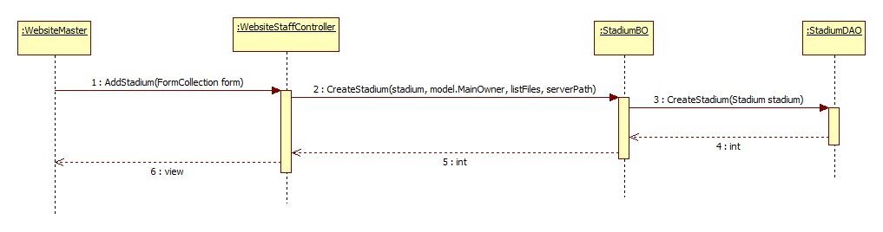

Figure 62: Create Stadium

#### Update Stadium

Reference:

#### Update Configuration

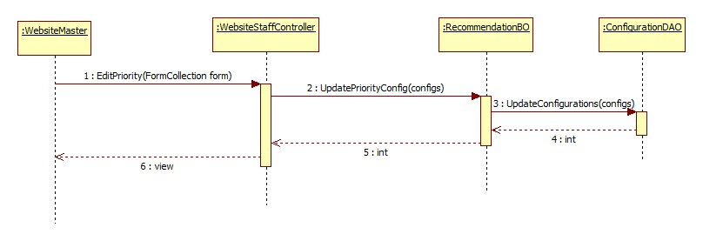

Figure 63: Update Configuration

#### Suggest Stadium

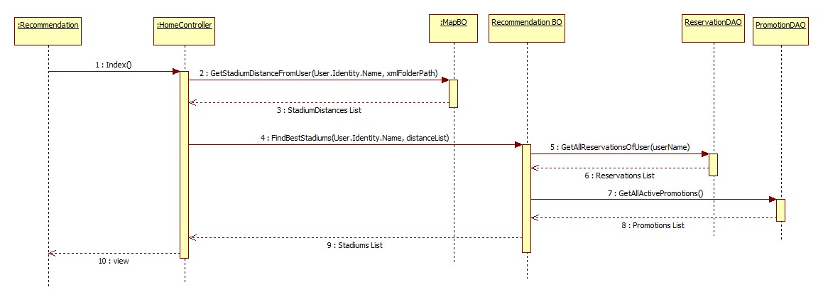

Figure 64: Suggest Stadium

#### Suggest Rival

Reference:

#### View Stadiums

Reference:

#### Create Member Rank

Reference:

#### Update Member Rank

Reference:

#### Delete Member Rank

Reference:

#### View Member Ranks

Reference:

#### Create Advertising

Reference:

#### Update Advertising

Reference:

#### Delete Advertising

Reference:

#### View Advertisings

Reference:

#### Punish User

Reference:

#### Update User

Reference:

#### View Users

Reference:

#### Update Stadium Profile

Reference:

#### Add Field To Stadium

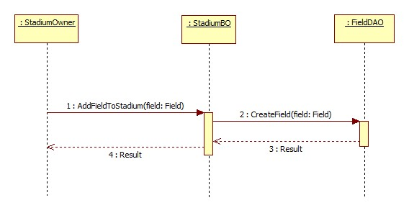

#### Update Field

Reference:

#### View Fields

Reference:

#### Create Reservation

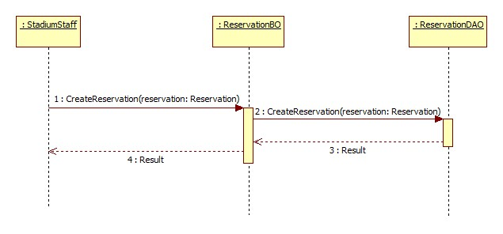

#### Update Reservation

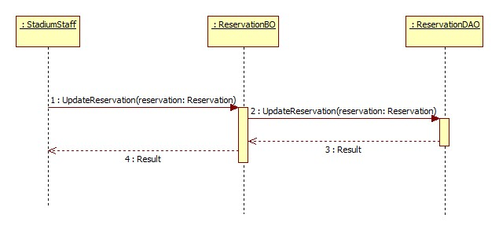

#### Approve Reservation

Reference:

#### Decline Reservation

Reference:

#### View Reservations

Reference:

#### Create Promotion

Reference:

#### Update Promotion

Reference:

#### View Promotions

Reference:

#### Find Stadium

Reference:

#### Find Available Stadium

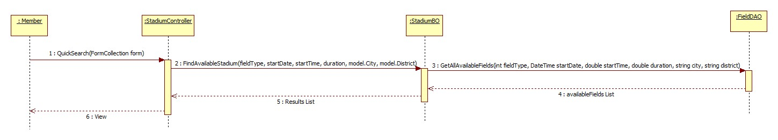

#### View Stadium Detail

Reference:

#### Book Field

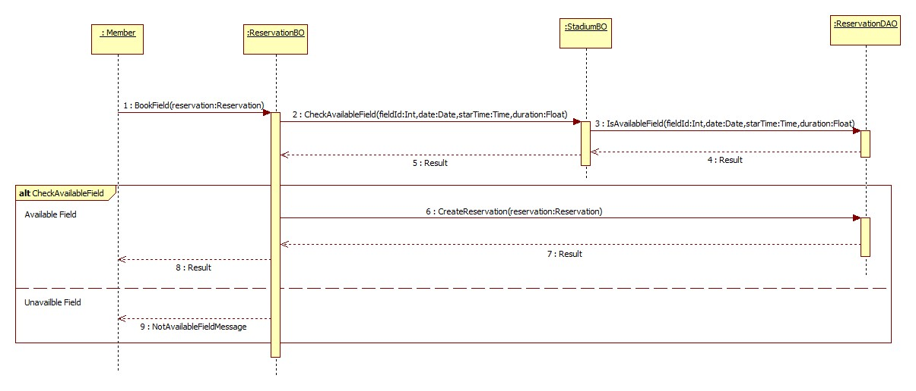

#### Cancel Reservation

Reference:

#### Find Rival

Reference:

#### Join Match

Reference:

#### View Booking History

Reference:

#### Rate Stadium

Reference:

#### Review Stadium

Reference:

#### Update Account Profile

Reference:

#### Feedback Website

Reference:

#### Request Join System

Reference:

### User Interface Design/ Hardware Interface Design (if any)

Update Later

### Database Design

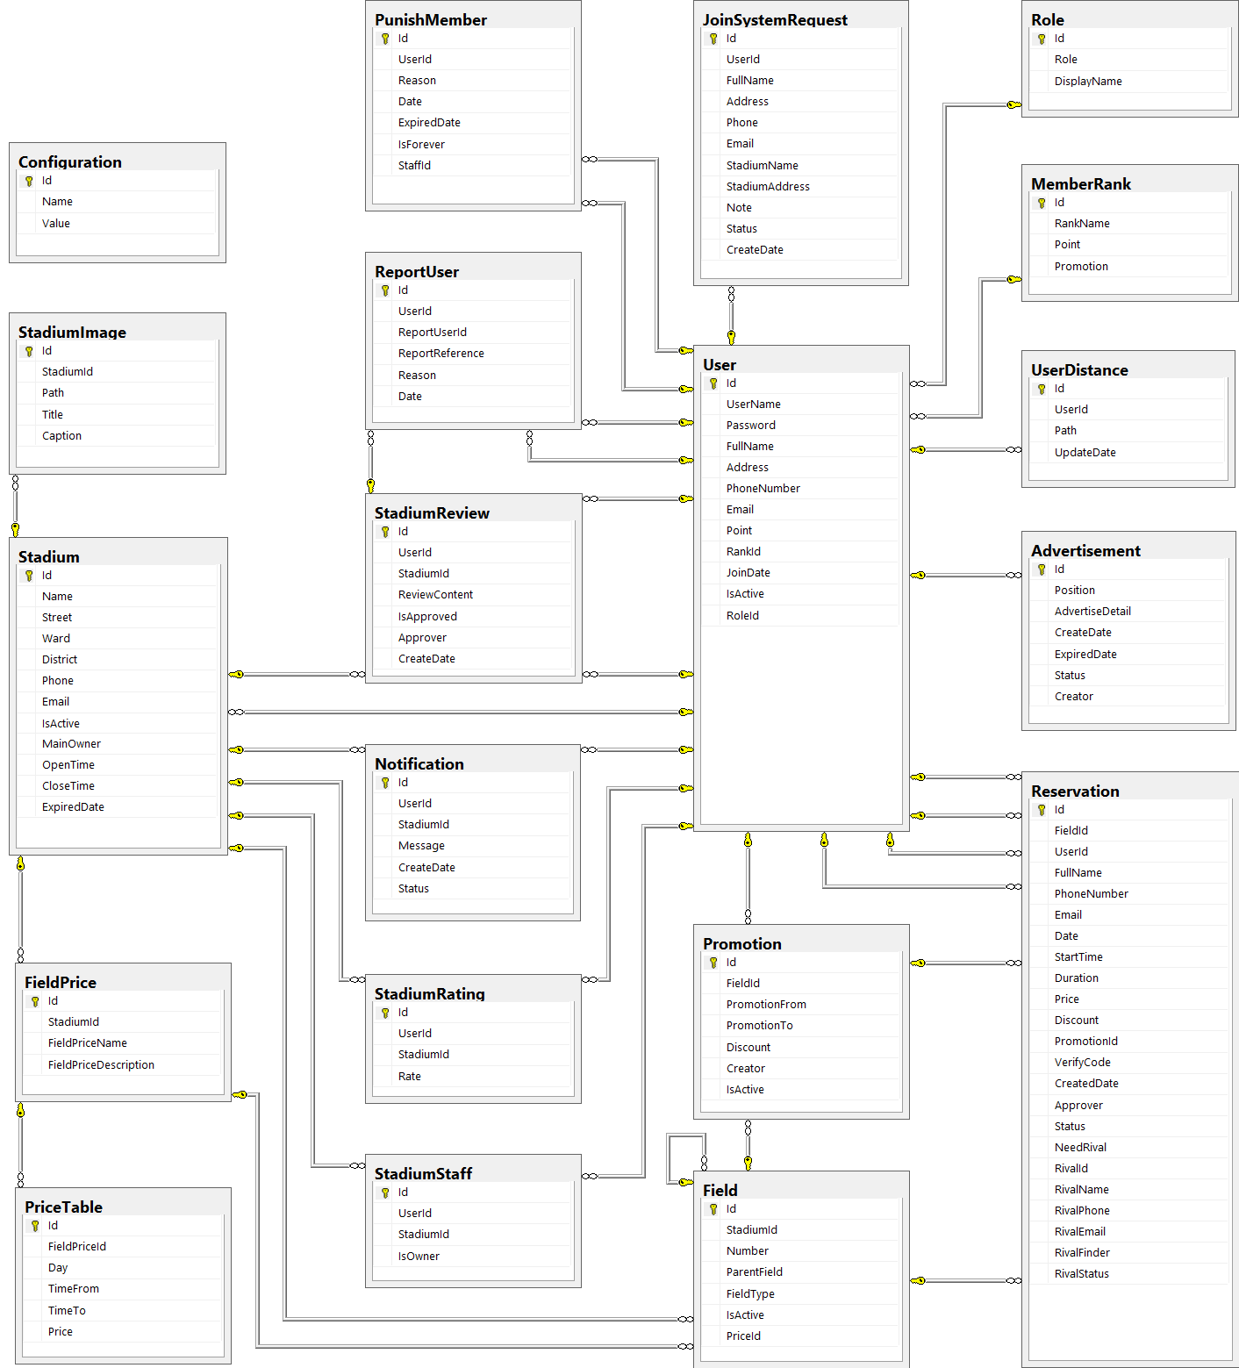

Figure 65: Database Diagram

#### Tables description

|  |  |  |
| --- | --- | --- |
| No. | Table name | Description |
| 1 | Advertisement | Store information about advertising of website |
| 2 | Field | Store information about fields in system |
| 3 | FieldPrice | Store information about price of fields in system |
| 4 | JoinSystemRequest | Store information about join system requests in system |
| 5 | MemberRank | Store information about rank of member in system |
| 6 | Promotion | Store information about promotions of stadiums in system |
| 7 | Reservation | Store information about reservations of stadiums in system |
| 8 | Role | Store information about roles of user in system |
| 9 | Stadium | Store information about stadiums in system |
| 10 | StadiumImage | Store information about images of stadiums in system |
| 11 | StadiumRating | Store information about rating of stadiums in system |
| 12 | StadiumReview | Store information about reviews of stadiums in system |
| 13 | StadiumStaff | Store information about staffs of stadiums in system |
| 14 | User | Store information about users in system |

#### Advertisement

|  |  |  |  |  |  |  |
| --- | --- | --- | --- | --- | --- | --- |
| Field name | Type | Null | Unique | P/F key | Default | Description |
| Id | int |  |  | PK |  | The index of this advertising |
| Position | nvarchar(10) |  |  |  |  | The position to display of the advertising |
| AdvertiseDetail | ntext |  |  |  |  | The content of this advertising |
| CreateDate | date |  |  |  |  | The date when this advertising is created |
| ExpiredDate | date |  |  |  |  | The date when this advertising is expired |
| Status | nvarchar(50) |  |  |  |  | The status of this advertising |
| Creator | int | true |  | FK |  | The creator who is created this advertising |

#### Field

|  |  |  |  |  |  |  |
| --- | --- | --- | --- | --- | --- | --- |
| Field name | Type | Null | Unique | P/F key | Default | Description |
| Id | int |  |  | PK |  | The index of this field |
| StadiumId | int |  |  | FK |  | The index of stadium which contain this field |
| Number | nvarchar(5) |  |  |  |  | The number of this field |
| ParentField | int | true |  | FK |  | The index of field which is parent of this field |
| FieldType | int |  |  |  |  | The type of this field |
| IsActive | bit | true |  |  |  | The status of this field |

#### FieldPrice

|  |  |  |  |  |  |  |
| --- | --- | --- | --- | --- | --- | --- |
| Field name | Type | Null | Unique | P/F key | Default | Description |
| Id | int |  |  | PK |  | The index of price of field |
| FieldId | int |  |  | FK |  | The index of field |
| TimeFrom | float |  |  |  |  | The price of field begin from this time |
| TimeTo | float |  |  |  |  | The price of field end from this time |
| Price | float |  |  |  |  | The price of field |
| Day | int |  |  |  |  | The price of fiend in this day |

#### JoinSystemRequest

|  |  |  |  |  |  |  |
| --- | --- | --- | --- | --- | --- | --- |
| Field name | Type | Null | Unique | P/F key | Default | Description |
| Id | int |  |  | PK |  | The index of this join system request |
| UserId | int |  |  | FK |  | The user who send this join system request |
| FullName | nvarchar(50) |  |  |  |  | The full name of user who send this join system request |
| Address | nvarchar(100) |  |  |  |  | The address of user who send this join system request |
| Phone | nvarchar(20) |  |  |  |  | The phone number of user who send this join system request |
| Email | nvarchar(50) |  |  |  |  | The email of user who send this join system request |
| StadiumName | nvarchar(100) |  |  |  |  | The name of stadium which is user want to join system |
| StadiumAddress | nvarchar(100) |  |  |  |  | The address of stadium which is user want to join system |
| Note | nvarchar(1000) | true |  |  |  | The note of this request |
| Status | nvarchar(50) |  |  |  |  | The status of this request |
| CreateDate | datetime |  |  |  |  | The date when this request is created |

#### MemberRank

|  |  |  |  |  |  |  |
| --- | --- | --- | --- | --- | --- | --- |
| Field name | Type | Null | Unique | P/F key | Default | Description |
| Id | int |  |  | PK |  | The index of this rank |
| RankName | nvarchar(50) | true |  |  |  | The name of this rank |
| Point | int | true |  |  |  | This point is condition to have this user rank |
| Promotion | nvarchar(500) | true |  |  |  | The promotion for user who have this rank |

#### Promotion

|  |  |  |  |  |  |  |
| --- | --- | --- | --- | --- | --- | --- |
| Field name | Type | Null | Unique | P/F key | Default | Description |
| Id | int |  |  | PK |  | The index of this promotion |
| FieldId | int |  |  | FK |  | The index of field which this promotion apply |
| PromotionFrom | date |  |  |  |  | The time when this promotion is started |
| PromotionTo | date |  |  |  |  | The time when this promotion is finished |
| Discount | float |  |  |  |  | The discount per cent of this promotion |
| Creator | int | true |  |  |  | The creator who is created this promotion |
| IsActive | bit | true |  |  |  | The status of this promotion |

#### Reservation

|  |  |  |  |  |  |  |
| --- | --- | --- | --- | --- | --- | --- |
| Field name | Type | Null | Unique | P/F key | Default | Description |
| Id | int |  |  | PK |  | The index of this reservation |
| FieldId | int |  |  | FK |  | The index of field is booked |
| UserId | int | true |  | FK |  | The index of user who book the field |
| FullName | nvarchar(50) |  |  |  |  | The full name of user who book the field |
| PhoneNumber | nvarchar(20) |  |  |  |  | The phone number of user who book the field |
| Email | nvarchar(50) | true |  |  |  | The email of user who book the field |
| Date | date |  |  |  |  | The date that is booked the field |
| StartTime | float |  |  |  |  | The start time when user need the field |
| Duration | float |  |  |  |  | The duration time that user need the field |
| Price | float |  |  |  |  | The price of field |
| Discount | float | true |  |  |  | The discount per cent of the promotion is applied to this reservation |
| PromotionId | int | true |  |  |  | The index of the promotion is applied to this reservation |
| VerifyCode | nvarchar(50) |  |  |  |  | The code which use for verifying this reservation |
| CreatedDate | datetime |  |  |  |  | The date when this reservation is created |
| Approver | int | true |  | FK |  | The index of stadium staff who approve this reservation |
| Status | nvarchar(20) |  |  |  |  | The status about approving of this reservation |
| HasRival | bit |  |  |  |  | The status about having rival of this reservation |
| RivalId | int | true |  | FK |  | The index of rival who join this request rival of this reservation |
| RivalName | nvarchar(50) | true |  |  |  | The name of rival who join this request rival of this reservation |
| RivalPhone | nvarchar(20) | true |  |  |  | The phone number of rival who join this request rival of this reservation |
| RivalEmail | nvarchar(50) | true |  |  |  | The email of rival who join this request rival of this reservation |
| RivalFinder | int | true |  |  |  | The index of user who find rival for this request rival of this reservation |

#### Role

|  |  |  |  |  |  |  |  |  |  |  |  |  |
| --- | --- | --- | --- | --- | --- | --- | --- | --- | --- | --- | --- | --- |
| Field name | Type | | Null | | Unique | | P/F key | | Default | | Description | |
| Id | | int | |  | |  | | PK, FK | |  | | The index of this role |
| Role | | nvarchar(50) | |  | |  | |  | |  | | The name of this role |

#### Stadium

|  |  |  |  |  |  |  |
| --- | --- | --- | --- | --- | --- | --- |
| Field name | Type | Null | Unique | P/F key | Default | Description |
| Id | int |  |  | PK |  | The index of this stadium |
| Name | nvarchar(100) |  |  |  |  | The name of this stadium |
| Street | nvarchar(50) |  |  |  |  | The street address of this stadium |
| Ward | nvarchar(50) |  |  |  |  | The ward address of this stadium |
| District | nvarchar(50) |  |  |  |  | The district address of this stadium |
| City | nvarchar(50) |  |  |  |  | The city address of this stadium |
| Description | nvarchar(500) |  |  |  |  | The description about this stadium |
| Phone | nvarchar(20) |  |  |  |  | The phone number to contact with this stadium staff |
| Email | nvarchar(50) |  |  |  |  | The email to contact with this stadium staff |
| IsActive | bit | true |  |  |  | The status of this stadium |

#### StadiumImage

|  |  |  |  |  |  |  |
| --- | --- | --- | --- | --- | --- | --- |
| Field name | Type | Null | Unique | P/F key | Default | Description |
| Id | int |  |  | PK |  | The index of this image |
| StadiumId | int |  |  | FK |  | The index of stadium which the image about |
| Path | nvarchar(100) |  |  |  |  | The path of this image store in server |
| Title | nvarchar(100) | true |  |  |  | The title of this image |
| Caption | nvarchar(200) | true |  |  |  | The caption of this image |

#### StadiumRating

|  |  |  |  |  |  |  |
| --- | --- | --- | --- | --- | --- | --- |
| Field name | Type | Null | Unique | P/F key | Default | Description |
| Id | int |  |  | PK |  | The index of this rating |
| UserId | int |  |  | FK |  | The index of user who rate the stadium |
| StadiumId | int |  |  | FK |  | The index of stadium which is rated |
| Rate | float |  |  |  |  | The point of this rating |

#### StadiumReview

|  |  |  |  |  |  |  |  |  |  |  |  |  |
| --- | --- | --- | --- | --- | --- | --- | --- | --- | --- | --- | --- | --- |
| Field name | Type | | | Null | | Unique | | P/F key | | Default | | Description |
| Id | | int |  | |  | | PK | |  | | The index of this review | |
| UserId | | int |  | |  | | FK | |  | | The index of user who review the stadium | |
| StadiumId | | int |  | |  | | FK | |  | | The index of stadium which is reviewed | |
| ReviewContent | | nvarchar(500) |  | |  | |  | |  | | The content of this review | |
| IsApproved | | bit |  | |  | |  | |  | | The status about approving of this review | |
| Approver | | int | true | |  | | FK | |  | | The index of stadium staff who approve this review | |
| CreateDate | | datetime |  | |  | |  | |  | | The date when this review is created | |

#### StadiumStaff

|  |  |  |  |  |  |  |  |  |  |  |  |  |
| --- | --- | --- | --- | --- | --- | --- | --- | --- | --- | --- | --- | --- |
| Field name | Type | | Null | | Unique | | P/F key | | Default | | Description | |
| Id | | int | |  | |  | | PK | |  | | The index of this stadium staff |
| UserId | | int | |  | |  | | FK | |  | | The index of user who is staff of stadium |
| StadiumId | | int | |  | |  | | FK | |  | | The index of stadium |
| IsOwner | | bit | |  | |  | |  | |  | | The role of this staff |

#### User

|  |  |  |  |  |  |  |
| --- | --- | --- | --- | --- | --- | --- |
| Field name | Type | Null | Unique | P/F key | Default | Description |
| Id | int |  |  | PK |  | The index of this user |
| UserName | nvarchar(50) |  |  |  |  | The user name of this user |
| Password | nvarchar(50) |  |  |  |  | The password of this user |
| FullName | nvarchar(50) | true |  |  |  | The full name of this user |
| Address | nvarchar(100) | true |  |  |  | The address of this user |
| PhoneNumber | nvarchar(20) | true |  |  |  | The phone number of this user |
| Email | nvarchar(50) |  |  |  |  | The email of this user |
| Point | int |  |  |  |  | The point of this user |
| RankId | int |  |  | FK |  | The index of rank of this user |
| IsReceivedReward | bit |  |  |  |  | The status about receiving reward of this user |
| JoinDate | date |  |  |  |  | The date when user register at website |
| IsActive | bit |  |  |  |  | The status of this user |
| RoleId | int |  |  |  |  | The index of role of this user |

### Other material (if any)

N/A

## System Implementation & Test (SIT)

### Introduction

#### System Overview

This document describes the approach and methodologies used by the testing group to plan, organize and manage the testing of this system. It describes implementation details of test cases or technical details of how the product features should work.

The system will be tested is also the system our team are currently developing. This system developed based on MVC4 framework.

#### Test Approach

* Test goals: the testing aims to identify the remaining bugs in the system before releasing and confirm the consistency in design and implementation.
* Test type: black box testing.
* Test level: system and integration test.

### Test Plan

The purpose of this section is to verify and ensure that BUSG meets its design specification and other requirements from user. The following part will describe which features will be tested and which will not.

#### Functions

##### Role ‘Website Master’

Test all functions of role ‘Website Master’ including:

* Stadium Management
* User Management
* Advertise Management
* Request Join System Management

##### Role ‘Stadium Owner’

* Field Management
* Stadium Management
* Promotion Management
* Reservation Management

##### Role ‘Member’

* Account Management
* Feedback Management
* Find
* Booking Field Management

#### Features not to be tested

##### Performance test

There was not enough time so we cannot optimize source code and improve performance. We can only ensure the system work well but not at its best performance.

##### Testing Tools and Environment

* Windows 7 operating system
* Google Chrome 19 or higher
* Microsoft Visual Studio 2012
* Microsoft SQL Server 2008 R2

### Test Cases

#### Function

##### Role ‘Website Master’

###### Stadium Managements

|  |  |  |  |  |  |
| --- | --- | --- | --- | --- | --- |
| **Test case No** | **Test case** | **Input** | **Expected Result** | **Status** | **Note** |
| **View Stadium Management** | | | | | |
| TC_1 | Test View Stadium List | 1. Login the system with admin role. 2. Click " Sân Bóng " link | The Stadium view form is displayed with the following informations:  - Image of Stadium - Tên sân bóng - Địa chỉ - Số điện thoại - Đánh giá  - “ Đặt sân “ buttons | Untested |  |
| **Create Stadium** | | | | | |
| TC_2 | Test View Create Stadium Form | 1. Login the system with admin role. 2. Click “ Quản trị website " link 3. Click " Sân bóng" link  4. Click “ Thêm sân mới “ button | The Create Stadium form is displayed with the following field:  - Tên sân bóng - Chủ sân  - Ngày hết hạn - Số điện thoại  - Email - Đường, phường , quận  - Hình ảnh sân  - Giờ hoạt động  - Thêm hình ảnh sân  - Trạng thái hoạt động  - “ Lưu “ button & “ Hủy bỏ “ button | Untested |  |
| TC_3 | Test Create Stadium Successfully | 1. Insert stadium's information 2. Click "Lưu" button | Display success message Redirect to “ Quản lý sân bóng “ page | Untested |  |
| TC_4 | Test Create Stadium With Blank Field | 1. Insert stadium's information 2. Leave empty some fields 3. Click “ Lưu" button | Error message will be displayed : “ Xin hãy điền đầy đủ những thông tin bắt buộc “ | Untested |  |
| TC_5 | Test Cancel Create Stadium | 1. Insert stadium's information 2. Click "Hủy bỏ" button | Confirm discard all recent activity is displayed Redirect to “ Quản lý sân bóng “ page | Untested |  |
| **Edit Stadium** | | | | | |
| Reference:  6 Test cases | | | | | |

###### User Managements

|  |  |  |  |  |  |
| --- | --- | --- | --- | --- | --- |
| **Test case No** | **Test case** | **Input** | **Expected Result** | **Status** | **Note** |
| **View User Management** | | | | | |
| TC_12 | Test View User List | 1. Login the system with admin role. 2. Click "Thành Viên" page | The User view form is displayed with the following informations: - Thành viên - Tên đầy đủ - Địa chỉ  - Email  - Quyền hạn  - “ Tìm kiếm “ textbox  - “ Tìm kiếm “ button & “ Xem tất cả “ button | Untested |  |
| **Update User's Profile** | | | | | |
| TC_13 | Test View Update User's Profile Form | 1. Login the system with admin role. 2. Click "Thành Viên" page  3. Click user which will be edited | The User edit form is displayed with the following informations: - Tên đăng nhập - Tên thành viên  - Địa chỉ  - Số điện thoại - “ Email “ textbox  - “ Mật khẩu “ textbox & “ Xác nhận mật khẩu “ textbox  - Point  - “ Trạng thái hoạt động “ drop down list  - “ Quyền hạn “ drop down list  - “ Lưu “ button & “ Hủy bỏ “ button” | Untested |  |
| TC_14 | Test Update User's Profile Successfully | 1. Insert new User's information 2. Click "Lưu" button | Update Successfully Redirect to “ Quản lý thành viên “ page | Untested |  |
| TC_15 | Test Update User's Profile With Blank Field | 1. Insert new User's information  2. Leave empty some fields 3. Click "Lưu" button | Error message will be displayed : “ Xin hãy điền đầy đủ những thông tin bắt buộc “ | Untested |  |
| TC_16 | Test Cancel Update User's Profile | 1. Insert new User's information 2. Click "Hủy" button | Confirm discard all recent activity is displayed Redirect to “ Quản lý thành viên “ page | Untested |  |

###### Advertising Management

|  |  |  |  |  |  |  |
| --- | --- | --- | --- | --- | --- | --- |
| **Test case No** | **Test case** |  | **Input** | **Expected Result** | **Status** | **Note** |
| **View Advertising Management** | | | | | | |
| TC_17 | Test View Advertising List | 1. Login the system with admin role.  2. Click "Quảng Cáo" link | | “ Quản lý quảng cáo “ page is displayed with the following informations: - Vị trí - Thông tin quảng cáo - Ngày hết hạn - Trạng thái  - “ Chỉnh sửa “ link  - “ Thêm quảng cáo “ button” | Untested |  |
| **Create Advertising** | | | | | | |
| TC_18 | Test View Create Advertising Form | 1. Login the system with admin role.  2. Click "Quảng Cáo" link  3. Click "Thêm quảng cáo" button | | “ Thêm quảng cáo “ page is displayed with the following informations: - “ Vị trí “ drop down list  - “ Chi tiết quảng cáo “ text box  - “ Ngày hết hạn “text box  - “ Trạng thái “ drop down list  - “ Lưu “ button & “ Hủy bỏ “ button | Untested |  |
| TC_19 | Test Create Advertising Successfully | 1. Insert advertising's information  2. Click "Lưu" button | | Create new Advertising successfully Redirect to “ Quản lý quảng cáo “ page | Untested |  |
| TC_20 | Test Create Advertising With Blank Field | 1. Insert advertising's information  2. Leave empty some fields  3. Click “ Lưu “ button | | Error message will be displayed :  - “ Xin vui lòng nhập vào chi tiết của quảng cáo “  - “ Xin vui lòng chọn thời gian khuyến mãi “ | Untested |  |
| TC_21 | Test Cancel Create Advertising | 1. Insert advertise's information  2. Click "Hủy" button | | Confirm discard all recent activity is displayed Redirect to “ Quản lý quảng cáo “ page | Untested |  |
| **Edit Advertising** | | | | | | |
| Reference:  4 Test Cases | | | | | | |

###### Rank management

|  |  |  |  |  |  |  |
| --- | --- | --- | --- | --- | --- | --- |
| **Test case No** | **Test case** |  | **Input** | **Expected Result** | **Status** | **Note** |
| **View Rank Management** | | | | | | |
| TC_26 | Test View Ranks List | 1. Login the system with admin role.  2. Click "Cấp bậc thành viên" link | | “ Cấp độ thành viên “ page is displayed with the following informations: - Tên cấp bậc - Điểm | Untested |  |
| **Create Rank** | | | | | | |
| TC_27 | Test View Create Advertising Form | 1. Login the system with admin role.  2. Click "Cấp bậc thành viên" link  3. Click "Thêm cấp bậc" button | | “ Thêm cấp bậc “ page is displayed with the following informations: - Tên cấp bậc - Điểm | Untested |  |
| TC_28 | Test Create Rank Successfully | 1. Insert rank’s information  2. Click "Lưu" button | | Create new rank successfully Redirect to “ Quản lý cấp bậc thành viên“ page | Untested |  |
| TC_29 | Test Create Rank With Blank Field | 1. Insert rank's information  2. Leave empty some fields  3. Click “ Lưu “ button | | Error message will be displayed :  - “ Xin vui lòng nhập vào chi tiết của cấp bậc thành viên“ | Untested |  |
| TC_30 | Test Cancel Create Rank | 1. Insert rank's information  2. Click "Hủy" button | | Confirm discard all recent activity is displayed Redirect to “ Quản lý cấp bậc thành viên “ page | Untested |  |
| **Edit Rank** | | | | | | |
| Reference:  4 Test Cases | | | | | | |

##### Role ‘Stadium Owner’

###### Field Managements

|  |  |  |  |  |  |
| --- | --- | --- | --- | --- | --- |
| **Test case No** | **Test case** | **Input** | **Expected Result** | **Status** | **Note** |
| **View List Fields** | | | | | |
| TC_35 | Test viewing "Quản lý sân con" list | 1. Login the system as Stadium Owner  2. Click "Quản lý sân bóng" link  3. Click “ Sân bóng “ link  4. Click " Sân con" button | "Quản lý sân con" page is displayed as list with the following informations:  - “ Tên sân“ - “ Kiểu sân“  - “ Tên sân cha“  - “ Trạng thái “  - “ Chỉnh sửa “ button & “ Thêm ssân con “ button & “ Bảng giá “ button | Untested |  |
| **Create Field** | | | | | |
| TC_36 | Test creating a field with blank fields | 1. Login the system as Stadium Owner  2. Click "Quản lý sân bóng" link  3. Click “ Sân bóng “ link  4. Click " Sân con" button  5. Click “ Thêm sân con “  6. Leave empty some fields  7. Click “ Lưu “ button | Error message will be displayed:  - " Bạn cần sử dụng mẫu nhập bên dưới để thêm đầy đủ thông tin vào sân bóng". | Untested |  |
| TC_37 | Test creating a field but don’t have price list | 1. Login the system as Stadium Owner  2. Click "Quản lý sân bóng" link  3. Click “ Sân bóng “ link  4. Click " Sân con" button  5. Click “ Thêm sân con “  6. Click “ Đây “ button | Error message will be displayed:  - " Bạn cần them bảng giá vào hệ thống trước khi thêm sân con vào hệ thống. Click vào ” “ Đây “ buton “ để đến trang them bảng giá".  - Redirect to “ Thêm bảng giá “ page | Untested |  |
| TC_38 | Test creating a field | 1. Login the system as Stadium Owner  2. Click "Quản lý sân bóng" link  3. Click “ Sân bóng “ link  4. Click " Sân con" button  5. Click “ Thêm sân con “  6. Input require information  7. Click "Lưu" button | Create successfully  Redirect to "Quản lý sân con" page with new "Sân con" is created | Untested |  |
| TC_39 | Test cancel creating action | 1. Login the system as Stadium Owner  2. Click "Quản lý sân bóng" link  3. Click “ Sân bóng “ link  4. Click " Sân con" button  5. Click “ Thêm sân con “  6. Click "Huỷ" button | Confirm discard all recent activity is displayed Redirect to “ Quản lý sân con “ page | Untested |  |
| **Update Field** | | | | | |
| Reference:  5 Test Cases | | | | | |

###### Promotion Managements

|  |  |  |  |  |  |
| --- | --- | --- | --- | --- | --- |
| **Test case No** | **Test case** | **Input** | **Expected Result** | **Status** | **Note** |
| **View List Promotions** | | | | | |
| TC_45 | Test viewing "Quản lý khuyến mãi" form | 1. Login the system as Stadium Owner  2. Go to "Quản lý sân bóng" page  3. Click “ Khuyến mãi" link  4. Click stadium you want to view promotion | "Quản lý khuyến mãi" page is displayed as list with the following informations:  - Số sân  - Thời gian khuyến mãi  - Giảm giá  - Trạng thái hoạt động  - “ Thêm khuyến mãi “ button & “ Chỉnh sửa “ button | Untesed |  |
| **Create Promotion** | | | | | |
| TC_46 | Test creating a promotion with blank fields | 1. Login the system as Stadium Owner  2. Go to "Quản lý sân bóng" page  3. Click “ Khuyến mãi" link  4. Click stadium you want to view promotion  5. Click "Thêm khuyến mãi" button  6. Leave empty some fields  7. Click "Lưu" button | Error message will be displayed:  - "Xin vui lòng chọn thời gian khuyến mãi  - “ Xin nhập và số ưu đãi giảm giá". | Untesed |  |
| TC_47 | Test creating a promotion with "Thời gian kết thúc" is over | 1. Login the system as Stadium Owner  2. Go to "Quản lý sân bóng" page  3. Click “ Khuyến mãi" link  4. Click stadium you want to view promotion  5. Click"Thêm khuyến mãi" button  6. Input require information  - Select "1" in "Số sân" field  - Input "05/03/2014" into "Thời gian bắt đầu"  - Input "06/03/2014" into "Thời gian kết thúc" field  - Input "10" into "Giảm giá (%)" field  7. Click "Lưu" button | Error message will be displayed:  - "Thời gian khuyến mãi đã kết thúc, xin vui lòng chọn thời gian kết thúc khác". | Untesed |  |
| TC_48 | Test creating a promotion with "Thời gian kết thúc" before "Thời gian bắt đầu" | 1. Login the system as Stadium Owner  2. Go to "Quản lý sân bóng" page  3. Click “ Khuyến mãi" link  4. Click stadium you want to view promotion  5. Click "Thêm khuyến mãi" button  6. Input require information  - Select "1" in "Số sân" field  - Input "25/03/2014" into "Thời gian bắt đầu" field  - Input "20/03/2014" into "Thời gian kết thúc" field  - Input "10" into "Giảm giá (%)" field  7. Click"Lưu" button | Error message will be displayed:  - "Thời gian khuyến mãi không đúng, vui lòng chọn thời gian khác". | Untesed |  |
| TC_49 | Test creating a promotion with "Giảm giá (%)" is not a number | 1. Login the system as Stadium Owner  2. Go to "Quản lý sân bóng" page  3. Click “ Khuyến mãi" link  4. Click stadium you want to view promotion  5. Click "Thêm khuyến mãi" button  6. Input require information  - Select "1" in "Số sân" field  - Input "11/11/2014" into "Thời gian bắt đầu" field  - Input "12/12/2014" into "Thời gian kết thúc" field  - Input "12a" into "Giảm giá (%)" field  7.Click"Lưu" button | Error message will be displayed:  - "Giá trị giảm giá không chính xác, vui lòng nhập lại". | Untesed |  |
| TC_50 | Test creating a promotion with "Giảm giá (%)" is not in a space | 1. Login the system as Stadium Owner  2. Go to "Quản lý sân bóng" page  3. Click “ Khuyến mãi" link  4. Click stadium you want to view promotion  5. Click "Thêm khuyến mãi" button  6. Input require information  - Select "1" in "Số sân" field  - Input "11/11/2014" into "Thời gian bắt đầu" field  - Input "12/12/2014" into "Thời gian kết thúc" field  - Input "500" into "Giảm giá (%)" field  7.Click "Lưu" button | Error message will be displayed:  - "Yêu cầu giảm giá nằm trong khoảng 0 đến 100". | Untesed |  |
| TC_51 | Test creating a promotion | 1. Login the system as Stadium Owner  2. Go to "Quản lý sân bóng" page  3. Click “ Khuyến mãi" link  4. Click stadium you want to view promotion  5. Click "Thêm khuyến mãi" button  6. Input require information  - Select "1" in "Số sân" field  - Input "11/11/2014" into "Thời gian bắt đầu" field  - Input "12/12/2014" into "Thời gian kết thúc" field  - Input "10" into "Giảm giá (%)" field  7. Click "Lưu" button | Create successfully  Redirect to "Quản lý khuyến mãi" page with new "Khuyến mãi" is created | Untesed |  |
| TC_52 | Test cancel creating action | 1. Login the system as Stadium Owner  2. Go to "Quản lý sân bóng" page  3. Click “ Khuyến mãi" link  4. Click stadium you want to view promotion  5. Click "Thêm khuyến mãi" button  6. Click "Huỷ bỏ" button | Confirm discard all recent activity is displayed Redirect to “ Quản lý khuyến mãi “ page | Untested |  |
| Update Promotion | | | | | |
| Reference: 9 Test Cases | | | | | |

###### Reservation Managements

|  |  |  |  |  |  |
| --- | --- | --- | --- | --- | --- |
| **Test case No** | **Test case** | **Input** | **Expected Result** | **Status** | **Note** |
| **View List Reservations** | | | | | |
| TC_62 | Test viewing "Quản lý đơn hàng" form | 1. Login the system as Stadium Owner  2. Go to "Quản lý sân bóng" page  3. Click “ Đặt sân" link  4. Click stadium you want to view promotion | "Quản lý đơn đặt sân “ page is displayed as list with the following informations:  - "Tên khánh hàng"  - "Số điện thoại"  - "Số sân"  - "Thời gian đặt sân "  - "Thời lượng"  - "Trạng thái "  - “ Chi tiết “ button & “ Thêm đơn đặt sân “ button | Untesed |  |
| **Create Reservation** | | | | | |
| TC_63 | Test creating a reservation with blank fields | 1. Login the system as Stadium Owner  2. Go to "Quản lý sân bóng" page  3. Click “ Đặt sân" link  4. Click "Thêm đơn đặt sân" button  5. Leave empty some fields 6. Click "Lưu" button | Error message will be displayed:  - "Xin vui lòng chọn ngày đặt sân".  - "Xin vui lòng chọn giờ đặt sân".  - “ Yêu cầu từ 1 đến 30 kí tự “  - “ Yêu cầu phải nhập đúng số điện thoại “  - “ Email không đúng “ | Untesed |  |
| TC_64 | Test creating a reservation with customer username is not existed | 1. Login the system as Stadium Owner  2. Go to "Quản lý sân bóng" page  3. Click “ Đặt sân" link  4. Click "Thêm đơn đặt sân" button  5. Input require information  - Select "1" in "Số sân" field  - Input customer information  + Input "abc123" into "Khách hàng" field  + Input "ABCDEF" into "Tên đầy đủ" field  + Input "1234567890" into "Số điện thoại" field  + Input "abcdef@ghi.jk" into "Email" field  + Input "15/03/2014" into "Ngày đặt" field  + Input "16:30" in "Giờ đặt" field  + Input "1:30" "Thời lượng" field  + Choose “ Không” in "Đối thủ" drop down list  6. Click"Lưu" button | Error message will be displayed:  - "Tên khách hàng không tồn tại". | Untesed |  |
| TC_65 | Test creating a reservation with blank customer username | 1. Login the system as Stadium Owner  2. Go to "Quản lý sân bóng" page  3. Click “ Đặt sân" link  4. Click "Thêm đơn đặt sân" button  5. Input require information  - Select "1" in "Số sân" field  - Input customer information  + Input "ABCDEF" into "Tên đầy đủ" field  + Input "1234567890" into "Số điện thoại" field  + Input "abcdef@ghi.jk" into "Email" field  + Input "15/03/2014" into "Ngày đặt" field  + Input "16:30" in "Giờ đặt" field  + Input "1:30" "Thời lượng" field  + Choose “ Không” in "Đối thủ" drop down list  6. Click "Lưu" button | Redirect to "Quản lý đơn đặt sân “ page with new "Đơn đặt sân" created | Untesed |  |
| TC_66 | Test creating a reservation with booking time is over | 1. Login the system as Stadium Owner  2. Go to "Quản lý sân bóng" page  3. Click “ Đặt sân" link  4. Click "Thêm đơn đặt sân" button  5. Input require information  - Select "1" in "Số sân" field  - Input customer information  + Input "ABCDEF" into "Tên đầy đủ" field  + Input "1234567890" into "Số điện thoại" field  + Input "abcdef" into "Email" field  + Input "15/03/2014" into "Ngày đặt" field  + Input "16:30" in "Giờ đặt" field  + Input "1:30" "Thời lượng" field  + Choose “ Không” in "Đối thủ" drop down list  6. Click "Lưu" button | Error message will be displayed:  - "Thời gian đặt sân đã kết thúc, vui lòng chọn thời gian khác". | Untesed |  |
| TC_67 | Test creating a reservation with check "Đối thủ" with blank rival information | 1. Login the system as Stadium Owner  2. Go to "Quản lý sân bóng" page  3. Click “ Đặt sân" link  4. Click "Thêm đơn đặt sân" button  5. Input require information  - Select "1" in "Số sân" field  - Input customer information  + Input "ABCDEF" into "Tên đầy đủ" field  + Input "1234567890" into "Số điện thoại" field  + Input "abcdef" into "Email" field  + Input "15/03/2014" into "Ngày đặt" field  + Input "16:30" in "Giờ đặt" field  + Input "1:30" "Thời lượng" field  + Choose “ Có” in "Đối thủ" drop down list  6. Click "Lưu" button | Error message will be displayed:  - "Xin vui lòng nhập thông tin của đối thủ". | Untesed |  |
| TC_68 | Test creating a reservation with rival username is not existed | 1. Login the system as Stadium Owner  2. Go to "Quản lý sân bóng" page  3. Click “ Đặt sân" link  4. Click "Thêm đơn đặt sân" button  5. Input require information  - Input customer information  + Input "ABCDEF" into "Tên đầy đủ" field  + Input "1234567890" into "Số điện thoại" field  + Input "abcdef@ghi.jk" into "Email" field  + Input "15/03/2014" into "Ngày đặt" field  + Input "16:30" in "Giờ đặt" field  + Input "1:30" "Thời lượng" field  + Choose “ Có” in "Đối thủ" drop down list  - Input rival information  + Input "aaaaaa" into "Đối thủ" field  + Input "ABC123" into "Tên đầy đủ" field  + Input "123456789" into "Số điện thoại" field  + Input "abc123@def.ghi" into "Email" field  6. Click"Lưu" button | Error message will be displayed:  - "Tên đối thủ không tồn tại". | Untested |  |
| TC_69 | Test creating a reservation with blank rival username | 1. Login the system as Stadium Owner  2. Go to "Quản lý sân bóng" page  3. Click “ Đặt sân" link  4. Click "Thêm đơn đặt sân" button  5. Input require information  - Select "1" in "Số sân" field  - Input customer information  + Input "ABCDEF" into "Tên đầy đủ" field  + Input "1234567890" into "Số điện thoại" field  + Input "abcdef@ghi.jk" into "Email" field  + Input "15/03/2014" into "Ngày đặt" field  + Input "16:30" in "Giờ đặt" field  + Input "1:30" "Thời lượng" field  + Choose “ Có ” in "Đối thủ" drop down list  - Input rival information  + Input "ABC123" into "Tên đầy đủ" field  + Input "123456789" into "Số điện thoại" field  + Input "abc123@def.ghi" into "Email" field  6. Click "Lưu" button | Redirect to "Quản lý đơn đặt sân" page with new "Đơn đặt sân" is created | Untested |  |
| TC_70 | Test creating a reservation | 1. Login the system as Stadium Owner  2. Go to "Quản lý sân bóng" page  3. Click “ Đặt sân" link  4. Click "Thêm đơn đặt sân" button  5. Input require information  - Select "1" in "Số sân" field  - Input customer information  + Input "ABCDEF" into "Tên đầy đủ" field  + Input "1234567890" into "Số điện thoại" field  + Input "abcdef@ghi.jk" into "Email" field  + Input "15/03/2014" into "Ngày đặt" field  + Input "16:30" in "Giờ đặt" field  + Input "1:30" "Thời lượng" field  + Choose “ Có ” in "Đối thủ" drop down list  - Input rival information  + Input "thinhnd" into "Đối thủ" field  + Input "ABC123" into "Tên đầy đủ" field  + Input "123456789" into "Số điện thoại" field  + Input "abc123@def.ghi" into "Email" field  6. Click "Lưu" button | Create successfully  Redirect to "Quản lý đơn đặt sân" page with new "Đơn đặt sân" is created | Untested |  |
| TC_71 | Test cancel creating action | 1. Login the system as Stadium Owner  2. Go to "Quản lý sân bóng" page  3. Click “ Đặt sân" link  4. Click "Thêm đơn đặt sân"  5. Click "Huỷ" button | Confirm discard all recent activity is displayed Redirect to “ Quản lý đơn đặt sân “ page | Untested |  |
| **Edit Reservation** | | | | | |
| Reference:  13 Test Cases | | | | | |
| **Decline Reservation** | | | | | |
| TC_84 | Test deny a reservation | 1. Login the system as Stadium Owner  2. Go to "Quản lý sân bóng" page  3. Click “ Đặt sân" link  4. Click "Chi tiết" button in “ Đơn đặt sân “ which you want to approve  5. Click “ Từ chối “ button | Reload "Quản lý đơn đặt sân" page with "Trạng thái" of this stadium is "Bị từ chối" | Untested |  |

###### Price list Management

|  |  |  |  |  |  |
| --- | --- | --- | --- | --- | --- |
| **Test case No** | **Test case** | **Input** | **Expected Result** | **Status** | **Note** |
| **View Price List** | | | | | |
| TC_85 | Test viewing "Quản lý sân con" list | 1. Login the system as Stadium Owner  2. Click "Quản lý sân bóng" link  3. Click " Sân bóng " link  4. Click “ Bảng giá “ button of the stadium which you want to view price lisst | "Quản lý sân con" page is displayed as list with the following informations:  - “ Tên bảng giá“ - “ Mô tả “  - “ Chi tiết “ button & “Xóa“ button | Untested |  |
| **Create Price List** | | | | | |
| TC_86 | Test creating a field with blank fields | 1. Login the system as Stadium Owner  2. Click "Quản lý sân bóng" link  3. Click " Sân bóng " link  4. Click “ Bảng giá “ button  4. Click “ Thêm bảng giá “  5. Leave empty some fields  6. Click “ Lưu “ button | Error message will be displayed:  - " Xin hãy điền đầy đủ vào những trường thông tin bắt buộc".  - “ Bảng giá mặc định không hợp lệ “ | Untested |  |
| TC_87 | Test creating a field | 1. Login the system as Stadium Owner  2. Click "Quản lý sân bóng" link  3. Click " Sân bóng " link  4. Click “ Bảng giá “ button  5. Click “ Thêm bảng giá “  5. Input require information  6. Click "Lưu" button | Create successfully  Redirect to "Quản lý bảng giá" page with new "Bảng giá" is created | Untested |  |
| TC_88 | Test cancel creating action | 1. Login the system as Stadium Owner  2. Click "Quản lý sân bóng" link  3. Click " Sân bóng " link  4. Click “ Bảng giá “ button  5. Click “ Thêm bảng giá “  “  6. Click "Huỷ" button | Confirm discard all recent activity is displayed Redirect to “ Quản lý bảng giá “ page | Untested |  |
| **Update Price List** | | | | | |
| Reference:  4 Test Cases | | | | | |

##### Role ‘Member’

###### Login/ Logout

|  |  |  |  |  |  |
| --- | --- | --- | --- | --- | --- |
| **Test case No** | **Test case** | **Input** | **Expected Result** | **Status** | **Note** |
| **Login** | | | | | |
| TC_93 | Login Page | 1. Go to website homepage.  2. Click " Đăng nhập " button | Login page is displayed. The content includes:  - " Tên tài khoản " (textbox)  - " Mật khẩu " (textbox)  - " Đăng nhập " button  - " Hủy bỏ " button  - " Lưu đăng nhập " (checkbox) | Untested |  |
| **Logout** | | | | | |
| Reference:  6 Test Cases | | | | | |

###### Account Managements

|  |  |  |  |  |  |
| --- | --- | --- | --- | --- | --- |
| **Test case No** | **Test case** | **Input** | **Expected Result** | **Status** | **Note** |
| **View Account Info** | | | | | |
| TC_100 | Account Profiles page | On Account bar  1. Click " Quản lý tài khoản " link | [Thông tin cá nhân] page of User " demologin " will be shown with:  - “Thông tin tài khoản" include: Info of User, “ Đổi mật khẩu “ button, “ Chỉnh Sửa “ button, “ Quay lại “ button | Untested |  |
| **Change Password** | | | | | |
| TC_101 | Test Change Validation Blank Field | 1.Click “ Đổi mật khẩu “ button  2. Click " Lưu " button | Error message will be displayed:  - "Yêu cầu mật khẩu cũ".  - “ Yêu cầu mật khẩu mới từ 6 đến 32 kí tự “  - “ Xác nhận mật khẩu mới phải giống với mật khẩu cũ “ | Untested |  |
| TC_102 | Test Change Validation Blank New Password Field | 1.Click “ Đổi mật khẩu “ button  2. Input " 12345678 " into " Password cũ " field.  3. Click " Lưu " button | Error message will be displayed:  - “ Yêu cầu mật khẩu mới từ 6 đến 32 kí tự “  - “ Xác nhận mật khẩu mới phải giống với mật khẩu cũ “ | Untested |  |
| TC_103 | Test Change Validation Blank Confirm Password Field | 1.Click “ Đổi mật khẩu “ button  2. Input " 12345678 " into " Password cũ " field.  3. Input “87654321” into New Password field.  4. Click " Lưu " button | Error message will be displayed:  " Xác nhận mật khẩu mới phải giống mật khẩu mới " | Untested |  |
| TC_104 | Test Change Validation Old Password and New Password | 1.Click “ Đổi mật khẩu “ button  2. Input "12345678 " into " Password cũ " field.  3. Input "12345678 " into " Password mới " field.  4. Click " Lưu " button | Error message will be displayed:  “ Yêu cầu mật khẩu mới không giống mật khẩu cũ “ | Untested |  |
| TC_105 | Test Change Validation New Password and Confirm New Password | 1.Click “ Đổi mật khẩu “ button  2. Input " 12345678 " into " Password cũ " field.  3. Input " 1234567 " into " Password mới " field.  4. Input " asdasd " into " Xác nhận Password mới " field.  5. Click " Lưu " button | Error message will be displayed:  " Xác nhận mật khẩu mới phải giống mật khẩu mới " | Untested |  |
| TC_106 | Test Password Changed Successfully | 1.Click “ Đổi mật khẩu “ button  2. Input " 12345678 " into " Password cũ " field.  3. Input " 1234567 " into " Password mới " field.  4. Input " 1234567 " into " Xác nhận Password mới " field.  5. Click on" Lưu " button | Redirect to “Thông tin cá nhân” page | Untested |  |
| TC_107 | Test cancel change Password | 1.Click “ Đổi mật khẩu “ button  2. Click " Hủy bỏ "button | - Discard recent action  - Redirect.to “Thông tin cá nhân” page | Untested |  |
| **Change Account Information** | | | | | |
| Reference:  7 Test Cases | | | | | |

###### Send Feedback

|  |  |  |  |  |  |
| --- | --- | --- | --- | --- | --- |
| **Test case No** | **Test case** | **Input** | **Expected Result** | **Status** | **Note** |
| **Send Feedback** | | | | | |
| TC_115 | Feedback Page | 1. Click “ Sân bóng “ on “ Trang chủ “ Page  2. Click the stadium you want to feedback  3. Click “ Nhận xét “ tab | A textbox will be shown, you can write your opinion or comment into it | Untesed |  |
| TC_116 | Test Send Feedback validation Blank Field | 1. Do not input information for any field  2. Click " Gửi đánh giá " button | Error message will be displayed: " Yêu cầu đánh giá nhiều hơn 10 ký tự “ | Untesed |  |
| TC_117 | Test Send Successful successfully | 1. Input information on the field  2. Click " Gửi đánh giá" button | - Reload that page and move to “ Bảng giá “ tab | Untesed |  |
| TC_118 | Test Receiver Mail of Feedback Successful successfully | 1. Go to Mail of Website | See new mail of feedback in Inbox | Untesed |  |
| TC_119 | Test length of Content field | 1. Input less than 10 or characters in Content field  2. Click " Gửi " button | Error message will be displayed: " Yêu cầu đánh giá nhiều hơn 10 ký tự “ | Untesed |  |
| TC_120 |  | 1. Input information  2. Click the other tab | This fields will not be set to blank | Untested |  |

###### Rate Stadium

|  |  |  |  |  |  |
| --- | --- | --- | --- | --- | --- |
| **Test case No** | **Test case** | **Input** | **Expected Result** | **Status** | **Note** |
| **Rate Stadium** | | | | | |
| Reference:  6 Test Cases | | | | | |

###### Review Stadium

|  |  |  |  |  |  |
| --- | --- | --- | --- | --- | --- |
| **Test case No** | **Test case** | **Input** | **Expected Result** | **Status** | **Note** |
| **Review Stadium** | | | | | |
| Reference:  6 Test Cases | | | | | |

###### Find Stadium

|  |  |  |  |  |  |
| --- | --- | --- | --- | --- | --- |
| **Test case No** | **Test case** | **Input** | **Expected Result** | **Status** | **Note** |
| **Find Stadium** | | | | | |
| TC_133 | Find Stadium Page | 1. Click “ Sân bóng “ button | “ Hệ thống sân bóng “ page will be displayed. The content includes:  - Find Stadium with “ Tên sân bóng “ textbox & “ Địa chỉ “ textbox  - “ Tìm kiếm “ button & “ Xem tất cả “ button  - List of all stadiums | Untested |  |
| TC_134 | Test Find Successful successfully | 1. Input information in all field  2. Click " Tìm kiếm" button | All result will be display with input in all field | Untested |  |
| TC_135 | Test Search with only input in " Tên sân bóng " field | 1. Input information in " Tên sân bóng " field  2. Click " Tìm kiếm" button | All result will be display with input in in " Tên sân bóng " field | Untested |  |
| TC_136 | Test Find with only input in " Địa chỉ " field | 1. Input information in " Địa chỉ " field  2. Click " Tìm kiếm" button | All result will be display with input in in " Địa chỉ " field | Untested |  |
| TC_137 | Reload all Stadiums | 1. Click “ Xem tất cả “ button | - Reload list of all Stadiums | Untested |  |
| **Find Available Stadium** | | | | | |
| TC_138 | Find Availble Stadium | 1. Click “ Tìm Sân Nhanh “ link on “ Trang chủ “ page | “ Tìm sân nhanh “ function will be displayed. The content includes:  - “ Loại sân “, “ Ngày “ , “ Giờ “ , “ Thời Lượng “, “ Tỉnh/TP “ , Quận Huyện “  - “ Yêu cầu hỗ trợ “ link - “ Tìm kiếm “ button | Untested |  |
| TC_139 | Test Find Available validation Blank Field | 1. Click “ Tìm Sân Nhanh “  2. Do not input information for “ Ngày “ field  3. Click " Tìm kiếm" button | Error message will be displayed: " Bạn hãy sử dụng mẫu bên dưới để tìm kiếm sân nhanh còn trống " | Untested |  |
| TC_140 | Test Find Successful successfully | 1. Input information in all field  2. Click " Tìm kiếm" button | All result will be display with input in all field | Untested |  |
| TC_141 | Test Find with with all remain fields - except " Ngày " field | 1. Input information in all remain fields - except " Ngày " field  2. Click " Tìm kiếm" button | Error message will be displayed: " Bạn hãy sử dụng mẫu bên dưới để tìm kiếm sân nhanh còn trống " | Untested |  |

###### Book Field Management

|  |  |  |  |  |  |
| --- | --- | --- | --- | --- | --- |
| **Test case No** | **Test case** | **Input** | **Expected Result** | **Status** | **Note** |
| **Book Field** | | | | | |
| TC_142 | Book Field Page | 1. Click “ Sân bóng “ link on “ Trang chủ “ page  2. Click " Đặt Sân " button in one stadium in list stadium or lick on one stadium and click “ Đặt sân “ button | “ Đặt sân “ page will be shown | Untested |  |
| TC_143 | Test Book Field Available validation Blank Field | 1. Click " Đặt Sân " button in one stadium in list stadium  2. Click “ Đặt sân “ button | Error message will be displayed: " Bạn phải dùng mẫu bên dưới để đặt sân " | Untested |  |
| TC_144 | Test Book Field Available validation Blank Field | 1. Do not input information for any field  2. Click “ Đặt sân “ button | Error message will be displayed: " Yêu cầu nhập nội dung " | Untested |  |
| TC_145 | Test Book Field Successful successfully | 1. Input information in all field  2. Click “ Đặt sân “ button | Book Field successfully.  - New message will be displayed : "Bạn đã đặt sân thành công. Mã số xác nhận của bạn là : abcxyz " | Untested |  |
| TC_146 | Test cancel BookField | 1. Click “ Hủy bỏ“ button | - Discard recent action  - Redirect to “Trang chủ” page | Untested |  |
| **Cancel Reservation** | | | | | |
| Reference:  4 Test Cases | | | | | |
| **View Reservation History** | | | | | |
| TC_151 | Booking History Page | On Account bar  1. Click your account 2. Click “ Lịch sử đặt sân “ link or Click “ Lịch sử đặt sân “ button after book field in “ Đặt sân “ page | “ Lịch sử đặt sân “ page will be shown | Untested |  |

###### Rival Management

|  |  |  |  |  |  |
| --- | --- | --- | --- | --- | --- |
| **Test case No** | **Test case** | **Input** | **Expected Result** | **Status** | **Note** |
| **Create Rival** | | | | | |
| TC_152 | Create Rival | 1. Click “ Sân bóng “ link on “ Trang chủ “ page  2. Click " Đặt Sân " button in one stadium in list stadium or lick on one stadium and click “ Đặt sân “ button  3. Input all information  4. Check on “ Yêu cầu tìm đội giao hữu “drop down list  5. Click “ Đặt sân “ button | Rival create successfully | Untested |  |
| **Find Rival** | | | | | |
| TC_153 | Find Rival Page | 1.Click " Tìm Kèo " button in “ Trang chủ “ page | “ Tìm kèo “ page will be shown with all team need rival | Untested |  |
| TC_154 | Test Search in Find Rival Page | 1. Go to “ Tìm kèo “ page  2. Click " Tìm Kiếm " button in to find one team in list of available teams | “ Tìm kèo “ page will be shown with input information of search | Untested |  |
| TC_155 | Test Search with only input in " Thời gian đá " field | 1. Input information in " Thời gian đá " field  2. Click " Tìm kiếm" button | All result will be display with input in in " Thời gian đá " field | Untested |  |
| TC_156 | Test Search with only input in " Loại sân " field | 1. Input information in " Loại sân " field  2. Click " Tìm kiếm" button | All result will be display with input in in " Loại sân " field | Untested |  |
| TC_157 | Test Search with only input in " Thông tin chủ sân " field | 1. Input information in " Thông tin chủ sân " field  2. Click " Tìm kiếm" button | All result will be display with input in in " Thông tin chủ sân " field | Untested |  |
| TC_158 | Reload all Rivals | 1. Click “ Xem tất cả “ button | - Reload list of all Rivals | Untested |  |
|  | Join Rival Page | 1.Click " Tìm Kèo " button in “ Trang chủ “ page  2. Click team want to book  3. Click " Chi tiết " button | “ Thông tin chi tiết kèo đá bóng “ page will be shown | Untested |  |
| TC_159 | Test Find Rival Successful successfully | 1.Click " Tìm Kèo " button in “ Trang chủ “ page  2. Click team want to book  3. Click " Chi tiết " button  4. Choose “ Có “ in “ Bạn muốn cáp kèo này “ drop down list  5. Input all information  6. Click “ Cáp kèo “ button | - Find rival successfully  - Redirect to “Tìm kèo ” page | Untested |  |

##### Role ‘WebsiteStaff’

###### User Managements

|  |  |  |  |  |  |
| --- | --- | --- | --- | --- | --- |
| **Test case No** | **Test case** | **Input** | **Expected Result** | **Status** | **Note** |
| **View User Management** | | | | | |
| TC_160 | Test View User List | 1. Login the system with admin role. 2. Click "Thành Viên" page | The User view form is displayed with the following informations: - Thành viên - Tên đầy đủ - Địa chỉ  - Email  - Quyền hạn  - “ Tìm kiếm “ textbox  - “ Tìm kiếm “ button & “ Xem tất cả “ button | Untested |  |
| **Update User's Profile** | | | | | |
| TC_161 | Test View Update User's Profile Form | 1. Login the system with admin role. 2. Click "Thành Viên" page  3. Click user which will be edited | The User edit form is displayed with the following informations: - Tên đăng nhập - Tên thành viên  - Địa chỉ  - Số điện thoại - “ Email “ textbox  - “ Mật khẩu “ textbox & “ Xác nhận mật khẩu “ textbox  - Point  - “ Trạng thái hoạt động “ drop down list  - “ Quyền hạn “ drop down list  - “ Lưu “ button & “ Hủy bỏ “ button | Untested |  |
| TC_162 | Test Update User's Profile Successfully | 1. Insert new User's information 2. Click "Lưu" button | Update Successfully Redirect to “ Quản lý thành viên “ page | Untested |  |
| TC_163 | Test Update User's Profile With Blank Field | 1. Insert new User's information  2. Leave empty some fields 3. Click "Lưu" button | Error message will be displayed : “ Xin hãy điền đầy đủ những thông tin bắt buộc “ | Untested |  |
| TC_164 | Test Cancel Update User's Profile | 1. Insert new User's information 2. Click "Hủy" button | Confirm discard all recent activity is displayed Redirect to “ Quản lý thành viên “ page | Untested |  |

###### Advertise Management

|  |  |  |  |  |  |
| --- | --- | --- | --- | --- | --- |
| **Test case No** | **Test case** | **Input** | **Expected Result** | **Status** | **Note** |
| **View Advertising Management** | | | | | |
| TC_165 | Test View Advertising List | 1. Login the system with admin role. 2. Click "Quảng Cáo" link | “ Quản lý quảng cáo “ page is displayed with the following informations: - Vị trí - Thông tin quảng cáo - Ngày hết hạn - Trạng thái  - “ Chỉnh sửa “ link  - “ Thêm quảng cáo “ button | Untested |  |
| **Create Advertising** | | | | | |
| TC_166 | Test View Create Advertising Form | 1. Login the system with admin role. 2. Click "Quảng Cáo" link  3. Click "Thêm quảng cáo" button | “ Thêm quảng cáo “ page is displayed with the following informations: - “ Vị trí “ drop down list  - “ Chi tiết quảng cáo “ text box  - “ Ngày hết hạn “text box  - “ Trạng thái “ drop down list  - “ Lưu “ button & “ Hủy bỏ “ button | Untested |  |
| TC_167 | Test Create Advertising Successfully | 1. Insert advertising's information  2. Click "Lưu" button | Create new Advertising successfully Redirect to “ Quản lý quảng cáo “ page | Untested |  |
| TC_168 | Test Create Advertising With Blank Field | 1. Insert advertising's information  2. Leave empty some fields  3. Click “ Lưu “ button | Error message will be displayed :  - “ Xin vui lòng nhập vào chi tiết của quảng cáo “  - “ Xin vui lòng chọn thời gian khuyến mãi “ | Untested |  |
| TC_169 | Test Cancel Create Advertising | 1. Insert advertise's information  2. Click "Hủy" button | Confirm discard all recent activity is displayed Redirect to “ Quản lý quảng cáo “ page | Untested |  |
| **Edit Advertising** | | | | | |
| Reference:  6 Test Cases | | | | | |

##### Role ’StadiumStaff’’

###### Promotion Managements

|  |  |  |  |  |  |
| --- | --- | --- | --- | --- | --- |
| **Test case No** | **Test case** | **Input** | **Expected Result** | **Status** | **Note** |
| **View List Promotions** | | | | | |
| TC_176 | Test viewing "Quản lý khuyến mãi" form | 1. Login the system as Stadium Owner  2. Go to "Quản lý sân bóng" page  3. Click “ Khuyến mãi" link  4. Click stadium you want to view promotion | "Quản lý khuyến mãi" page is displayed as list with the following informations:  - Số sân  - Thời gian khuyến mãi  - Giảm giá  - Trạng thái hoạt động  - “ Thêm khuyến mãi “ button & “ Chỉnh sửa “ button | Untesed |  |
| **Create Promotion** | | | | | |
| TC_177 | Test creating a promotion with blank fields | 1. Login the system as Stadium Owner  2. Go to "Quản lý sân bóng" page  3. Click “ Khuyến mãi" link  4. Click stadium you want to view promotion  5. Click "Thêm khuyến mãi" button  6. Leave empty some  7. Click "Lưu" button | Error message will be displayed:  - "Xin vui lòng chọn thời gian khuyến mãi  - “ Xin nhập và số ưu đãi giảm giá". | Untesed |  |
| TC_178 | Test creating a promotion with "Thời gian kết thúc" is over | 1. Login the system as Stadium Owner  2. Go to "Quản lý sân bóng" page  3. Click “ Khuyến mãi" link  4. Click stadium you want to view promotion  5. Click"Thêm khuyến mãi" button  6. Input require information  - Select "1" in "Số sân" field  - Input "05/03/2014" into "Thời gian bắt đầu"  - Input "06/03/2014" into "Thời gian kết thúc" field  - Input "10" into "Giảm giá (%)" field  7. Click "Lưu" button | Error message will be displayed:  - "Thời gian khuyến mãi đã kết thúc, xin vui lòng chọn thời gian kết thúc khác". | Untesed |  |
| TC_179 | Test creating a promotion with "Thời gian kết thúc" before "Thời gian bắt đầu" | 1. Login the system as Stadium Owner  2. Go to "Quản lý sân bóng" page  3. Click “ Khuyến mãi" link  4. Click stadium you want to view promotion  5. Click "Thêm khuyến mãi" button  6. Input require information  - Select "1" in "Số sân" field  - Input "25/03/2014" into "Thời gian bắt đầu" field  - Input "20/03/2014" into "Thời gian kết thúc" field  - Input "10" into "Giảm giá (%)" field  7. Click"Lưu" button | Error message will be displayed:  - "Thời gian khuyến mãi không đúng, vui lòng chọn thời gian khác". | Untesed |  |
| TC_180 | Test creating a promotion with "Giảm giá (%)" is not a number | 1. Login the system as Stadium Owner  2. Go to "Quản lý sân bóng" page  3. Click “ Khuyến mãi" link  4. Click stadium you want to view promotion  5. Click "Thêm khuyến mãi" button  6. Input require information  - Select "1" in "Số sân" field  - Input "11/11/2014" into "Thời gian bắt đầu" field  - Input "12/12/2014" into "Thời gian kết thúc" field  - Input "12a" into "Giảm giá (%)" field  7.Click"Lưu" button | Error message will be displayed:  - "Giá trị giảm giá không chính xác, vui lòng nhập lại". | Untesed |  |
| TC_181 | Test creating a promotion with "Giảm giá (%)" is not in a space | 1. Login the system as Stadium Owner  2. Go to "Quản lý sân bóng" page  3. Click “ Khuyến mãi" link  4. Click stadium you want to view promotion  5. Click "Thêm khuyến mãi" button  6. Input require information  - Select "1" in "Số sân" field  - Input "11/11/2014" into "Thời gian bắt đầu" field  - Input "12/12/2014" into "Thời gian kết thúc" field  - Input "500" into "Giảm giá (%)" field  7.Click "Lưu" button | Error message will be displayed:  - "Yêu cầu giảm giá nằm trong khoảng 0 đến 100". | Untesed |  |
| TC_182 | Test creating a promotion | 1. Login the system as Stadium Owner  2. Go to "Quản lý sân bóng" page  3. Click “ Khuyến mãi" link  4. Click stadium you want to view promotion  5. Click "Thêm khuyến mãi" button  6. Input require information  - Select "1" in "Số sân" field  - Input "11/11/2014" into "Thời gian bắt đầu" field  - Input "12/12/2014" into "Thời gian kết thúc" field  - Input "10" into "Giảm giá (%)" field  7. Click "Lưu" button | Create successfully  Redirect to "Quản lý khuyến mãi" page with new "Khuyến mãi" is created | Untesed |  |
| TC_183 | Test cancel creating action | 1. Login the system as Stadium Owner  2. Go to "Quản lý sân bóng" page  3. Click “ Khuyến mãi" link  4. Click stadium you want to view promotion  5. Click "Thêm khuyến mãi" button  6. Click "Huỷ bỏ" button | Confirm discard all recent activity is displayed Redirect to “ Quản lý khuyến mãi “ page | Untested |  |
| Update Promotion | | | | | |
| Reference:  9 Test Cases | | | | | |

###### Reservation Managements

|  |  |  |  |  |  |
| --- | --- | --- | --- | --- | --- |
| **Test case No** | **Test case** | **Input** | **Expected Result** | **Status** | **Note** |
| **View List Reservations** | | | | | |
| TC_193 | Test viewing "Quản lý đơn hàng" form | 1. Login the system as Stadium Staff  2. Click "Quản lý đơn hàng" tab in the menu. | The "Quản lý đơn hàng" view form is displayed as list with the following informations:  - "Khánh hàng"  - "Số sân"  - "Thời gian"  - "Giá"  - "Ngày tạo đơn hàng"  - "Tình trạng hoạt động" | Untesed |  |
| **Create Promotion** | | | | | |
| TC_194 | Test creating a reservation with blank fields | 1. Login the system as Stadium Staff  2. Go to "Quản lý đơn hàng" page  3. Click "Thêm đơn hàng" button  4. All fields are blank  5. Click "Lưu" button | Error message will be displayed:  - "Xin vui lòng nhập các thông tin bắt buộc". | Untesed |  |
| TC_195 | Test creating a reservation with customer username is not existed | 1. Login the system as Stadium Staff  2. Go to "Quản lý đơn hàng" page  3. Click "Thêm đơn hàng" button  4. Input require information  - Select "1" in "Số sân" field  - Input customer information  + Input "abc123" into "Khách hàng" field  + Input "ABCDEF" into "Tên đầy đủ" field  + Input "1234567890" into "Số điện thoại" field  + Input "abcdef@ghi.jk" into "Email" field  - Input "15/03/2014" into "Ngày" field  - Input "16:30" in "Giờ đá bóng" field  - Input "1:30" "Kéo dài" field  - Uncheck "Đối thủ" checkbox  5. Click "Lưu" button | Error message will be displayed:  - "Tên khách hàng không tồn tại". | Untesed |  |
| TC_196 | Test creating a reservation with blank customer username | 1. Login the system as Stadium Staff  2. Go to "Quản lý đơn hàng" page  3. Click "Thêm đơn hàng" button  4. Input require information  - Select "1" in "Số sân" field  - Input customer information  + Input "ABCDEF" into "Tên đầy đủ" field  + Input "1234567890" into "Số điện thoại" field  + Input "abcdef@ghi.jk" into "Email" field  - Input "15/03/2014" into "Ngày" field  - Input "16:30" in "Giờ đá bóng" field  - Input "1:30" "Kéo dài" field  - Uncheck "Đối thủ" checkbox  5. Click "Lưu" button | Redirect to "Quản lý đơn hàng" page with new "Đơn hàng" created | Untesed |  |
| TC_197 | Test creating a reservation with booking time is over | 1. Login the system as Stadium Staff  2. Go to "Quản lý đơn hàng" page  3. Click "Thêm đơn hàng" button  4. Input require information  - Select "1" in "Số sân" field  - Input customer information  + Input "ABCDEF" into "Tên đầy đủ" field  + Input "1234567890" into "Số điện thoại" field  + Input "abcdef" into "Email" field  - Input "06/03/2014" into "Ngày" field  - Input "16:30" in "Giờ đá bóng" field  - Input "1:30" "Kéo dài" field  - Uncheck "Đối thủ" checkbox  5. Click "Lưu" button | Error message will be displayed:  - "Thời gian đặt sân đã kết thúc, vui lòng chọn thời gian khác". | Untesed |  |
| TC_198 | Test creating a reservation with check "Đối thủ" with blank rival information | 1. Login the system as Stadium Staff  2. Go to "Quản lý đơn hàng" page  3. Click "Thêm đơn hàng" button  4. Input require information  - Select "1" in "Số sân" field  - Input customer information  + Input "ABCDEF" into "Tên đầy đủ" field  + Input "1234567890" into "Số điện thoại" field  + Input "abcdef" into "Email" field  - Input "15/03/2014" into "Ngày" field  - Input "16:30" in "Giờ đá bóng" field  - Input "1:30" "Kéo dài" field  - Check "Đối thủ" checkbox  5. Click "Lưu" button | Error message will be displayed:  - "Xin vui lòng nhập thông tin của đối thủ". | Untesed |  |
| TC_199 | Test creating a reservation with rival username is not existed | 1. Login the system as Stadium Staff  2. Go to "Quản lý đơn hàng" page  3. Click "Thêm đơn hàng" button  4. Input require information  - Select "1" in "Số sân" field  - Input customer information  + Input "ABCDEF" into "Tên đầy đủ" field  + Input "1234567890" into "Số điện thoại" field  + Input "abcdef@ghi.jk" into "Email" field  - Input "15/03/2014" into "Ngày" field  - Input "16:30" in "Giờ đá bóng" field  - Input "1:30" "Kéo dài" field  - Check "Đối thủ" checkbox  - Input rival information  + Input "aaaaaa" into "Đối thủ" field  + Input "ABC123" into "Tên đầy đủ" field  + Input "123456789" into "Số điện thoại" field  + Input "abc123@def.ghi" into "Email" field  5. Click "Lưu" button | Error message will be displayed:  - "Tên đối thủ không tồn tại". | Untested |  |
| TC_200 | Test creating a reservation with blank rival username | 1. Login the system as Stadium Staff  2. Go to "Quản lý đơn hàng" page  3. Click "Thêm đơn hàng" button  4. Input require information  - Select "1" in "Số sân" field  - Input customer information  + Input "ABCDEF" into "Tên đầy đủ" field  + Input "1234567890" into "Số điện thoại" field  + Input "abcdef@ghi.jk" into "Email" field  - Input "15/03/2014" into "Ngày" field  - Input "19:00" in "Giờ đá bóng" field  - Input "1:30" "Kéo dài" field  - Check "Đối thủ" checkbox  - Input rival information  + Input "ABC123" into "Tên đầy đủ" field  + Input "123456789" into "Số điện thoại" field  + Input "abc123@def.ghi" into "Email" field  5. Click "Lưu" button | Redirect to "Quản lý khuyến mãi" pageRedirect to "Quản lý đơn hàng" page with new "Đơn hàng" created | Untested |  |
| TC_201 | Test creating a reservation | 1. Login the system as Stadium Staff  2. Go to "Quản lý đơn hàng" page  3. Click "Thêm đơn hàng" button  4. Input require information  - Select "1" in "Số sân" field  - Input customer information  + Input "ABCDEF" into "Tên đầy đủ" field  + Input "1234567890" into "Số điện thoại" field  + Input "abcdef@ghi.jk" into "Email" field  - Input "16/03/2014" into "Ngày" field  - Input "16:30" in "Giờ đá bóng" field  - Input "1:30" "Kéo dài" field  - Check "Đối thủ" checkbox  - Input rival information  + Input "thinhnd" into "Đối thủ" field  + Input "ABC123" into "Tên đầy đủ" field  + Input "123456789" into "Số điện thoại" field  + Input "abc123@def.ghi" into "Email" field  5. Click "Lưu" button | Redirect to "Quản lý đơn hàng" page with new "Đơn hàng" created | Untested |  |
| TC_202 | Test blank all fields in creating form | 1. Login the system as Stadium Staff  2. Go to "Quản lý đơn hàng" page  3. Click "Thêm đơn hàng" button  4. Input require information  - Select "1" in "Số sân" field  - Input customer information  + Input "ABCDEF" into "Tên đầy đủ" field  + Input "1234567890" into "Số điện thoại" field  + Input "abcdef@ghi.jk" into "Email" field  - Input "16/03/2014" into "Ngày" field  - Input "16:30" in "Giờ đá bóng" field  - Input "1:30" "Kéo dài" field  - Check "Đối thủ" checkbox  - Input rival information  + Input "thinhnd" into "Đối thủ" field  + Input "ABC123" into "Tên đầy đủ" field  + Input "123456789" into "Số điện thoại" field  + Input "abc123@def.ghi" into "Email" field  5. Click "Nhập lại" button | Blank all fields in this form | Untested |  |
| TC_203 | Test cancel creating action | 1. Login the system as Stadium Staff  2. Go to "Quản lý đơn hàng" page  3. Click "Thêm đơn hàng" button  4. Click "Huỷ" button | Redirect to "Quản lý đơn hàng" page | Untested |  |
| **Update Reservation** | | | | | |
| Reference:  11 Test Cases | | | | | |
| **Deny Reservation** | | | | | |
| TC_215 | Test deny a reservation | 1. Login the system as Stadium Staff  2. Go to "Quản lý đơn hàng" page  3. Click "Ngừng hoạt động" link on row have booking time is "16:30 15/03/2014" | Reload "Quản lý đơn hàng" page with "Tình trạng hoạt động" in that row is "Ngừng hoạt động" | Untested |  |

### Checklist

#### Checklist validation

N/A

#### Submission Checklist

N/A

### Other material (if any)

N/A

## Report No.6 : System User’s Manual

### Installation Guide

#### System requirements

* Operation system: Windows 7 (32 or 64 bit) or laster
* Memory: 2G RAM or more
* Browser: Firefox v25 or laster
* IIS feature is turned on

#### Installation

#### Deploy Database

* Run script file “~/FootballPitchesBooking/Database/FootballPitchesBooking.sql” in SQL Server Management Studio.

#### Deploy Application

* Open “Internet information Services (IIS) Manager”.
* Right click on “Sites” folder in left content, select “Add Web Site”.

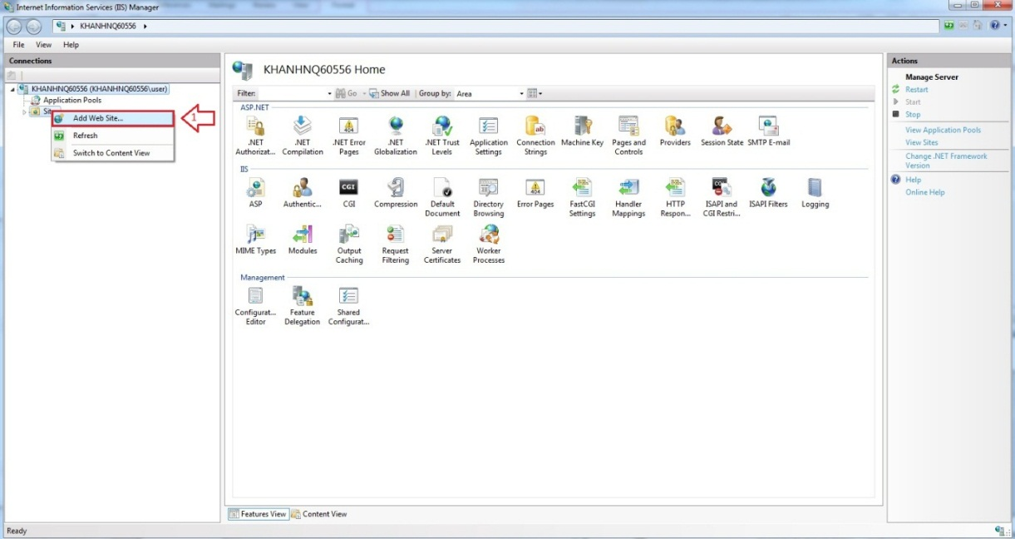

Firgure 6.1 Add Web Site

* Enter “Site Name”.
* Click on “Select” button to select Application pool.

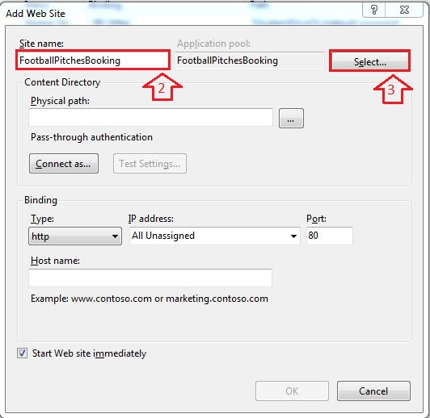

Figure 6.2 Add Site Name

* Select “ASP.NET v4.0”.

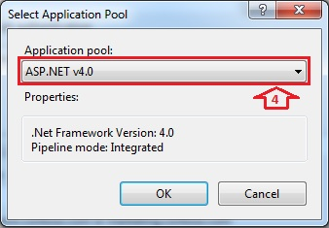

Figure 6.3 Select ASP.NET

* Browse physical path: “~/ FootballPitchesBooking”.

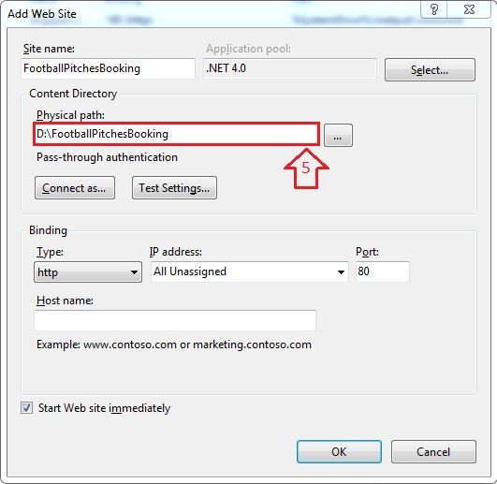

Figure 6.4 Add Path Link

* Open “~/ FootballPitchesBookingProject/Web.config” file by Notepad.

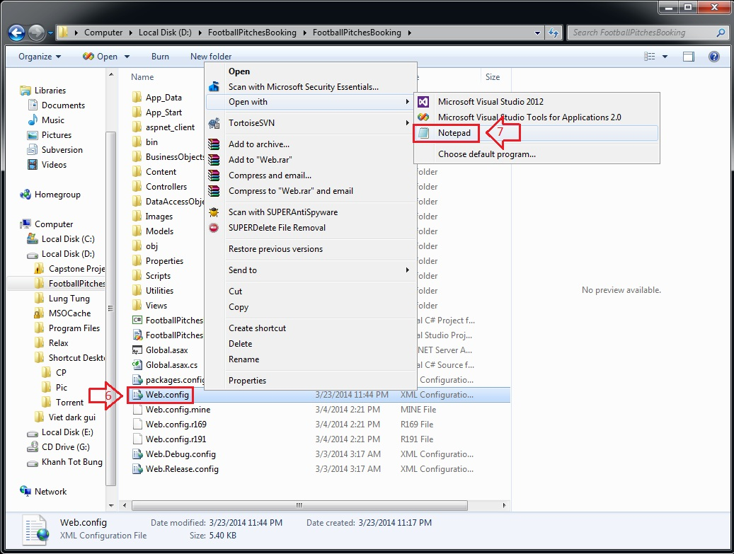

Figure 6.5 Edit Web.config

* Find “connectionStrings” tag, change “Server Name”, “User ID” and “Password” in its connection string depend on your computer.

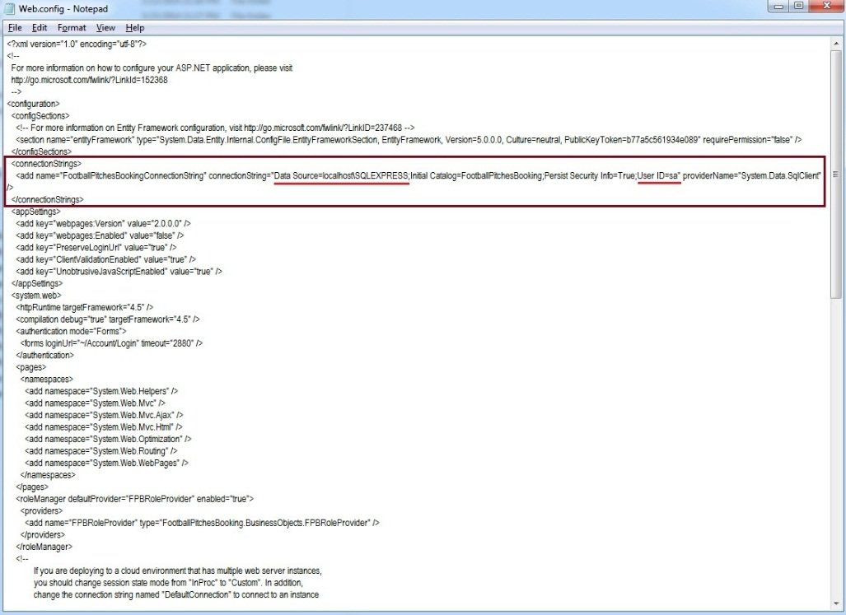

Figure 6.6 Edit Web.config

* Right click on new site name (FootballPitchesBooking) in left content -> Manage Web Site -> Browse to view the website.

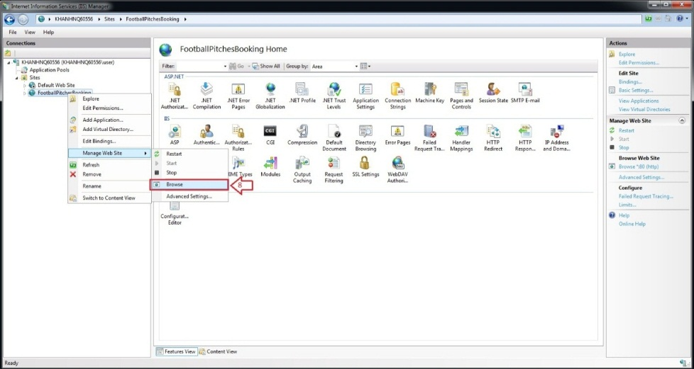

Figure 6.7 How to open Website

* The website is deployed.

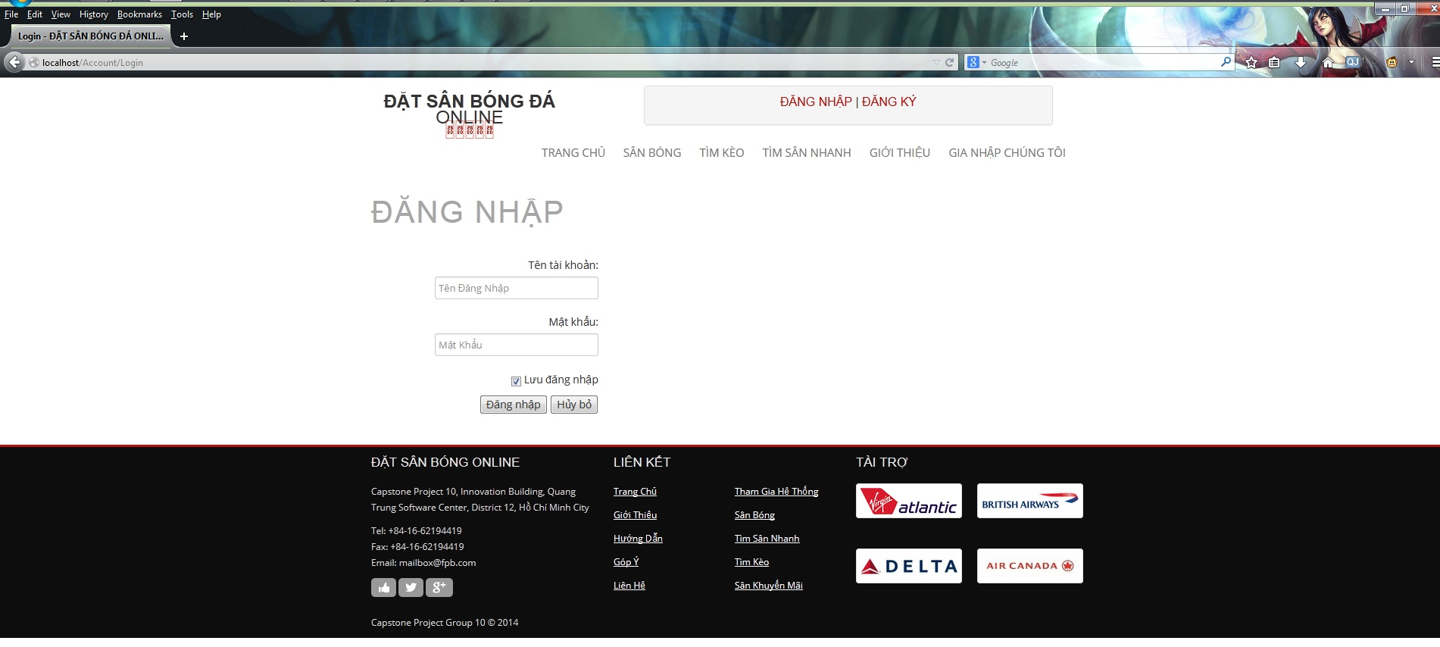

Figure 6.8 Website is deployed

### 6.2 User’s Guide

#### Website Master

- Step 1 : Login with WebsiteMaster role

- Step 2 : Click on “Quản Trị Website” link in Admin page

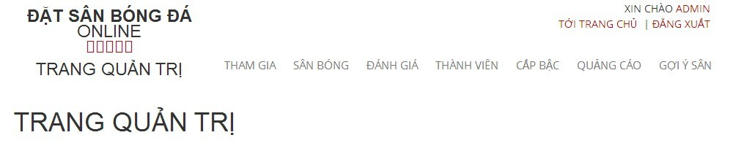

##### Join Request Management

Reference:

##### View All Join Request

- Step 1 : Click on “ Tham Gia “ link to view all join request from member

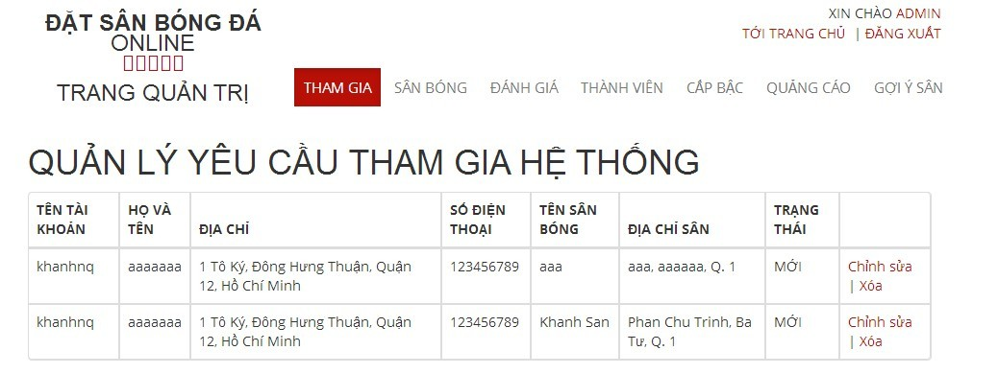

##### Stadium Management

###### View All Stadiums

- Step 1 : Click on “ Sân Bóng “ link to view all stadiums

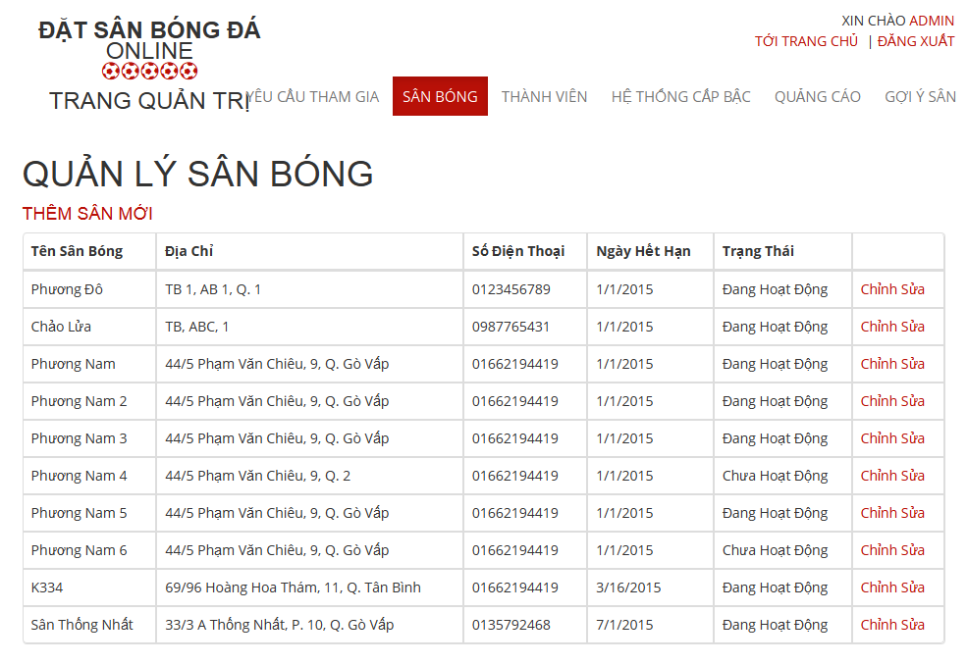

Figure 6.10 View All Stadiums

###### Add New Stadium

- Step 1 : Click on “ Thêm Sân Mới “ link

- Step 2 : Input all required fields

- Step 3 : Click on“ Thêm Sân Mới” button to add new stadium or click “ Hủy Bỏ “ button to cancel

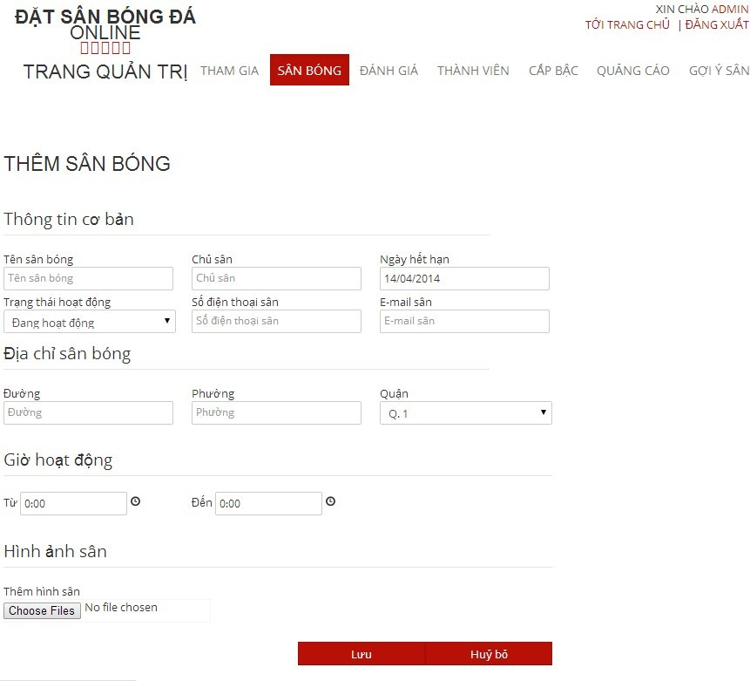

Figure 6.11 Add New Stadium

###### Edit Stadium

Reference:

##### User Management

###### View List Members

- Step 1: Choose “ Thành Viên “ link to view all members of the website

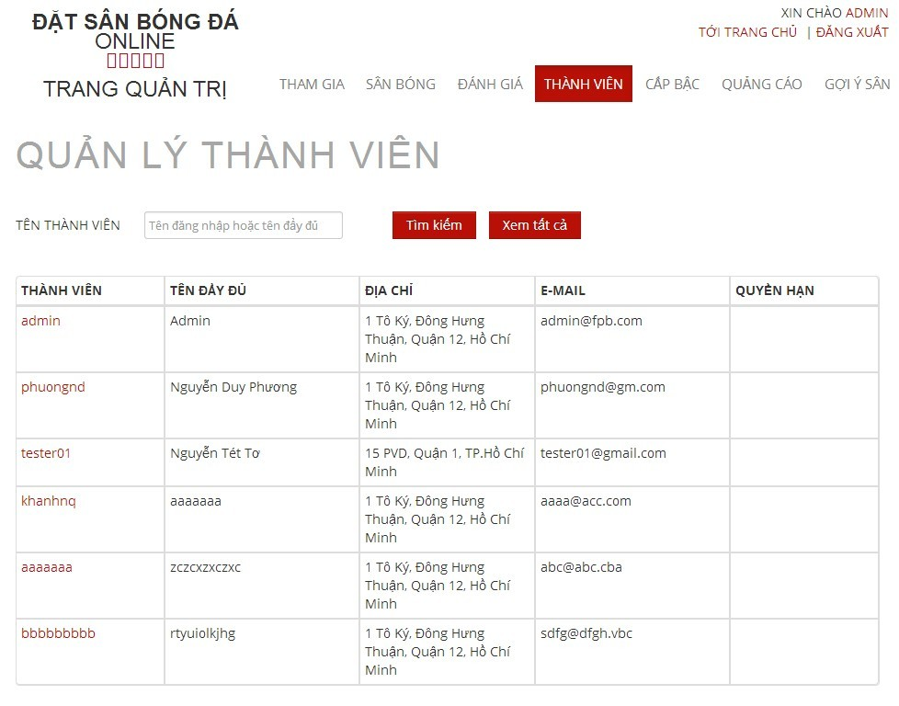

###### Search Members

Reference:

###### Edit Members

- Step 1 : Click on name of the member you want to change information

- Step 2 : Change information of field which you want to change

- Step 3 : Click on “ Cập Nhật” button to save the information of member or click “ Hủy Bỏ “ button to cancel

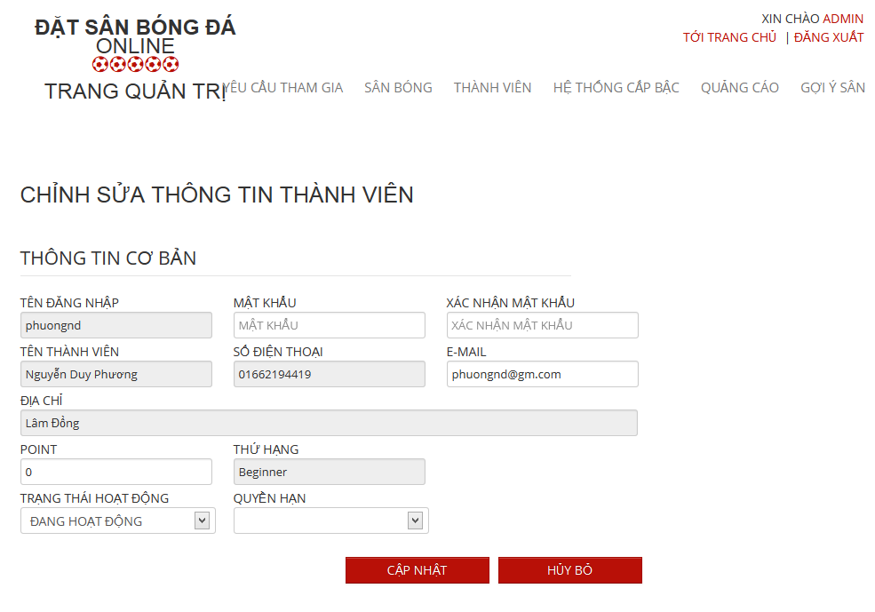

###### Punish User

Reference:

##### Advertise Management

###### View All Advertises

- Step 1 : Click on “ Quảng Cáo “ link to view all advertises

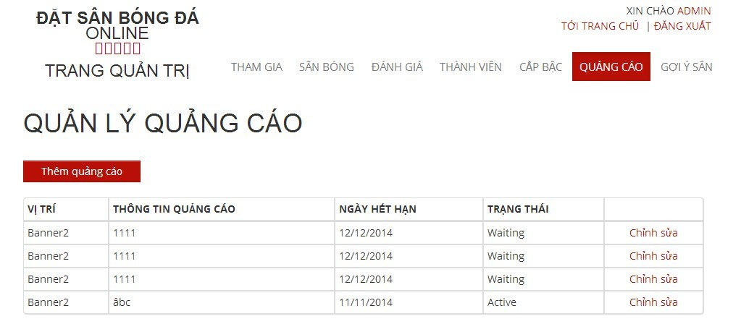

###### Add New Advertises

- Step 1 : Click on “ Thêm Quảng Cáo “ button in “ Quảng Cáo “ page

- Step 2: Input in all required fields

- Step 3: Click on “ Lưu” button to add new advertise or click “ Hủy Bỏ “ button to cancel

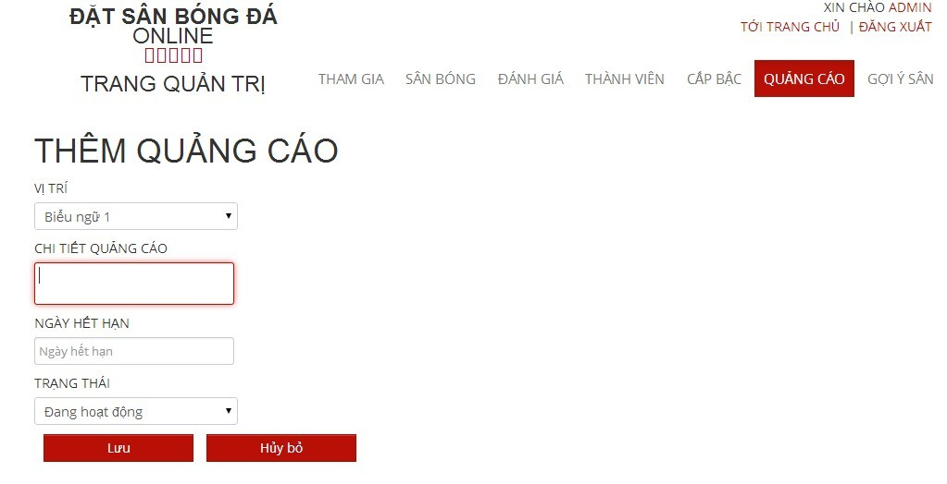

##### Rank Management

###### View List Ranks

Reference:

###### Create Ranks

Reference:

###### Edit Ranks

Reference:

##### Recommendation Management

###### View Recommendation Management Page

- Step 1 : Click on “ Gợi Ý Sân “ link

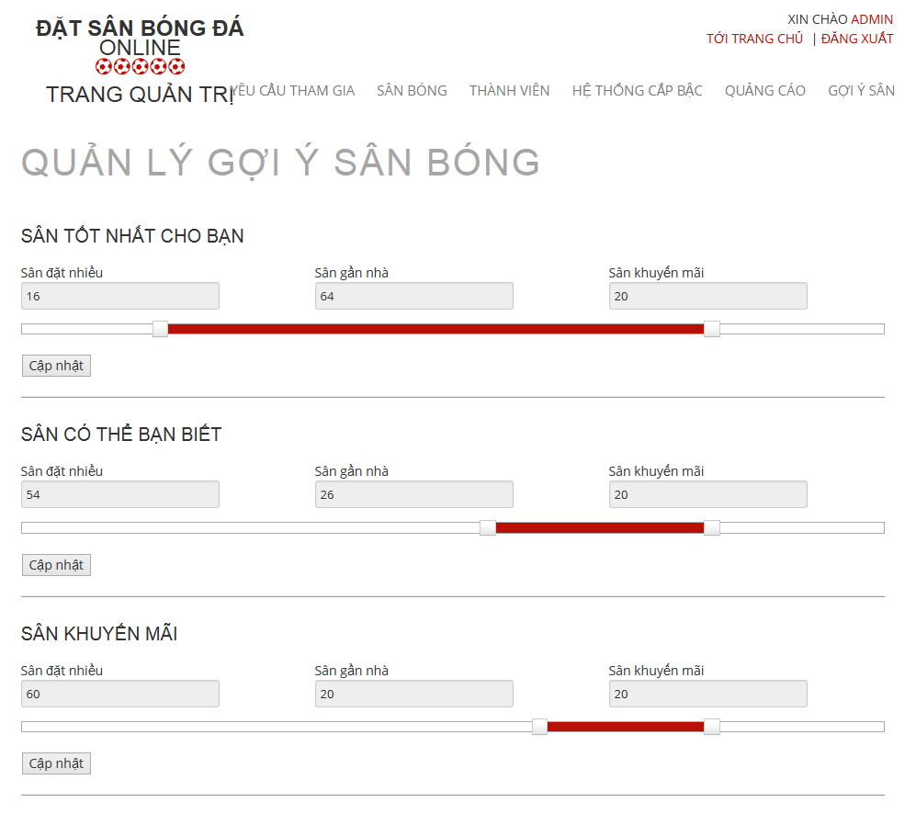

###### Edit in Recommendation Management Page

- Step 1 : Drag on the point to change the value of each priority

- Step 2 : Click on “ Cập Nhật “ button to save

#### Website Staff

- Step 1 : Login with WebsiteStaff role

- Step 2 : Click on “Quản Trị Website” link

##### User Management

###### View List Members

- Step 1: Choose “ Thành Viên “ link to view all members of the website



###### Search Members

Reference:

###### Edit Members

- Step 1 : Click on name of the member you want to change information

- Step 2 : Change information of field which you want to change

- Step 3 : Click on “ Cập Nhật” button to save the information of member or click “ Hủy Bỏ “ button to cancel



#### Stadium Staff

- Step 1 : Login with Stadium Staff role

- Step 2 : Click on “Quản Lý Sân Bóng ” link

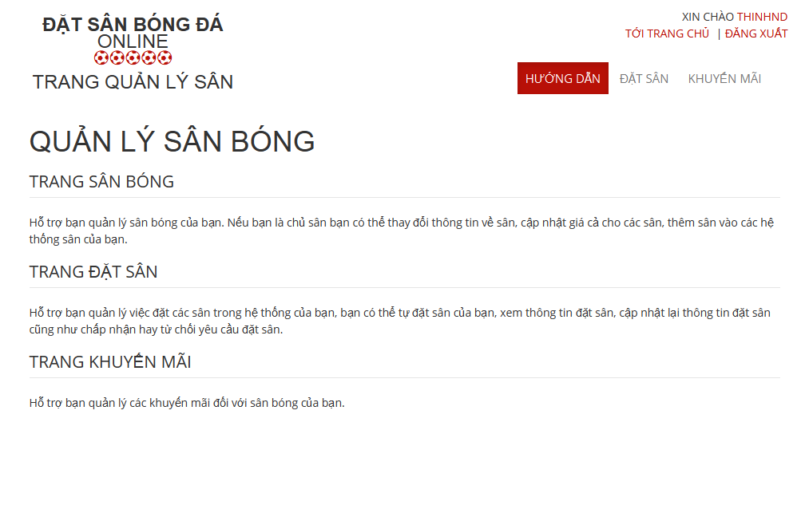

##### Promotion Management

###### View List Promotions

- Step 1: Click on “Khuyến mãi” link in “ Quản lý sân “ page

- Step 2: Choose Stadium to view promotions of that stadium

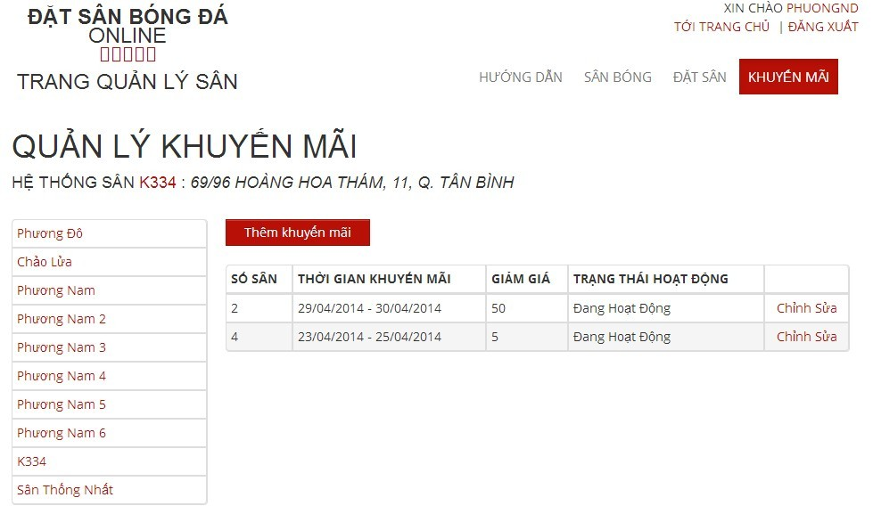

###### Add New Promotion

- Step 1: Click on “Thêm khuyến mãi” button from “ Thêm khuyến mãi “page

- Step 2: Input information about promotion

- Step 3: Click on “Lưu” button to save or click “Hủy bỏ” to cancel

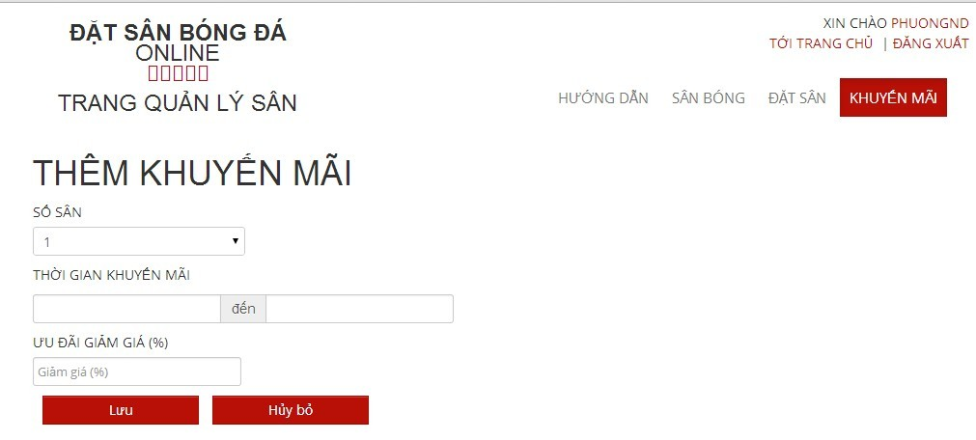

###### Edit Promotion

Reference:

##### Reservation Management

###### View All Reservations :

- Step 1 : Click on “ Đặt Sân “ link to view all reservations

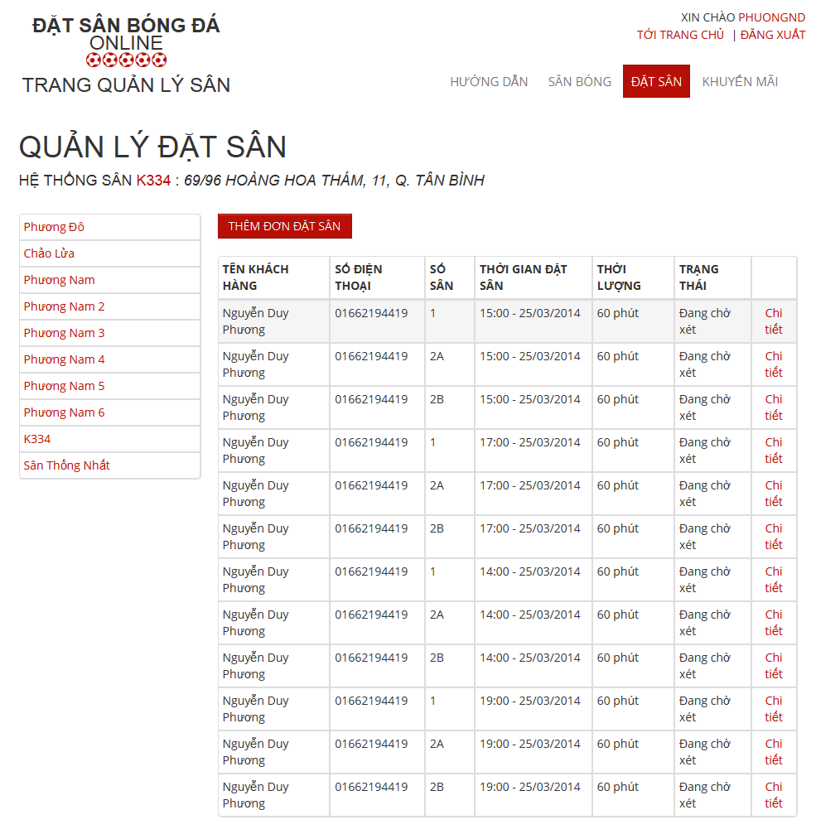

###### Add New Reservation

- Step 1 : Click on “ Thêm Đơn Đặt Sân “ button in “ Quản Lý Đặt Sân “ page

- Step 2: Input in all required fields

- Step 3: Click on “ Lưu” button to add new price list or click “ Hủy Bỏ “ button to cancel

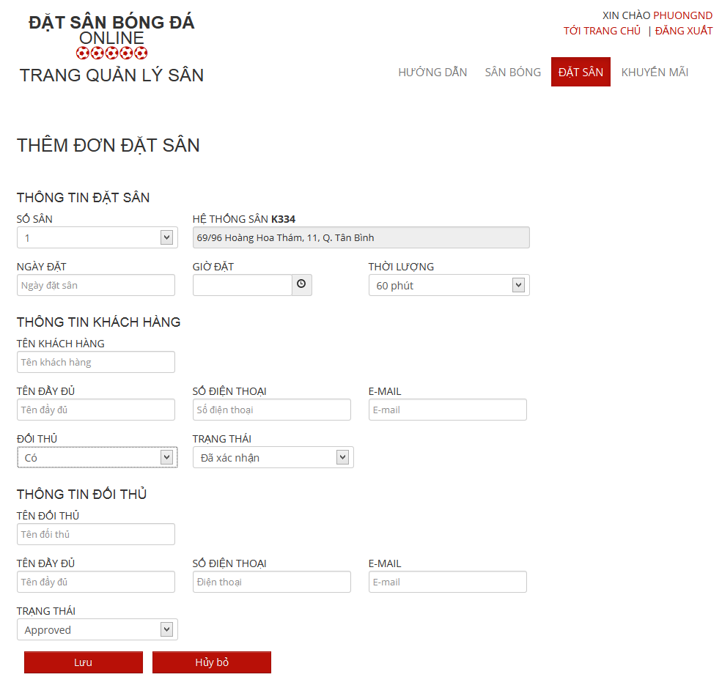

###### Confirm Reservation

- Step 1 : Click on “ Chi tiết “ link of the reservation which you want to examine

- Step 2 : Click on “Xác Nhận” button to confirm or click on “Từ Chối” to deny or Click on “ Chỉnh Sửa “ to edit reservation or click on “ Quay Lại “ to cancel

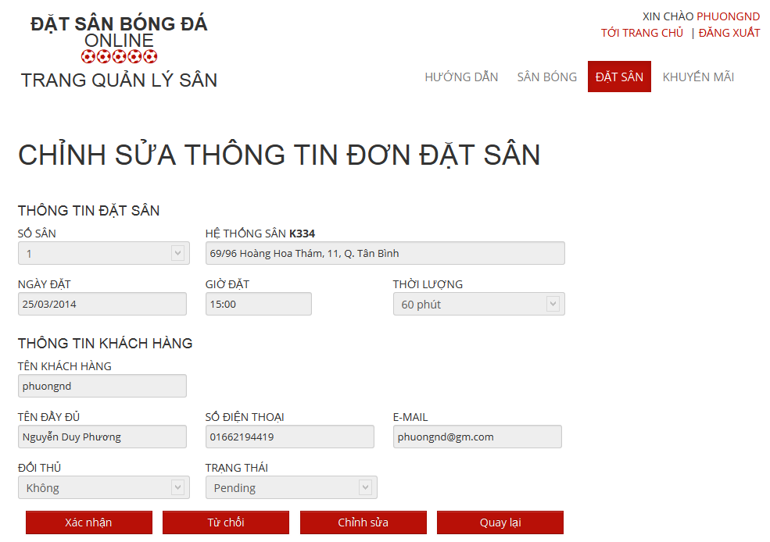

###### Edit Reservation

Reference:

#### Stadium Owner

- Step 1 : Login with StadiumOwner role

- Step 2 : Click on “Quản Trị Sân Bóng” link

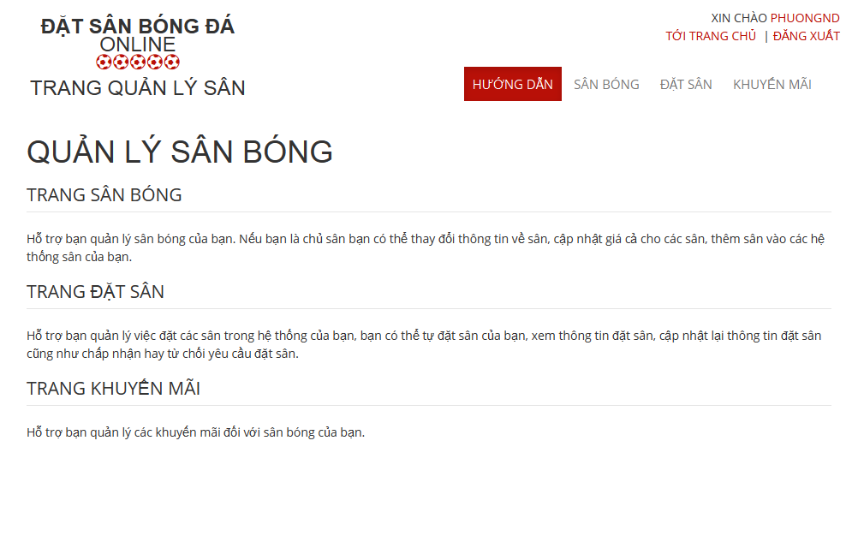

##### Stadium Management

###### View All Stadiums

-Step 1 : Click on “ Sân Bóng “ link

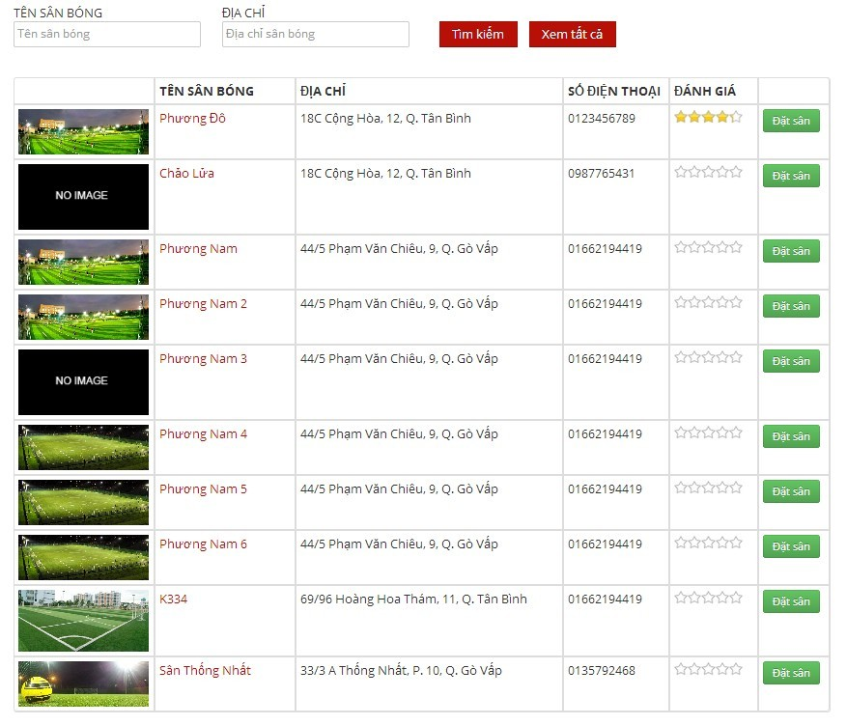

###### Edit Stadium

- Step 1 : Click on “ Chỉnh sửa “ link of the stadium which you want to change

- Step 2 : Change information of field which you want to change

- Step 3 : Click on “ Chọn Hình Ảnh “ button to choose new image about this stadium

- Step 4 : Click on “Lưu ” button to save or click “Hủy bỏ” to cancel

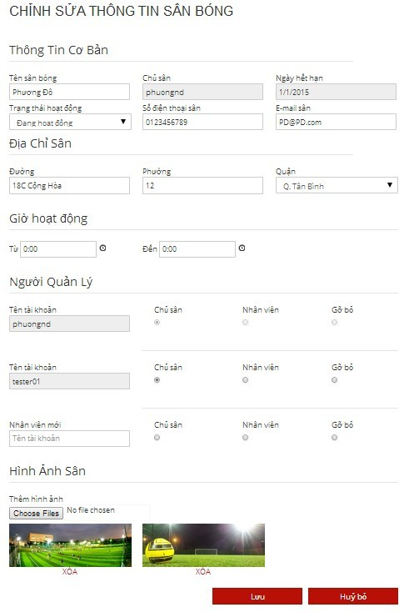

###### View Child Field

- Step 1 : Click on “ Sân Con “ link to see all child fields of this stadium

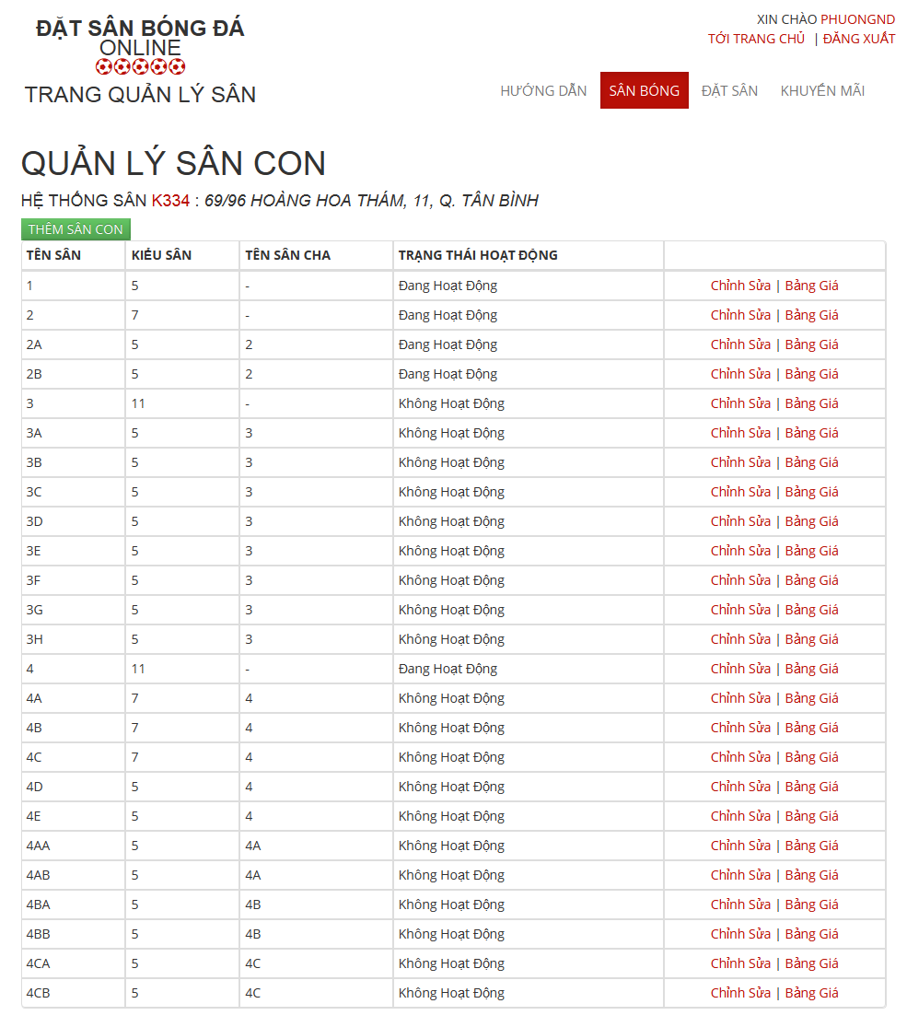

###### Add New Child Field

Reference:

###### Edit Child Field

Reference

###### View Price List of Child Filed

Reference:

###### View Price Tables

- Step 1 : Click on “ Bảng Giá “ link to see all child fields of this stadium

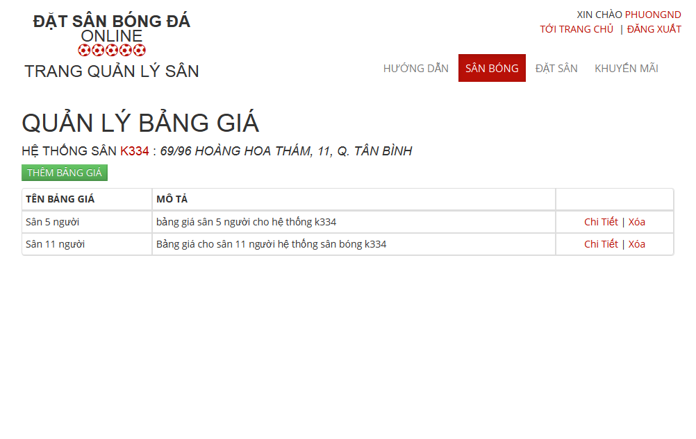

###### Add New Price Tables

- Step 1 : Click on “ Thêm Bảng Giá “ button in “ Quản Lý Bảng Giá“ Page

- Step 2: Input in all required fields

- Step 3: Click on “ Lưu” button to add new price list or click “ Hủy Bỏ “ button to cancel

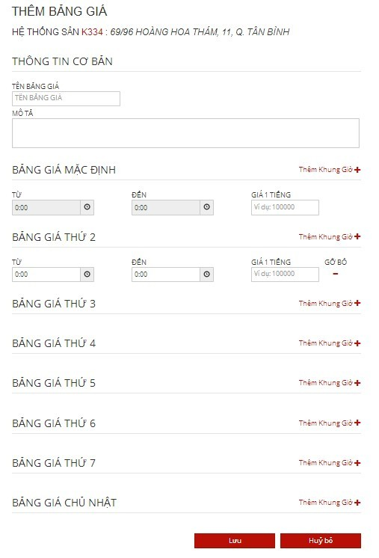

##### Promotion Management

###### View List Promotions

- Step 1: Click on “Khuyến mãi” link in “ Quản lý sân “ page

- Step 2: Choose Stadium to view promotions of that stadium



###### Add New Promotion

- Step 1: Click on “Thêm khuyến mãi” button from “ Thêm khuyến mãi “page

- Step 2: Input information about promotion

- Step 3: Click on “Lưu” button to save or click “Hủy bỏ” to cancel



###### Edit Promotion

Reference:

##### Reservation Management

###### View All Reservations :

- Step 1 : Click on “ Đặt Sân “ link to view all reservations



###### Add New Reservation

- Step 1 : Click on “ Thêm Đơn Đặt Sân “ button in “ Quản Lý Đặt Sân “ page

- Step 2: Input in all required fields

- Step 3: Click on “ Lưu” button to add new price list or click “ Hủy Bỏ “ button to cancel



###### Confirm Reservation

- Step 1 : Click on “ Chi tiết “ link of the reservation which you want to examine

- Step 2 : Click on “Xác Nhận” button to confirm or click on “Từ Chối” to deny or Click on “ Chỉnh Sửa “ to edit reservation or click on “ Quay Lại “ to cancel



###### Edit Reservation

Reference:

##### Register

Reference:

##### Login

Reference:

##### View Account Profiles

* Step 1: Click on username link to open management window
* Step 2: Click on “Quản lý tài khoản” link

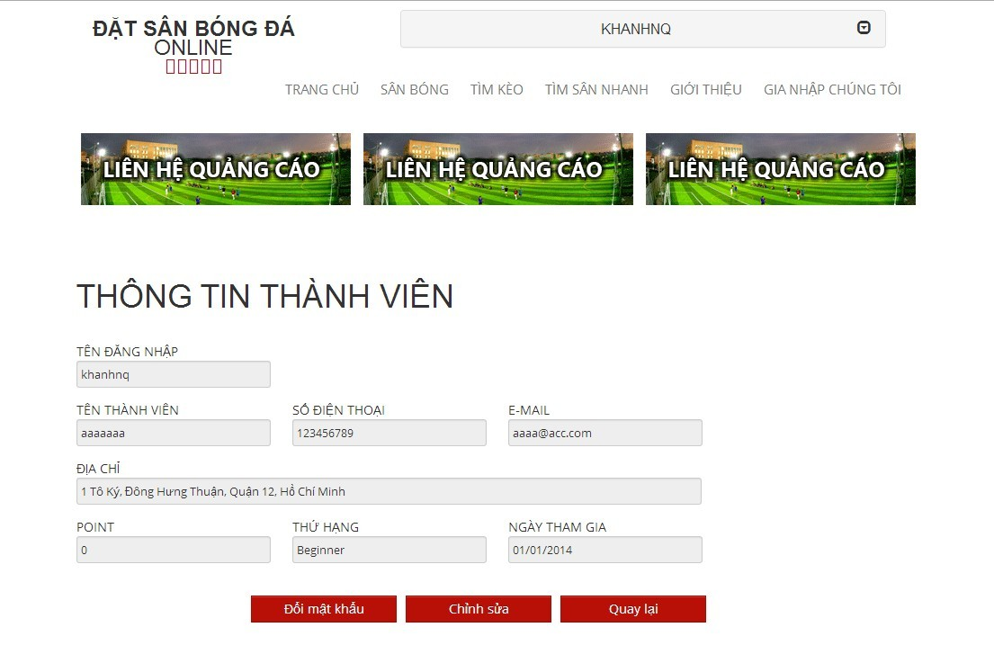

##### Edit Account Profiles

Reference:

##### Find Available Stadium

- Step 1: Click on “Tìm sân nhanh” link or open “Tìm sân nhanh” drop down list at “ Trang chủ “ page

- Step 2: Choose information

- Step 3: Click on “Tìm kiếm” button to find available stadium

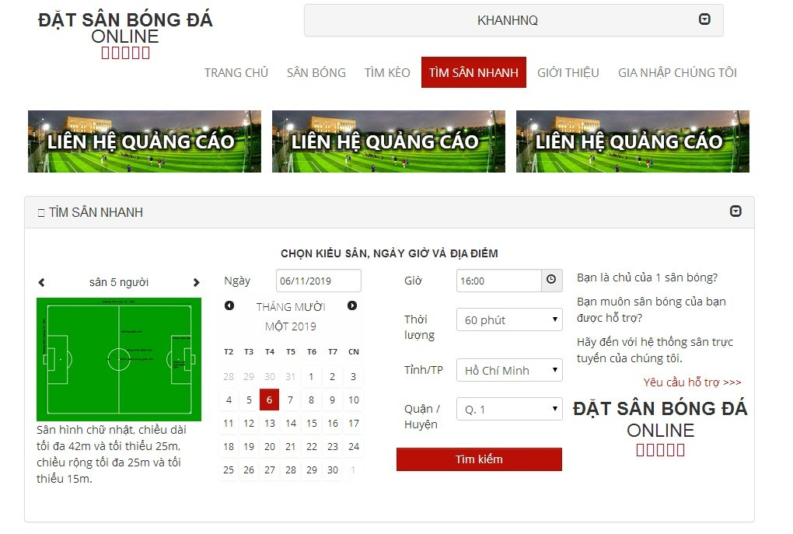

##### Find Stadium

- Step 1 : Click on “ Sân bóng “ link in “ Trang chủ “ page

- Step 2 : Input all information about the stadium you want to find

- Step 3 : Click on “ Tìm Kiếm “ button to find

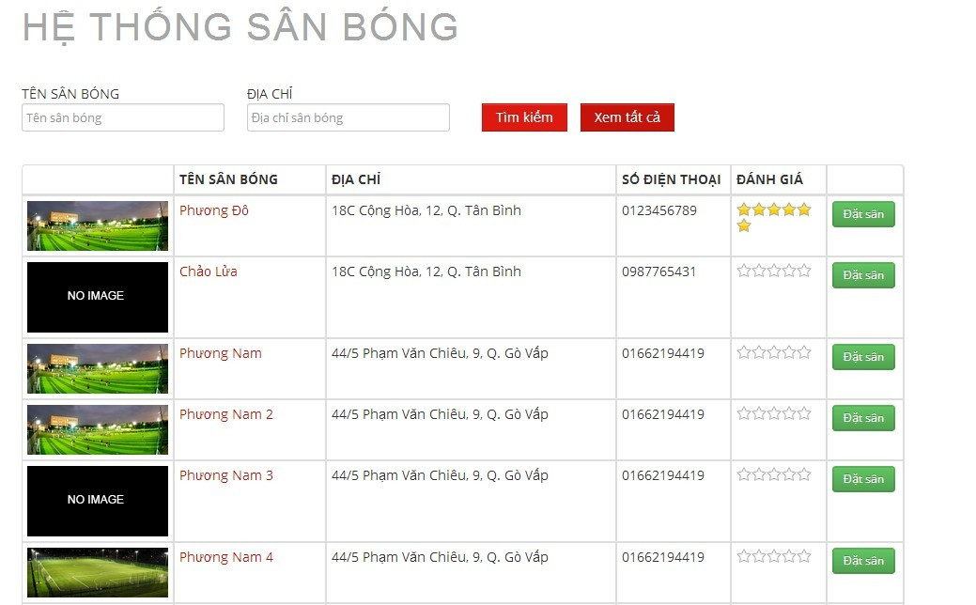

##### View Stadium’s Details

- Step 1 : Click on “ Sân Bóng “ link in “ Trang chủ “ page

- Step 2 : Click on a stadium you want to view information

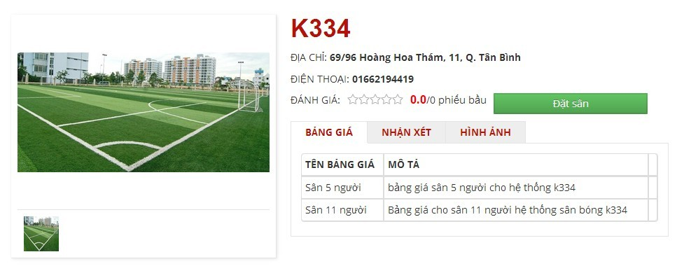

##### Rating Stadium

- Step 1 : Click on “ Sân Bóng “ link in “Trang chủ “ page

- Step 2 : Click on a stadium which you want to rate

- Step 3 : Click on 1 – 5 star for rating stadium

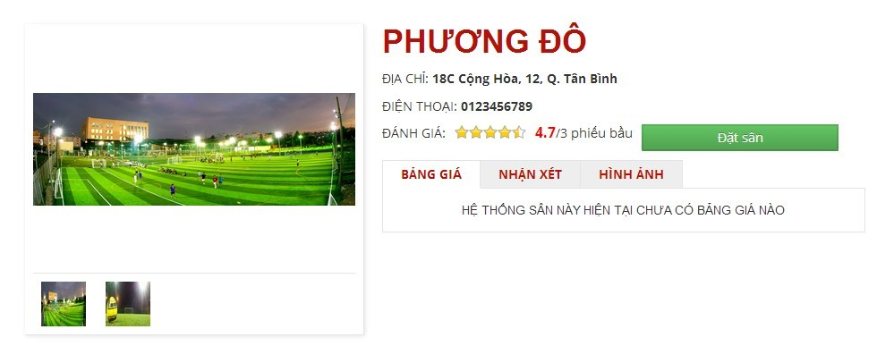

##### Review Stadium

Reference:

##### Feedback Stadium

Reference:

##### Booking Pitches

- Step 1 : Click on “ Sân Bóng “ link in Homepage

- Step 2 : Click on “ Đặt Sân “ button on the stadium you want to book or click on the stadium which you want to book and click on “ Đặt Sân “ button

- Step 3 : Input all require information about stadium you want to book

- Step 4 : Click on “ Đặt Sân “ button to book stadium or “ Hủy Bỏ “ button to cancel or “ Lưu “ button to edit “ Thông Tin Cập Nhật “

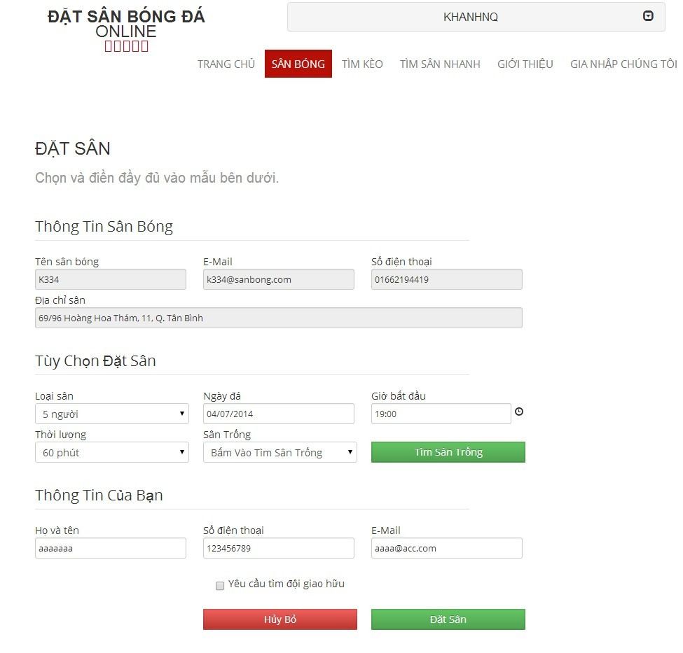

##### Cancel Reservation

- Step 1 : Click on your account

- Step 2 : Click on “ Lịch Sử Đặt Sân “ link

- Step 3 : Click on “ Chỉnh sửa “ link on the stadium which you want to cancel reservation

- Step 4 : Click on “ Hủy Đặt Sân “ button to cancel reservation

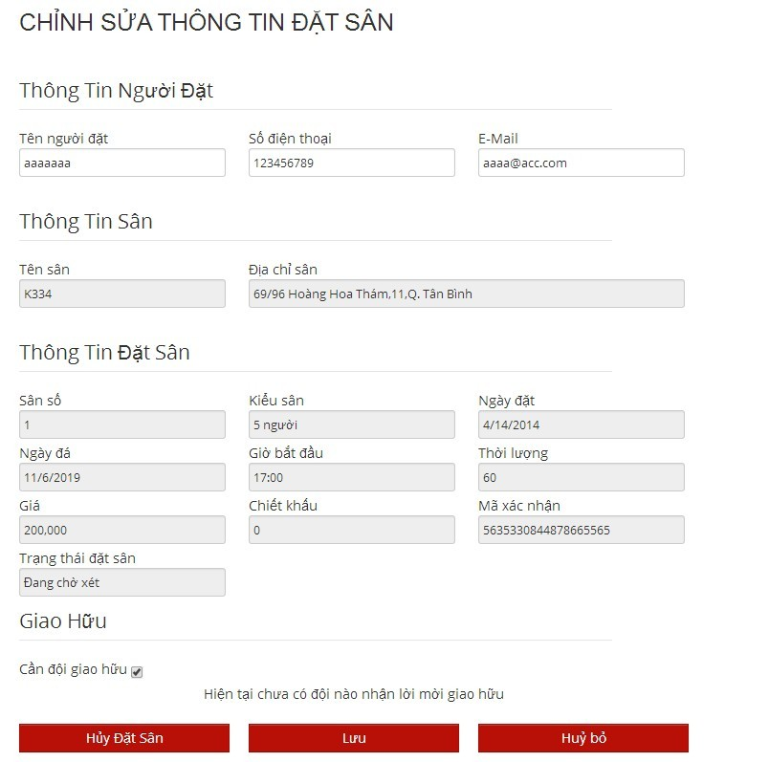

##### Find Rival

- Step 1 : Click on “ Tìm Kèo “ link in Homepage

- Step 2 : Click on “ Chi tiết “ button on the team you want to fight or view information

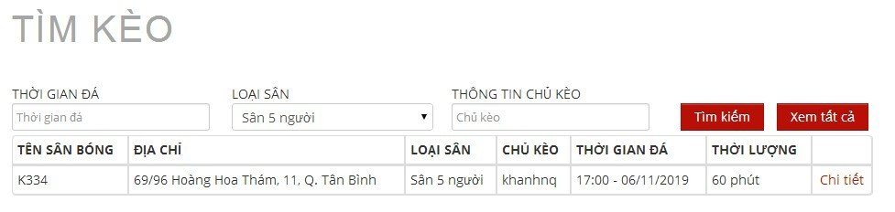

##### Join Rival

- Step 1 : Click on “ Sân bóng “ link on “ Trang chủ “ page

- Step 2 : Click on " Đặt Sân " button in one stadium in list stadium or lick on one stadium and click “ Đặt sân “ button

- Step 3 : Input all information

- Step 4 : Check on “ Yêu cầu tìm đội giao hữu “ drop down list

- Step 5 : Click “ Đặt sân “ button

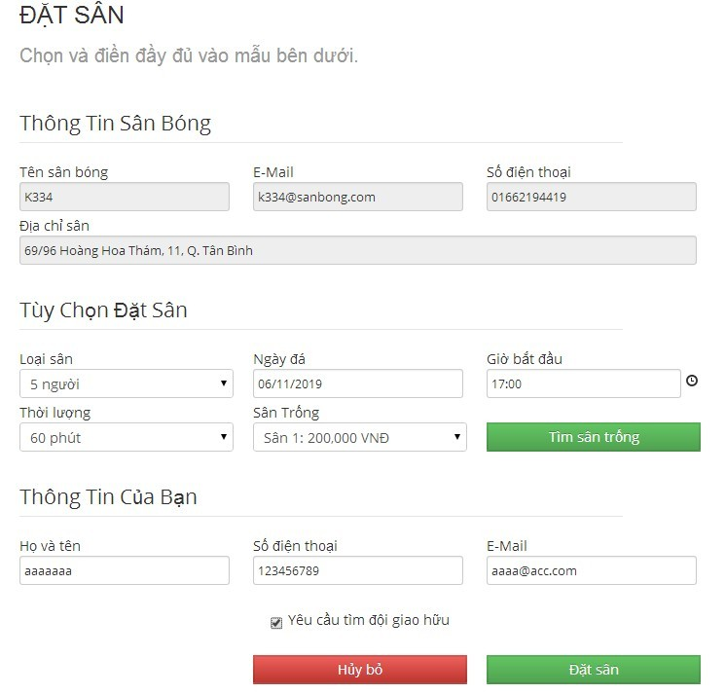

##### View Booking History

Reference

##### Request Join System

Reference